Four and counting for Black Gold

12/10/2024 by Timothy Hampson

Campaign

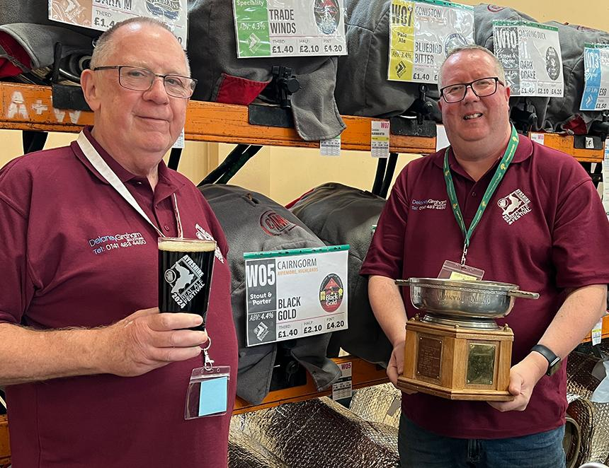

CAMRA’s Champion Beer of Scotland competition saw Cairngorm’s Black Gold repeats its win from last year, bringing its total to four. Held at the Ayrshire Real Ale Festival featuring more than 140 cask ales, the 4.4 per cent session stout retained the title that it won last year, as well as in 2015 and 2005. Black Gold is described as having roast malt which dominates throughout, slight smokiness in aroma leading to a liquorice and blackcurrant background taste giving it a background sweetness with a long, dry, bitter finish. No less than four colours of malt make the grist. CAMRA’s Scotland director Stuart McMahon said: “Cairngorm brewery, which is based in Aviemore, continues to brew a variety of tasty beers. “Black Gold was a very worthy winner, despite the strong competition from the other category winners. It is a very good example of a rich stout, with the strong roast and burnt malts to the fore, but with a lovely smooth, bitter but sweet aftertaste. “Since it was initially brewed, Black Gold has now received the most awards from CAMRA in Scotland.” Five Kingdoms brewery, Scotland’s most southerly brewery based in Isle of Whithorn took the silver award, with Dark Storm, a 6.9 per cent strong stout.  Pictured, from left, Scottish Champion Beer of Britain coordinator Lindsay Grant and Stuart McMahon with Black Gold and the Dan Kane Memorial trophy.