New vice chair for CAMRA

11/10/2024 by Timothy Hampson

Campaign

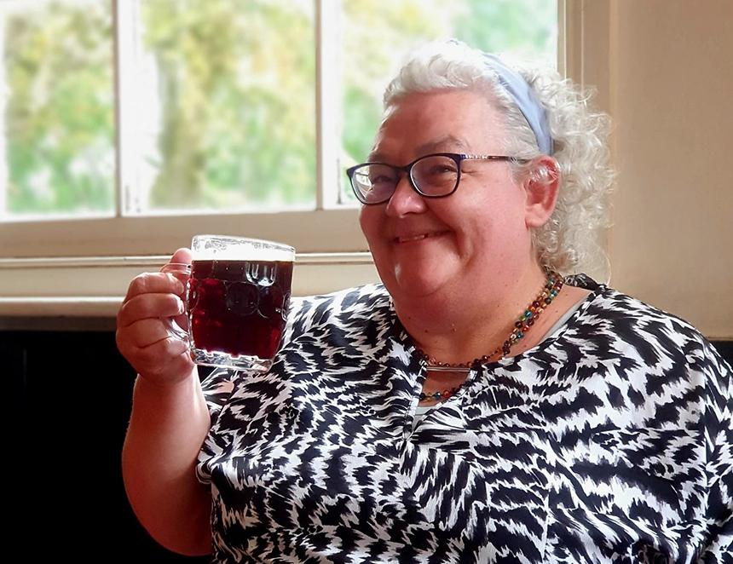

Gillian Hough is CAMRA’s new vice chair, replacing Ash Corbett-Collins following his election as national chairman. The appointment completes the new top team for the Campaign. Gillian joined CAMRA at the Pig’s Ear Beer Festival in 1984, when she was still a student. Hailing from Northern Ireland, she was inspired by the wide variety and quality on offer at beer and cider festivals in London. She has served for more than 10 years on CAMRA’s National Executive, first from 2003 to 2007 and again since 2018. A previous chair of CAMRA’s Books Committee, she was also part of CAMRA’s most recent Governance and Beer Styles Review. Gillian will remain CAMRA’s director for real ale cider and perry. Gillian said: “I am delighted to have been appointed CAMRA’s new vice chair. CAMRA is the consumer voice for cask-conditioned beer, real cider, and perry, and with so many threats to our pub heritage and demands on the money in our pockets, it is vital that consumers unite to make our voice heard.  “I am particularly passionate about our campaigning for changes to legislation on provenance and ingredient labelling so consumers have the full story about what's in their glass.  “Along with Ash’s election as CAMRA national chairman, I believe this heralds an exciting new chapter for us. I look forward to the challenges ahead, and I will continue to listen to voices from across the Campaign as I work with my fellow directors to campaign for consumers and the licensed trade.” Ash said: "I'm so glad that Gill will be taking up the role of vice chair at what is a really exciting time for the Campaign. Her enthusiasm and experience as a campaigner will be invaluable in providing a strong voice for beer drinkers and pub-goers in the UK. "We have already been colleagues on the National Executive for almost seven years, after both being elected in 2018, and I'm looking forward to working with her more closely. I'm sure she will be a great success in her new role."