Pomona prize for perry’s ‘knight in shining armour’

11/10/2024 by WB Reporter

Campaign

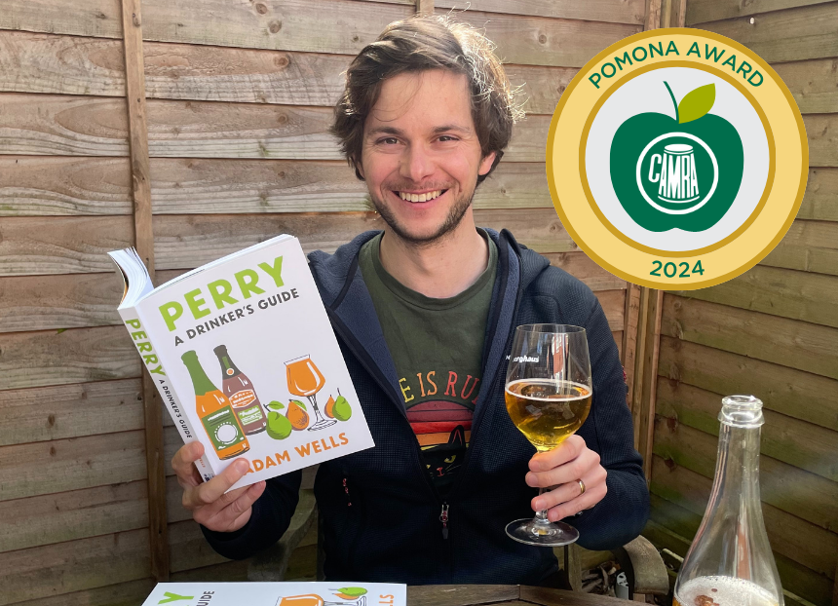

Drinks writer Adam Wells (above) is the winner of CAMRA’s 2024 Pomona Award. The award will be presented today at the end of a presentation he is giving at the Applefest Perry Day at the Courtyard Theatre in Hereford.  Named after the goddess of fruit trees, gardens and orchards, the Pomona Award is presented by CAMRA to a person, group, organisation, idea or concept that has made an outstanding achievement, commitment, or contribution to the promotion of real cider or perry.  Adam is an award-winning drinks writer and one of the UK’s leading voices on cider and perry. As the founder-editor and primary contributor on Cider Review, the nation’s leading source of long-form articles on cider and perry, and co-host of the Cider Voice podcast, Adam has been at the forefront of championing producers and growers, becoming an advocate for the cider and perry making industry.  He is one of the most dedicated and effective communicators for cider and perry, engrossing audiences across the globe as a speaker at events, including CiderCon in Oregon, USA and the Hereford AppleFest banquet. Noted for illustrating how fiendishly difficult it is to produce perry, his talks are described as engaging, passionate and humorous.  As well as having written for numerous platforms such as Pellicle and Burum Collective, Adam has produced content for CAMRA’s educational Learn and Discover website, discussing the ecological need for perry pear orchards and arguing the need for clearer, more transparent labelling on cider and perry.  His nominations praised Adam’s unparalleled commitment to the perry industry, helping to revive interest in the drink with his groundbreaking CAMRA publication, Perry: A Drinker’s Guide. The book is the world’s first consumer guide to the ancient, yet often overlooked, drink. Published in March following a Kickstarter campaign so popular the title achieved 100 per cent funding in under 24 hours. The book charts perry’s remarkable history, guiding the reader through the styles, flavours and varieties, plus countries, regions and producers behind the traditional beverage. Leading wine expert and writer Oz Clarke described the book as “…a cracker – opinionated, witty, critical, yet passionate, intensely researched and wonderfully readable. The past, present and future of perry – it’s all here.” Nominators went as far as describing Adam as “perry’s knight in shining armour”!  Adam said: “I’m absolutely astonished to have the honour and privilege of receiving CAMRA’s Pomona Award, joining a roster of former recipients who have been such a source of personal inspiration. “I’m aware that awards like this usually go to those who have the luxury of a prominent platform, such as I'm lucky enough to have via Cider Review and the opportunities that it has provided. But nothing I’ve done within cider and perry has been the result of individual endeavour; rather it has come about through the collective efforts of people too numerous to list, to all of whom I’m immensely grateful. “In the comparatively short time I’ve been part of the aspirational cider community I’ve seen it go from strength to strength in every respect, be it making or advocacy. This has only been possible because of the dedication, belief and industry of so many, many people, from producers to hospitality and retail professionals, to volunteers at CAMRA festivals, to writers and other communicators.  “Being a part of that broad international group has been one of the greatest pleasures of my career. The cider community, at its best, is the most welcoming, positive and enthusiastic in all of drinks, and it is with that enthusiasm and positivity that the global cider revolution will continue to blossom and grow. I hope I’ll continue to play a role within it for a long time to come. “In addition to thanking CAMRA, everyone who put me forward for this award, and my incredible group of co-writers on Cider Review, I’d like to pay tribute to former Pomona winner Susanna Forbes. Susanna was a source of guidance, mentorship and encouragement to me from before I even began writing about cider and perry – as she was for so many people – and the world of cider that I am so proud to be part of exists in no small part because of her. Without the support she constantly offered I wouldn’t be in a position to receive this award today.” Andrea Briers, who oversees CAMRA’s Pomona Award said: “Adam Wells has shown outstanding commitment to cider and perry, sharing his vast knowledge and keen enthusiasm about the drinks, the producers and the industry to varied audiences. I would like to congratulate Adam on his Pomona win, and I look forward to witnessing his continued success and further impact upon the cider and perry scene. There is no doubt that he has inspired others to learn more about these wonderful, historic drinks, and his dedication to the industry is something to be celebrated.”  The Pomona Award reveal is part of CAMRA’s Cider and Perry Month. CAMRA supports and campaigns for cider and perry throughout the year and spotlights them with celebrations throughout May and October, coinciding with the natural production cycle of apples and pears. October is when producers will harvest and press fruit from orchards, ready to be stored for fermentation.