2024 Finance Award Round Up

10/10/2024 by Matthew Rogers

Campaign

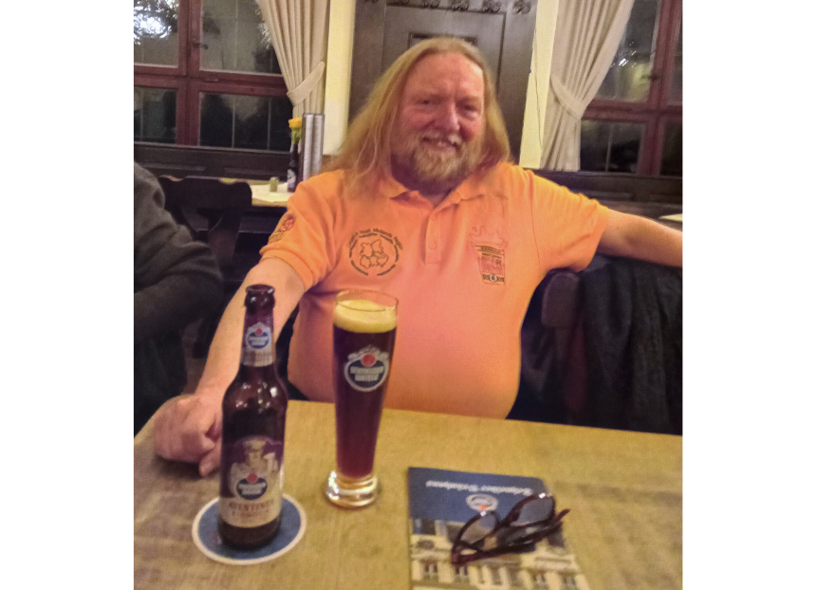

As the Campaign gears up for its Members’ Weekend, AGM & Conference 2025 in Torquay, we are rounding up announcements from this year’s event in Dundee. The late Steve Edwards was the recipient of the inaugural Finance Award. View both a video recording of the presentation and the transcript below. Nik Antona: “We’ll now go over to the Finance Award, so I’ll invite Ben Wilkinson down to present the inaugural Finance Award.” Ben Wilkinson: “Morning Conference. Ben Wilkinson, South Hertfordshire branch and here on behalf of the National Executive, and for anyone who isn’t aware I’m CAMRA’s finance director. “I’ve been in that role for about three and a half years now and the experience has been, for someone like me who didn’t have much in the way of a financial background, quite a steep learning curve. I’ve relied very heavily, therefore, on the group of volunteers who make up CAMRA’s Finance and General Purposes Committee that, as finance director, I’m responsible for chairing. “Having been appointed to what at the time was quite a daunting new job, I was very reassured to meet the group of people that I’ll be working with. They really know their stuff and they take their responsibilities very seriously and I think that the Campaign owes them a lot for the unsung and sometimes unpopular, but very important and crucial work that they do. “Until last year, one of those people on that committee was Steve Edwards, and Steve epitomised everything I just said and everything I value about the Finance Committee. Steve was the one on the team who, you might say had, come up through the ranks. His first financial role within the Campaign had been as Treasurer for his local branch, Coventry and District, where he’d proven himself to be exceptional in the role, not just in managing money for the branch but in taking an active role in the organisation and running of beer festivals as well. “He went on to become finance officer for the whole of the West Midlands region. Not just overseeing, guiding, training, and supporting other branch treasurers across that part of the country, but also being a reliable right-hand man to a succession of regional directors - like my NE colleague, Gary Timmins, who used to be RD for the West Midlands, and describes Steve as having being absolutely instrumental in helping him to run the region. “And while continuing to fulfil those busy and important branch and regional finance roles, Steve also joined the national Finance Committee which is how I came to meet him. When I arrived, it would be fair to say that he was firmly apart of the furniture having, among many other things, already played a leading role in the implementation and roll out of COBAS which is CAMRA’s online branch accounting system. “From day one as finance director, Steve was someone I could, and regularly did, turn to for advice. Having served in those roles at different levels for so long he understood CAMRA’s financial structure from top to bottom, like the back of his hand. And while he understood completely the financial position and challenges from a national perspective, he also got what it was like to be at the coalface and understood the pressures of making everything add up at a local level as well. “So, if anyone was going to do it, Steve would be the one who would take me aside and, sucking air through his teeth like a plumber about to deliver an expensive quote, would say something like – I won’t to the Brummie accent – but he’d say something like, ‘Listen I just want to warn you that branch memo that you’re planning to put out is going to make you pretty unpopular.’ And he’d always be right as well, but I know that he’s also always be the first to defend our collective decisions even when they were bad news and that he’s go the extra mile to explain and back-up difficult calls that we had to take, particularly during the very challenging Covid period when we had to change a lot of things. And, actually, it was some of the changes that Steve helped to shape that proved most critical during the pandemic and helped ensure the Campaign survived in its current form when, at one stage, it really might not have. “It wasn’t just his knowledge and background that helped us get through that time though, Steve’s enduringly upbeat and cheerful nature and his great sense of humour also helped turn what could have been some very depressing meetings into a much better experience for everybody. He wasn’t just a finance person, he was a CAMRA person, a real ale person through and through. He cared passionately about beer and pubs and all our campaigning aims as an organisation. Steve was one of the most level-headed, objective and thoughtful volunteers I’ve had the pleasure to work with in CAMRA, but he was also one of the most modest and self-effacing. On different occasions, I encouraged him to consider standing as a regional director, and as a national director, and I think he would have been exceptional in either of those roles, but I never succeeded in convincing him of that. “Now, of course, I never will because in November last year Steve very sadly died, aged just 65. He had been diagnosed with cancer and experienced a rapid decline in his health shortly afterwards, and to say that we were shocked and devastated to learn the news would be an understatement. And I for one very much miss him being around, not least at events like this. “As part of his regional finance officer job, Steve instituted a Regional Finance Award that he would present to a branch treasurer or someone else involved in the regions financial management, who he recognised as demonstrating excellence in carrying out their role. And it was with that in mind that Steve brought to the national finance committee, what the rest of us all thought was an excellent proposal, which was to introduce at Members’ Weekend a National Finance Award, recognising outstanding performance or dedication in this, sometimes underappreciated, realm across all levels of the campaign here on a national stage. “Everybody agreed very quickly that it was a good idea and Steve was the coordinator of the award, the first of which was to be presented here today. Sadly, of course, he never got to see that first presentation of his brainchild, but I’m very pleased that it’s something that we will now be able to continue to do every year in his honour. So, if you know of anybody who deserves consideration for 2025’s award, please do let us know. “But for this year, there really can only be one recipient of this award. I obviously wish so much that I was presenting it in different circumstances, but in recognition of his exceptional contributions to the support and improvement of sound financial management across the campaign over many years, please put your hands together for the late Steve Edwards.” Steve Edwards’ nephew, collecting the award on behalf of Steve: “Hello, thank you, I’ll keep this very brief but I’m very proud to accept this award on behalf of my uncle today. Thank you so much, obviously I accept it on behalf of our family, but really you at CAMRA are the family that he chose for himself so thank you for the warmth and love and generosity that you showed him. Thank you.” Elaine Tierney: “Elaine Tierney, branch consult Coventry and District. Ben, last night, said I could have an opportunity to share with you our branch’s decision to institute an annual Steve Day. And we’re intending to announce a date, each year, where we will go and visit somewhere, that anyone is welcome to join us on the day by raising a glass for Steve, on Steve Day. There will be one later this year when we will be handing the final version of the folder of condolence to the family in Nottingham. So, this is full of memories, comments about Steve and there are some sheets of paper in the Members Bar that anybody who wants to add their voice to this, please do so and say again – Steve.”