Hundreds save the Hundred

09/10/2024 by Timothy Hampson

Pub

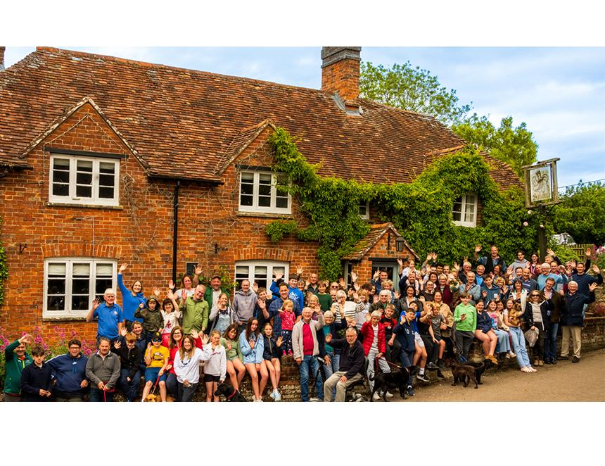

People in Ashendon and surrounding villages in Buckinghamshire are on target to buy their local and have begun a hunt for a tenant. The Ashendon Community Pub Society raised £549,494 to save the Hundred of Ashendon as a community asset. The total includes £300,000 in Community Ownership government funding with the remainder coming through a share offer and donations. A price for the pub has been agreed at £420,000 but, although the share offer surpassed its minimum target, the society continues to raise money targeting a further £50,000 to pay essential work. The society is also on the hunt for community-minded tenants to create a vibrant community hub and a welcoming destination for visitors. The group has been thrilled by the support from outside the village – 72 per cent of the community share value came from Ashendon residents, yet by volume of applications, more than half came from outside the village, including the USA, Europe, and Japan. Society chair Luke Jamieson said: “This achievement is a testament to the collective spirit and determination of our local population to preserve its community, maintain inter-village connectivity, and support UK village pubs. Former Spandau Ballet singer Tony Hadley, a local supporter of the save the pub campaign, has promised to perform at the pub’s opening night. Jamieson thanked the Plunkett Foundation for helping the society secure the Community Ownership grant and providing practical advice throughout the process.