Steel City brewer scoops top title

08/10/2024 by Dave Pickersgill

Industry

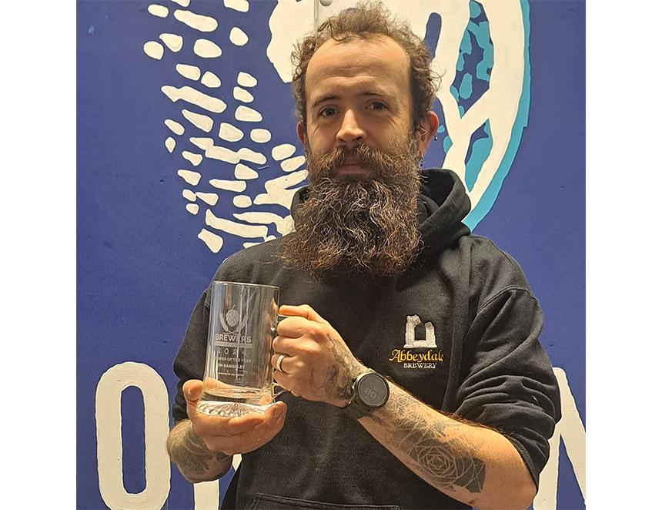

Sheffield’s oldest brewery Abbeydale is celebrating its lead brewer Jim Rangeley being named as Brewer of the Year at the Brewers Choice Awards. Jim (pictured) was presented with his award at a London ceremony where he, and the team, celebrated alongside hundreds of their brewing industry colleagues. Jim, 35, heads Abbeydale’s small-batch, mixed-fermentation Funk Dungeon project. Jim said: “I’m privileged to have a job I truly enjoy, working as part of a brilliant team for a company that puts its trust in me. To have even been shortlisted was incredibly humbling and it’s a true honour to have won.” Judged by a panel of industry experts, this accolade recognises Jim’s talent and passion, as well as his strong sense of values and commitment to progress within the wider industry. Beer writer and judge Melissa Cole said: “What Jim has achieved at Abbeydale is nothing short of excellent. From the Funk Dungeon to churning out great core ranges and being a decent human at the same time, this award is well-deserved.” Tim Sheahan, editor of the Brewers Journal and organiser of the awards, added: “The level of competition for the category is always incredibly high and in 2024 this was no different. But the judging panel at the Brewers Choice Awards recognised not only Jim’s ability to produce a wealth of different styles with unerring ease but his commitment to the industry, too.” In addition, Abbeydale was also shortlisted in the Branding of the Year category for its cask beer focused travel poster series. This artwork was created by designer James Murphy, who has been working with Abbeydale since 2016. James described making the top three as “fantastic”. Established in 1996, last year Abbeydale brewed 382 times (88 individual beers) producing more than 200 barrels a week of which over 75 per cent was cask. There were more than 50 new beers, including both the popular Dr Morton’s range (a tribute to owners Pat and Sue Morton) and limited releases of barrel-aged beers from the Funk Dungeon. There were also many collaborations with other breweries. Jim and marketing manager, Laura Rangeley will be leading a tutored tasting of its beers at the forthcoming Sheffield Beer and City Festival (Kelham Island Museum, 16-19 October). Abbeydale has also produced the charity beer for the event. Photo: Abbeydale brewery