Historic cask beer haven lives on

06/10/2024 by Steve Hobman

Pub

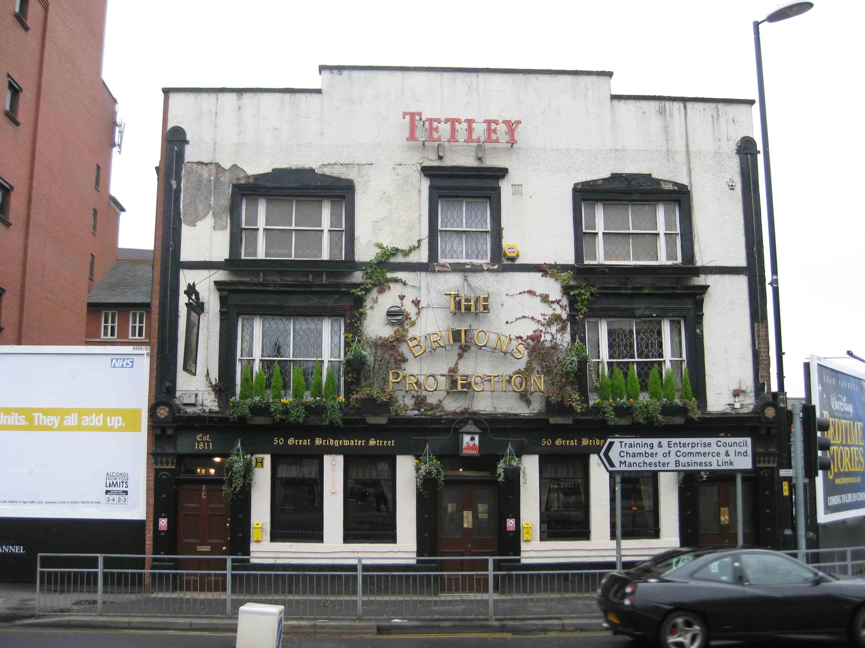

A three-year legal struggle to safeguard the future of Manchester’s much-loved Britons Protection has been settled. In an out-of-court deal the Heineken-owned Star Pubs and Bars chain has dropped its move to terminate the lease on the historic venue. Licensee Allan Hudd has successfully run the popular Great Bridgewater Street hostelry for 13 years as a free-of-tie market rent only operation, creating a cask ale haven alongside his near 400-strong whisky collection, and attracting many international visitors alongside loyal regulars. Hudd said: “It’s a victory for both sides. It guarantees the pub for the next 10 years and means we can go on trading as before, with our cask beers from independent brewers and with our unique whisky selection from around the world.” A costly legal battle – said to run into many hundreds of thousands of pounds – began when Star announced it would not renew the 10-year long tenancy on the pub for Hudd and his business partner, multi-site operator Mark West. Serving an eviction notice, Star stated it wished to take the pub into its managed house portfolio. Allan and Mark resisted under security of tenure legislation and earlier this summer a Manchester Civic Court hearing set for five days was halted on day two due to a “technical error” on the part of Star. A Star spokesperson said: “Both Mark West and Star Pubs are committed to the long-term future of the Britons Protection and, aware of the potential impact on the site that an ongoing dispute could have, are pleased to have reached an amicable agreement regarding the future of the pub. “It is a beautiful, historic pub that appeals to both locals who love real ale and visitors looking to experience the traditional Mancunian great British pub. Star Pubs will build on the well-loved current offer, continuing to support the pub’s historic status and maintain its focus on serving an interesting range of real ales. Mark and Star Pubs will be working together to ensure a smooth transition and the successful ongoing operation of this site. Star Pubs would like to thank Mark for his ongoing commitment to the Britons Protection.”    Listed under the CAMRA National Inventory of Pub Interiors, Britons Protection dates to early 1800s and was used for army recruitment during the Napoleonic Wars and gave refuge to the Peterloo Massacre victims in 1819. Today the distinctive building stands as a proud tribute to the city’s heritage, dwarfed amid modern tower block apartment and hotel developments. Fears had also been expressed for the long-term future of the Britons Protection site. Star Pubs & Bars has previously announced plans to increase its Just Add Talent (JAT) managed operator business from its current 150 pubs to 250 by 2026, which it will see it make up around 12 per cent of the company’s pub estate.