Regional Cider Pub of the Year winners

04/10/2024 by Camilla Weddell

Campaign

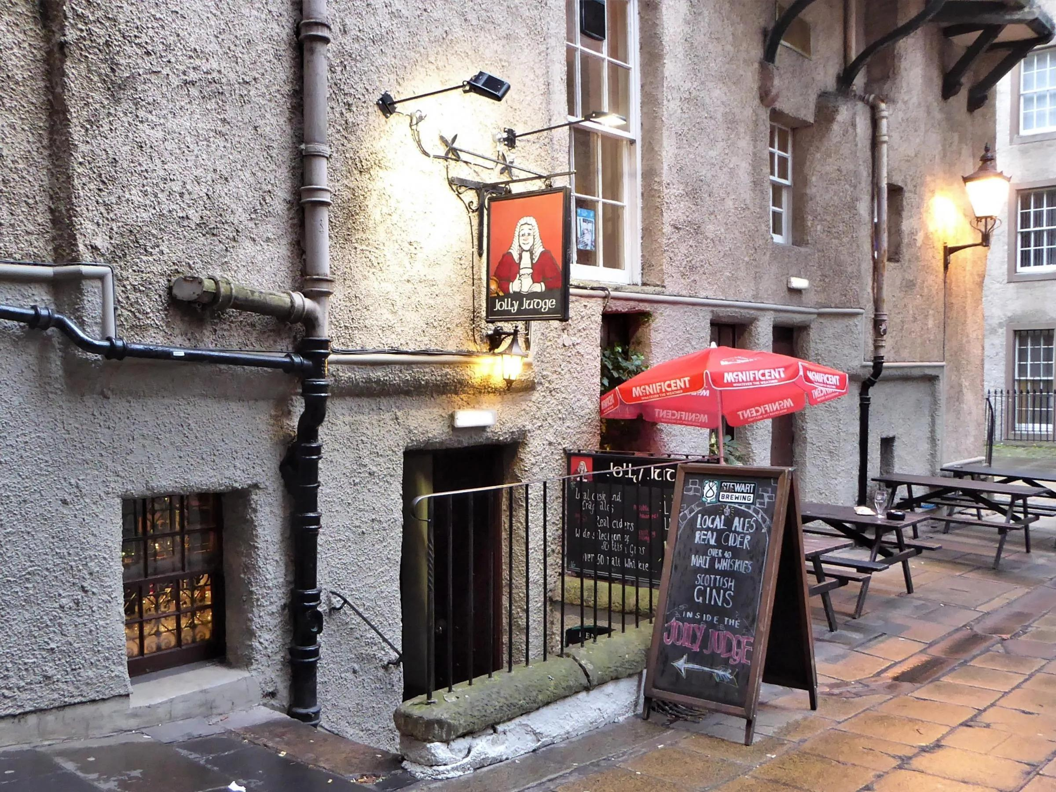

That Beer Place may have taken the overall National Cider and Perry Pub of the Year title, but the regional winners are still worth checking out and visiting. Here’s our look at five - watch out later this month for profiles of the others. Scotland Jolly Judge (pictured) 7 James Court, 493 Lawnmarket, Edinburgh, EH1 2PB    A small, comfortable bar with an attractive painted ceiling just off the Royal Mile hidden down an Old Town close. Outdoor tables in the close provide extra seating.   A varying selection of up to six real ciders is available and the Jolly Judge hosts two or three cider and perry festivals a year. Real ale fans are well catered for too. Up to four cask beers are on draught, usually from smaller breweries UK-wide, and sparklers are occasionally used. You’ll find a welcoming spot for refreshment after visiting the castle and other Old Town attractions. Bring a furry friend as dogs are welcome.  The Jolly Judge is a fixture of CAMRA awards and has been:   CAMRA Edinburgh Pub of the Year 2024

CAMRA Edinburgh & SE Scotland Cider Pub of the Year 2024

CAMRA Scotland and Northern Ireland Cider Pub of the Year 2023.  https://jollyjudge.co.uk/     Northern Ireland Dog and Duck  30 Main Street, Lisbellaw, BT94 5ER  The Dog and Duck Inn is in the village of Lisbellaw about five miles from Enniskillen.   It specialises in independent beers, ciders and spirits with 14 guest taps including four traditional cask beer pumps usually serving one real ale and three ciders. Locally brewed ales such as Inishmacsaint, Hercules and Lacada have appeared, but the selection is always changing. Tuck into its food menu offering freshly prepared traditional recipes using locally sourced and seasonal produce.   The pub is also home to the Glenwinny brewstillery producing small batch Irish whiskey and rum, and you’ll find live music nights around once a month.   The Dog and Duck celebrates seasonal events, including Oktoberfest and a range of beer and cider festivals.  https://www.thedogandduckinn.com/     North East Station House  North Road, Durham, DH1 4SE   Opened in 2015 by a couple passionate about quality, the pub is an independent operation. A changing range of beer and cider is available year-round along with a back-to-basics approach and an emphasis on conversation.   You’ll be able to choose from four or five bag-in-box ciders, usually including one from the popular Ross-on-Wye. Perry is usually available too, making it a venue worth seeking out for something different. Bottle-conditioned and keg-conditioned real cider is also available.  Handpumps have been installed, with traditional gravity dispense remaining an option. A dark beer is always available.   Visitors should note the Station House is closed on Mondays.   The Station House has won:  Branch Cider Pub of the Year in 2022

Branch City Pub of the Year 2022

CAMRA North East Region Pub of the Year 2022.   It was also a runner up in the national CAMRA Pub of the Year competition 2022.  http://stationhousedurham.co.uk/     West Pennines Black Horse  166 Friargate, Preston, PR1 2EJ   A classic, Victorian Grade II-listed pub in the main shopping area close to the historic open market, with its tiled bar and walls and mosaic floor, it has a nationally important historic pub interior. The two front rooms, with real fires are adorned with Robinson’s memorabilia and photos of old Preston; the “hall of mirrors” seating area is to the rear.  There is usually a range of flat ciders on offer on the handpumps along with a range of 10 cask beers, usually featuring at least four from Robinson’s and four changing guests. These are sourced through Titanic but are not simply limited to its own range, so you’re likely to find a varied range on offer. You’ll also find an extensive range of pork pies from Jones of Huddersfield.  There is an open smoking terrace and an upstairs function room, which is also now open every weekend as Unplugged, a craft and cider bar with live music.  Awarded the 2019/20 George Lee Memorial Trophy, the local branch's premier award.  The Black Horse has also won:  Central Lancashire Branch Pub of the Year 2023

Central Lancashire Branch Pub of the Year 2024

Central Lancashire Branch Cider Pub of the Year 2024

Lancashire Branches Pub of the Year 2024

West Pennines Regional Cider Pub of the Year 2024  https://www.robinsonsbrewery.com/pubs/black-horse-preston/     Yorkshire Nan Moors  18 Rochdale Road, Todmorden, OL14 7LD  A relaxed bar located in a narrow former tattoo parlour adjacent to the Rochdale Canal bridge in Todmorden town centre, catering to an eclectic clientele. A small, covered patio area at the rear is alongside the towpath and directly accessible from it, with additional seating waterside in fine weather.  Various cider options and a selection of bottles and cans from home and abroad are on offer, along with a full range of spirits and other drinks. Its bottled range also includes a selection of 75cl craft ciders.  It is run by two local artists. Background music is played at low volume during the day (sometimes sourced from classic vinyl) and there are various evening events. Folk night is the 2nd and 4th Wednesday of each month. Occasional events incur an entrance fee, but these are generally not at weekends.  Cask ale is offered by gravity dispense direct from casks stillaged behind the bar. A second cask beer is sometimes available, and this is often a dark beer in autumn and winter. Due to limited stillage, the availability of cask ale is not guaranteed at every session – it would be advisable to check before traveling to avoid disappointment, this also applies to bank holiday Monday opening. Nan Moors offers 10 per cent off cask ale for CAMRA members  The venue has won:  Yorkshire Cider Pub of the Year 2024

Cider Pub of the Year 2024

Pub of The Season Spring 2024  https://facebook.com/Nanmoors