Chills and thrills in our haunted pub guide

03/10/2024 by Camilla Weddell

Campaign

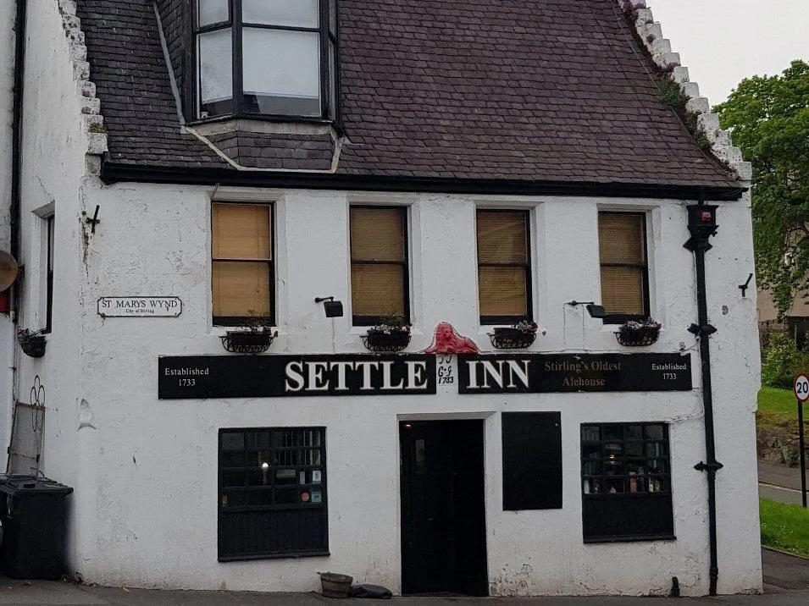

Autumn is well under way and Halloween is growing ever closer, so it’s time to check out the first instalment in our guide to haunted pubs this Cider and Perry Month. As well as serving up real cider and perry, these pubs are reputed to contain spectral jilted mistresses, executed sheep rustlers, and the ghost of a black Labrador.   Gun Lodge Hotel   High Street, Ardersier, IV2 7QB   Built in 1769, the pub was still in use during Word War I and II but fell into disrepair during the 1950s and 1960s before being reopened as the Gun Lodge. The ghost of a broken-hearted war mistress is apparently still in residence.  Other than real cider, there is a good selection of whiskies available, but careful how you settle into the comfy sofas by the open fire, you may not want to get up. If the tide is right, you can watch the Moray Firth dolphins.  The menu includes haggis which apparently is “free range”, and the children’s menu shows how to catch one (a net is best).  http://www.gunlodgehotel.co.uk/   Settle Inn   91 St. Marys Wynd, Stirling, FK8 1BU   Built in 1733 the Settle Inn (pictured) is the oldest pub in Stirling, located on a hill leading to Stirling Castle. It is an atmospheric inn with a selection of regular ghosts allegedly dating from Bonnie Prince Charlie’s siege of Stirling Castle. Whether you’ll run into 18th-century French and Irish soldiers is debatable, but it’s currently frequented by a mix of tourists, students and locals alike.   The front bar is cosy and friendly, aided by a roaring fire with old curling stones in the hearth. The cavern-style room at the rear provides extra seating and hosts music events on various evenings, plus a Sunday night quiz.   https://facebook.com/settleinnstirling   Hanging Gate   Meg Lane, Higher Sutton, SK11 0NG   Reopened in 2021 after long closure, the pub is slowly being refurbished and the bar and adjacent room together with the outside are now open. The Hanging Gate is a fascinating pub, dating from 1621 and its name is believed to be a combination of the Scandinavian gata, meaning pathway, and the fact that Royal Macclesfield Forest poachers were hanged here. You’ll find an intimate a cosy pub, with low ceilings, open fires, and a witches' circle in the top room. The bottom room commands a magnificent panoramic view over the Cheshire plain and Welsh hills, which reputedly includes the Liver Building (beer may help to see this!). The pub ghost is either a sheep rustler hung outside, or an early landlord, according to choice. http://www.thehanginggate.com   Blue Bell Inn  Thorpe Road, Tattershall Thorpe, LN4 4PE   This ancient building has 13th-century origins and is one of Lincolnshire's oldest inns.    It has a large open fire and beamed ceilings that are covered in signatures and photographs of airmen from World War II RAF squadrons who used the pub, including the 617 Dambusters and 627 Pathfinders.    King Henry VIII reputedly visited the Blue Bell and there is a ghostly bomber crew in residence, so you’ll find a fascinating slice of history even if you don’t find any ghosts.  http://www.bluebell-inn.com   Wheatsheaf Inn  18-22 Church Terrace, Wisbech, PE13 1BL   This pub has been in use as the Wheatsheaf since at least the late 18th century and may be even older.   You’re sure to find some grisly history here, as murderers were once gibbeted on the nearby common. It is also said that the last man to be hanged in Wisbech ate his last meal in the pub. The jury is out on ghost sightings, but plenty of recent reviews tell of paranormal goings on!  http://www.jdwetherspoon.co.uk/home/pubs/the-wheatsheaf-inn-wisbech   Ye Olde Griffin   High Street, March, PE15 9JS   Large, 16th-century town-centre coaching inn with striking panelling and carvings inside.  Ye Olde Griffin is still a hotel and if you fancy a night away, you might see former chamber maid said to haunt the building. Less frighteningly, card-carrying CAMRA members can enjoy a 10 per cent discount at the bar.  https://www.greatukpubs.co.uk/ye-olde-griffin-hotel-march   Starving Rascal   1 Brettell Lane, Amblecote, DY8 4BN   Recently purchased by Black Country Ales and refurbished during the last lockdown, you’ll find a central servery for all areas upstairs, while downstairs is a cosy little room for events and functions.   Reputedly one of Britain’s most haunted pubs, the eponymous rascal is said to have cursed the pub and now snatches at people’s pints while leaving wet footprints around the bar.   https://facebook.com/starvingrascalamblecote   Fox Inn   The Street, Garboldisham, IP22 2RZ   This 17th-century coaching inn was bought by the community and successfully reopened December 2016. You’ll find up to 15 real ciders, regular street food vendors and – possibly the best ghost on the list – a spectral black Labrador. This was the Mid Anglia CAMRA Branch Cider Pub of the Year 2019, 2020, 2021, 2022, and 2023 so you know you’re in good hands.   https://garboldishamfox.co.uk/   Barnt Green Inn   22 Kendal End Road, Barnt Green, B45 8PZ   This very large Tudor roadhouse was built in 1651 and extensively refurbished in the 19th century.   You’ll find a comfortable and upmarket venue with a focus on food and a spacious outdoor seating area in case you manage to catch any autumn sunshine. There is reputedly a tunnel leading from the building formerly known as Barnt Green House to Cofton a couple of miles away. Investigators should keep an eye out for the ghost of a white lady.   https://www.barntgreeninn.co.uk/   Plume of Feathers   West Steet, Weedon, NN7 4QU   The pub is in the heart of this large sprawling village. It has a very long history and some parts of the building date back to the 17th century including two cosy inglenooks served by a double-sided open fireplace.   Get your bearings with a terrific wall-sized aerial photo of Weedon and enjoy the stories of two resident ghosts – George and Elizabeth. George makes mischief in the cellar and bar whereas Elizabeth restricts herself to flinging cutlery around in the kitchen!   http://www.everards.co.uk/our-pubs/plume-of-feathers-weedon   Rose & Crown   Featherbow Lane, Ratley, OX15 6DS   A superb, friendly country pub at the bottom of the village. Dating back to the 11th century, it is stone-built with exposed beams and a flagstone floor.  Reputedly haunted by the ghost of a roundhead from the nearby battle of Edgehill you can stay cosy with log-burning stoves and an exceptionally well curated drinks menu.  https://www.roseandcrownratley.co.uk/   Butchers Arms  Chapel Lane, Mickleton, GL55 6SD   A cosy one-bar timber framed pub with stone-flagged floors.   Visit for the delightfully named Hubert they ghost, stay for the range of home-cooked, locally sourced menu of pub classics. You’ll also find a range of pub games including a traditional skittle alley, roaring fires, and plenty of live sport in this Grade II-listed venue.  http://butchersarmsmickleton.com