Beer Place takes top cider title

02/10/2024 by WB Reporter

Campaign

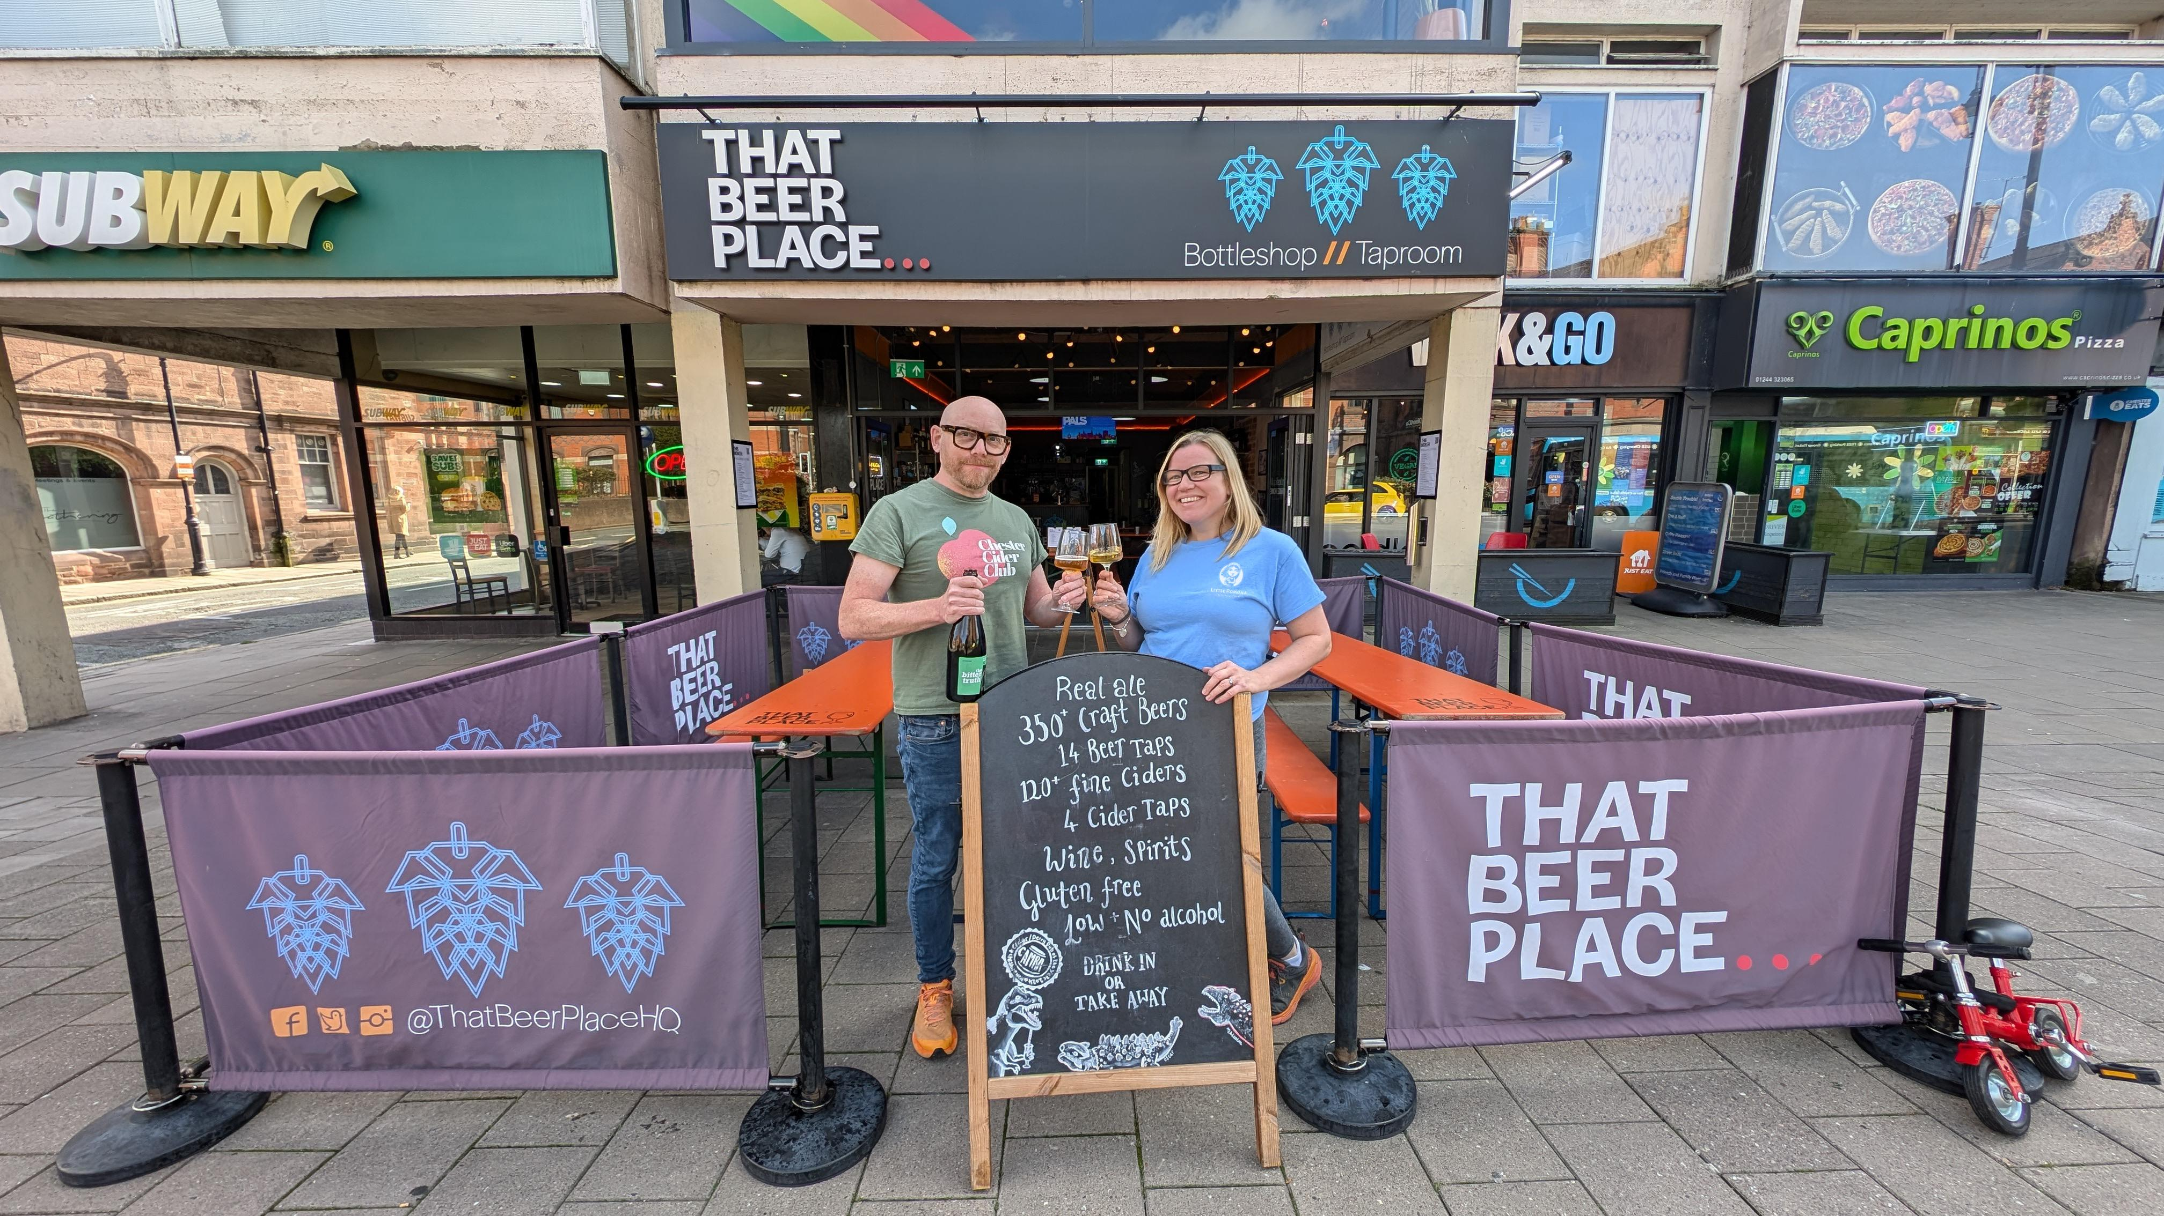

That Beer Place in Chester, Cheshire, has been crowned CAMRA’s National Cider and Perry Pub of the Year 2024.  Owners Lisa and Dale Lord (above) were presented with the award as part of the Campaign’s Cider and Perry Month.  That Beer Place has become a hub for both beer and cider enthusiasts, with a focus on showcasing a diverse range of ciders and perries. Judges were impressed with the select and interesting variety of draught ciders and perries, supplemented by a diverse and wide choice of bottles.   The pub boasts of up to 140 real ciders and perries, promoting producers from the UK, Europe, America and beyond, along with around 350 beers. The popular and inclusive venue attracts visitors from far and wide and is well respected within the local community.  Lisa said: “We’re chuffed to bits! For the past three and a half years, we’ve had a passion for being at the forefront of championing real cider and perry, and it’s great to finally be recognised on a national level. Our goal has always been to make Chester a destination for cider and perry celebration in the UK. This award only solidifies that vision.”  She added: “Cider and perry are more than just drinks - they’re expressions of craft, heritage, and innovation. We believe cider has been left on the sidelines for far too long. It’s time for cider to take its place at the dining table, next to the wines and beers that have dominated for decades. That’s why we’re partnering with local restaurants to create cider and perry fine dining tasting menus. Wine’s had its day, now it’s cider’s turn. “Our commitment to cider education runs deep. Every member of our team has gone through formal cider training with The Ciderologist, Gabe Cook, and we’re working to bring Chester its very first pomellier. We’ve hosted events with some of the UK’s top cider people, including Albert and Martin Johnson of Ross on Wye, Tom Oliver, Adam Wells and the much-loved late author, advocate and co-founder of Little Pomona, Susanna Forbes.  “It’s not just about the cider we sell, it’s about fostering a genuine community of cider lovers who are open to exploring new flavours and rejecting the chaptilised, diluted, industrial “ciders” that masquerade under the same name. “Let’s be clear: industrial ciders, with as little as 34 per cent juice, should not even be allowed to share the name. They are worlds apart from the real thing. The difference in taste and quality between what we offer and what you find on supermarket shelves and in many pubs is staggering. It’s time for the industry to stop pretending they’re the same thing. “We’ve got big plans ahead. We’ll be hosting the first North West Cider Salon in the summer of 2025, bringing some of the world’s most exciting cider makers to Chester Storyhouse for a celebration of cider. Our goal is simple: we want to put cider front and centre in the UK drinks scene.” Judges praised the extensive knowledge and enthusiasm for cider and perry shown by the pub’s team, and its deep commitment to educate the public about the drinks. That Beer Place regularly stages events with independent UK cider makers and industry experts and has plans to launch a training programme named That Cider School to teach local restaurants and drinks buyers about the diversity and variety of cider.  The pub hosts monthly Chester Cider Club evenings which aim to foster a community of cider lovers who are open to exploring new flavours and reject the diluted, industrial drinks that masquerade under the same name.  CAMRA’s competition co-ordinator Sarah Newson said: “That Beer Place is a very worthy winner, and I congratulate Lisa and Dale for creating such a positive environment for cider and perry education to flourish. Their desire to put cider front and centre in the UK drinks scene is admirable and one we can all support.  “As in previous years, the competition was fierce with the top four all being fantastic examples of pubs who champion cider and perry. I would thoroughly recommend pub-goers to seek out all the regional winners and experience what a truly great pint of real cider and perry can be. The difference in taste between what these pubs can offer and the mass-produced ciders from commercial producers commonly found in supermarkets is astounding.”   Sarah also praised the other three finalists in the competition: Frothblowers, Peterborough; Hop Inn, Hornchurch and Woodman, Bridport.    The presentation of the award kicks off CAMRA’s Cider and Perry Month. CAMRA supports and campaigns for cider and perry throughout the year and highlights them with celebrations throughout May and October, coinciding with the natural production cycle of apples and pears. October is when producers will harvest and press fruit from orchards, ready to be stored for fermentation.