Halloween pint and a fright for cider and perry lovers

01/10/2024 by WB Reporter

Campaign

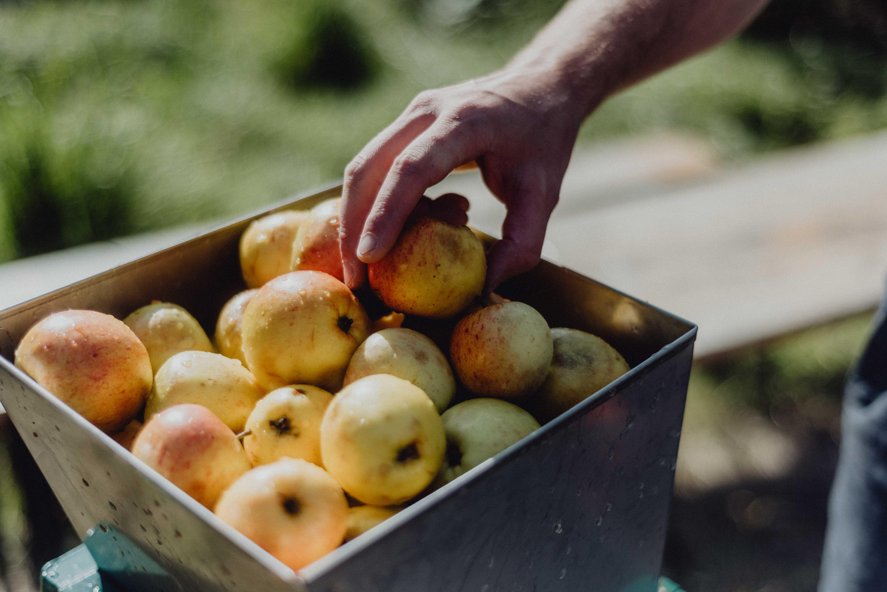

As autumn nights draw in, the Campaign is giving fans of the spooky season the ultimate guide to haunted pubs, all of which serve real cider and perry. For history buffs, ghost hunters, and lovers of real cider and perry looking for a memorable night, Cider and Perry Month offers the perfect excuse to explore new pubs this autumn, as instalments of a new online guide to haunted pubs are released throughout October.   Those who want to sample real cider and perry, but don’t want to brave the possibility of the paranormal, are also well catered for as the month will see the announcement of CAMRA’s Cider and Perry Pub of the Year later today. As well as the UK champion, the guide includes regional heat winners and will be released throughout the month, ensuring there’s a nearby pub for (almost) everyone to experience the best that the UK cider and perry scene has to offer.  October is a busy time in the cider makers’ calendar as it’s when fruit is harvested, milled, pressed and stored for fermentation plus cider and perry production is in full flow. This Cider and Perry Month, see everything that goes into production with CAMRA Learn & Discover. Join writer Rachel Hendry for A Day in the Life of a Harvester on 19 October, and Gabe Cook for a two-part video series on How Cider is Made available on 7 and 16 October on the CAMRA YouTube channel. Gabe will be taking cider lovers further afield on 23 October too, with the latest instalment of his World of Cider tour, where he’ll be visiting Asturias in northern Spain.  The Pomona Award is also due to be awarded, with the official presentation taking place on 11 October.  CAMRA’s real ale, cider and perry campaigns director Gillian Hough said: “I encourage everyone to raise a glass of real cider or perry in celebration this October. Whether you brave your nearest haunted pub, visit our regional and UK Cider and Perry Pub of the Year champion, or stay in for a deep dive into CAMRA Learn & Discover, there are plenty of ways to explore what makes cider and perry so special.  “There’s a serious side to our Cider and Perry Month campaign too. Current labelling laws mean that consumers don’t have all the information they need to make an informed decision about the products they enjoy. Legally, cider can be as little as 35 per cent juice and contain all sorts of Halloween horrors that don’t need to be declared on the label. We believe consumers deserve to know what they’re getting and it’s time that government takes action to protect our rights as consumers.  “Head to the CAMRA website or follow us on social media to get all the latest throughout the month.”  Find Cider and Perry Month here: https://camra.org.uk/what-we-do/cider-and-perry-months/   Photo: Amelia Claudia