Top ratings for pubco’s cask pubs

30/09/2024 by Timothy Hampson

Pub

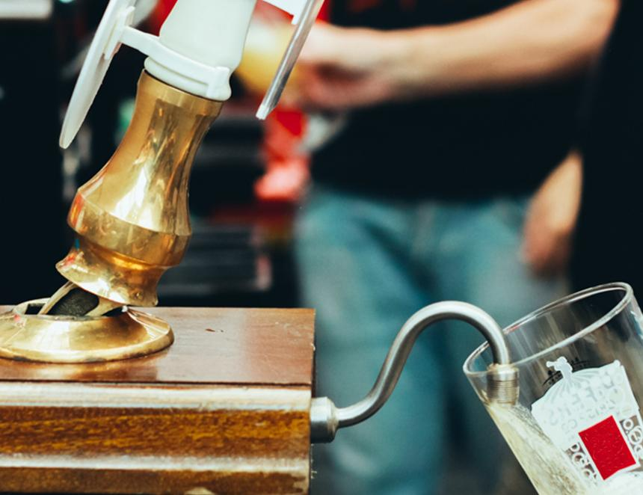

More than 1,100 Admiral Tavern pubs have achieved a significant milestone by 97 per cent of those assessed achieving four or five-star Cask Marque’s ratings, following their annual 11-point Beer and Cellar Hygiene Audit (BCHA). The BCHA is designed to improve standards in pub cellars and recognise excellence. To earn the accreditation, pubs must achieve a minimum of four stars. Currently, around 89 per cent of pubs assessed by Cask Marque within the hospitality industry achieve this accreditation, placing Admiral Taverns above the national average. Pubs are audited on a range of aspects, from stock rotation and beer line cleanliness to equipment maintenance and hygiene. Admiral Taverns CEO Chris Jowsey said: “We are incredibly proud of this fantastic achievement which stands as a testament to all our licensees who maintain the highest of standards to the operations and maintenance of their pubs. “We recently launched our own initiative to recognise best practice across our pubs which has received brilliant feedback and in turn, raised quality standards – putting us at the forefront of the industry. Our next goal is to achieve 100 per cent accreditation across the estate.” Admiral Taverns’ own Cellar Excellence Recognition Programme, which recognises licensees for consistently achieving 100 per cent in line cleaning and outstanding cellar management, involves business development managers monitoring cellar standards as part of their regular visits, promoting best practices across the estate. Cask Marque’s head of sales – north, Paul Chambers, said: “We at Cask Marque believe that all pubs should have a star rating for their cellar as the cellar is to beer as the kitchen is to food and kitchens are star rated. We are so pleased with the Admiral commitment to best practice in the cellar as it delivers better yields for the pub and a quality pint for their customers.”