Our top guide shows power of protecting pubs
26/09/2024 by Timothy Hampson
Campaign

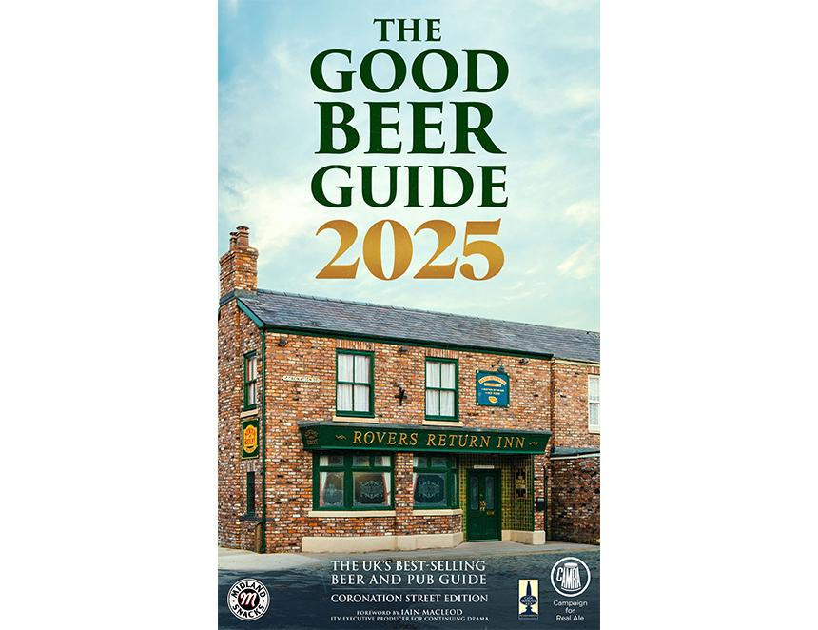

CAMRA’s Good Beer Guide – the UK’s best-selling beer and pub guide – is celebrating its 52nd edition with not one but two covers, featuring two of the UK’s favourite locals: Coronation Street’s Rovers Return Inn, and Emmerdale’s Woolpack. The 2025 guide, which lists 4,500 of the best pubs across the UK, is the definitive beer drinker’s guide for those seeking the best pints in the nations’ pubs and is on sale now. The foreword has been written by award-winning Iain Macleod, ITV’s executive producer for continuing drama. In his foreword, MacLeod said: “...the story which threatened one of our pubs the most was also the one which most resonated with our times. In 2023, the Rovers Return closed its doors. “A combination of the lingering legacy of the Covid lockdowns and the cost-of-living crisis meant that landlady Jenny Bradley couldn’t afford to keep it open. The characters – and the viewers – lamented the news like the loss of a loved one. If it were needed, it was a timely reminder of the central place the nation’s pubs have in our lives and in our affections.” Despite a slight slowdown in the number of pubs lost forever to conversion or demolition in recent years, CAMRA’s data shows worrying trends developing. More venues are reportedly redeveloped without the proper permissions – including the high profile case of the Crooked House, Himley in 2023, which is still awaiting an appeal decision despite the efforts of local campaigners. Licensees are also feeling the rising pressure, with more than 1,000 businesses shuttered in the last 12 months alone as pubs can’t afford to keep the lights on. The guide is an essential resource for ensuring the future of pubs across the UK, and a tool to show off the incredible culture of pubs and social clubs that is at risk. Through dedication and staunch work from licensees and pub lovers in the face of a difficult economic year, the guide boasts more than 900 pubs that are new to this edition. This information is collated by thousands of CAMRA volunteers who give up their time every year to promote the best of the best across the UK. CAMRA national chairman Ash Corbett-Collins said: “The Rovers Return Inn and the Woolpack represent the UK’s love of their local, and to have them featured on the covers for this year’s guide is very exciting. CAMRA’s mission is to ensure support from the government as well as tangible legislation to protect pubs across each nation of the UK. By next year’s edition of the guide, we want to be talking about the beer and pub trade growing with the support of communities and parliament alike.” Coronation Street and Emmerdale are available to watch on ITV and ITVX. This year’s guide is sponsored by Midland Snacks Traditional Pork Scratchings and endorsed by Cask Marque. The Good Beer Guide 2025 is published today and is available to order now from https://shop1.camra.org.uk/product/the-good-beer-guide-2025/

