Hogs Back celebrates hop harvest

25/09/2024 by Timothy Hampson

Industry

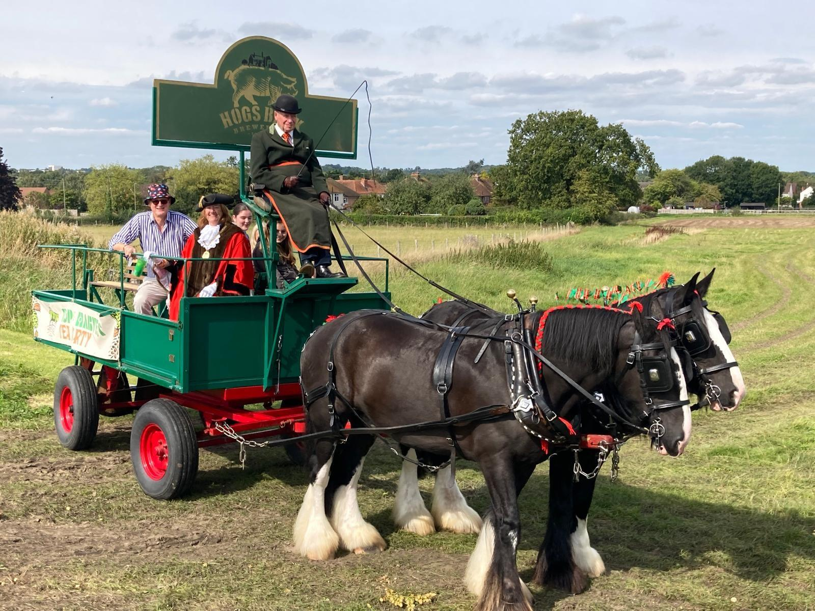

Hogs Back brewery has celebrated its 10th hop harvest with a record 4,200 fans flocking to the brewery over three days. The celebrations followed two weeks of harvesting in the hop garden next to the brewery by the brewery’s volunteer hoppers. The hop hangar, where the crop is processed and dried, was transformed on Friday night into a party space for the crowds. On Sunday, families joined in the fun of the TEA Party, with entertainment for children of all ages in the Kidzone. This included the ever-popular dray rides around the hop garden (above). Across the weekend, guests enjoyed the full range of Hogs Back beers, including Green TEA, a variation of the brewer’s flagship Tongham TEA, brewed with fresh green hops straight from the garden. There was also Surrey Nirvana, One Planet Hazy IPA and, for the first time, Dennis Hopp’r IPA from Mondo Brewing, Hogs Back’s sister brewery in south London. The weekend’s events raised more than £3,300 for the British Heart Foundation, Hogs Back’s chosen charity this year. “The Hop Harvest Party is always the highlight of our year, and this year’s celebrations were extra special as we marked 10 years of hop growing,” said Hogs Back MD Rupert Thompson. “Over that decade, our hop garden has gone from strength to strength. Although this year’s crop wasn’t our biggest ever, largely because of wet weather early in the growing cycle, the quality of the hops is excellent, and they will add a distinctive flavour to our beers. “With more hops still to be harvested this week, we’re only down 10 per cent on last year’s volumes across the Fuggles, Cascade, and Farnham White Bine varieties. “As always, we are enormously grateful to our band of volunteer hoppers who now number than 70, and who help us year-round in the hop garden. Thanks also go to estate manager Matthew King for his skilful and dedicated care of our hops. “We planted our first hop garden in 2014 to help us become a more sustainable brewery, to bring hop farming back to the Farnham region, and to build ties with the local community. “It gives me great pleasure to see how we have achieved all these goals, with the Hop Harvest celebrations a wonderful reflection of the community’s support, as local businesses and volunteers helped to make the event a success. “We’ve already set the dates for next year’s Hop Harvest celebrations, which will run 12-14 September.”