Members’ Weekend, AGM &amp; Conference 2025

20/09/2024 by Timothy Hampson

Campaign

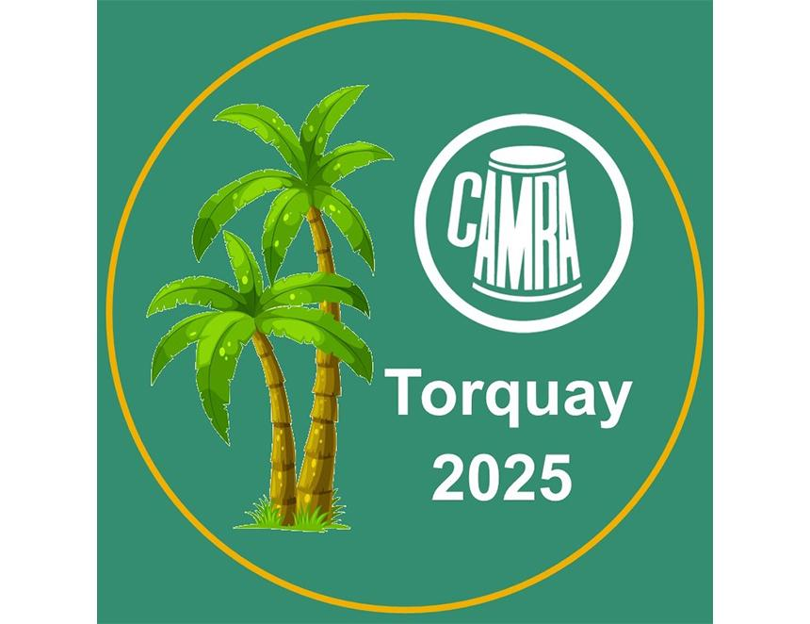

CAMRA’s AGM, which is open to all members and is part of the Campaign’s Members’ Weekend, will take place on the morning of Saturday 12 April at the Riviera Centre, Torquay and registration is now open. Members’ Weekend incorporates the AGM and Conference and is not only a chance to discuss Motions, but it also gives the opportunity to socialise in the onsite bar, attend information sessions and explore the local beer scene. National vice-chairman Ash Corbett-Collins said: “If you have opted out of all news and events emails from CAMRA, you will not receive any further communication about attending the Members’ Weekend, AGM & Conference, but will receive your AGM voting information next year, including the notice of AGM. “You can find more information and register using the link below. Once registered, you will be sent information about activities and organised trips nearer the time.” Register to attend Members' Weekend or volunteer to take part here: https://www1.camra.org.uk/members-weekend