2024 Conference Round Up

20/09/2024 by Matthew Rogers

Campaign

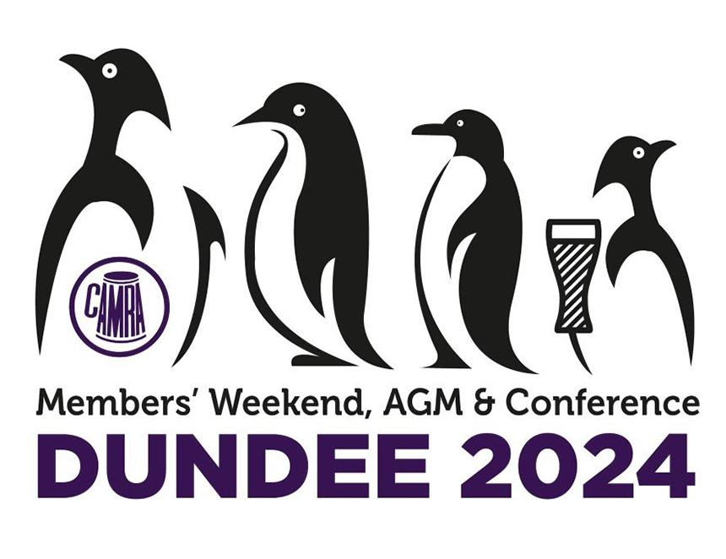

Following registration opening for CAMRA’s Members’ Weekend, AGM & Conference 2025 in Torquay, we are rounding up key moments from this year’s event in Dundee. Here you can see how the motions fared, with a video for each one: Motion 1 carried  Proposed by: National Executive   This Conference agrees to adopt the Policy Documents presented for adoption at Conference 2024, subject to any amendments to policy decided at this Conference.  Motion 2 carried  Proposed by: Bradford  This Conference instructs the National Executive to reinstate the 2019-20 definition of “Real Ale”, as detailed in clause 3.1 of the External Policy Document at that time (“CAMRA defines real ale as beer that has been brewed and stored in the traditional way and has undergone secondary fermentation in the container from which it is dispensed. Secondary fermentation is an essential and indispensable characteristic of real ale.”), within all relevant policy documents and collateral, clearly indicating that CAMRA was the originator of its definition and that “Real Ale” is a core part of the wider “Live Beer” scene.  Motion 3 defeated  Proposers: Edinburgh and South East Scotland  This Conference agrees that the campaign for full pints (per Motions 9 and 20 in 1992 and Motion 2b in 1998) has been, by any metric, a failure. It instructs the National Executive to remove all references to campaigning for full pints from policy documents and instructs the National Executive to inform Beer Festival Organisers that all beer festivals should be allowed to revert to 20 and 10 ounce glasses (or their 1/3 and 2/3 pint equivalents) with effect from 1 January 2025.  Motion 4 carried  Proposers: Colin Valentine and Terry Lock  This Conference instructs the National Executive, with a Westminster election this year, to mount a vigorous campaign to persuade all the major political parties to include a commitment in their manifesto to enact legislation to ensure a pint of beer equals 20 fluid ounces of liquid plus any head.  Motion 5 defeated  Proposers: Swale  Amendments to the motion were accepted by the proposers, and it was debated and voted upon as:  This Conference agrees that oversized lined glasses shall be available to customers on request for pubs and clubs to be entered into the Good Beer Guide. It therefore instructs the National Executive to ensure that licensees are aware of this change and shall be given until the 2028 edition to comply.​  The original motion wording was:  This Conference agrees that oversized lined glasses should be mandatory for pubs and clubs to be entered into the Good Beer Guide. It therefore instructs the National Executive to ensure that licensees are aware of this change and shall be given until the 2026 edition to comply.  Motion 6 remitted to the National Executive  Proposers: Swale  Amendments to the motion were accepted by the proposers, and it was debated and voted upon as:  This Conference instructs the National Executive to ensure that the intentions of the CAMRA policy on ingredients labelling are enacted. Brewers, pubs and clubs that do not indicate that a beer on sale is intended to be cloudy should be ineligible for entry in the Good Beer Guide and such beers excluded from sale at CAMRA beer festivals.  The original motion wording was:  This Conference instructs the National Executive to ensure that the intentions of the CAMRA policy on ingredients labelling are enacted. Brewers, pubs, clubs and off licenses that do not give a clear indication whether or not a beer on sale is intended to be cloudy or clear should be ineligible for entry in the Good Beer Guide and excluded from sale at CAMRA beer festivals.    Motion 7 defeated  Proposers: Colin Valentine and Terry Lock  This Conference agrees there are too many pubs in the Good Beer Guide and instructs the National Executive to implement the exact wording of Motion 9 passed in 2002 and reduce the number of entries to no more than 4,000 for the 2026 edition.  Motion 8 carried  Proposers: Colin Valentine and Steve Bury  This Conference instructs the National Executive to implement a comprehensive review of the Good Beer Guide. The review shall report to Conference in 2025 to ensure all relevant recommendations are implemented for the 2027 or 2028 edition, whichever is the more practicable.  Motion 9 tellers called – defeated 122 votes for, 147 against  Proposers: Bradford  This Conference agrees that the monthly publication agreed upon at Conference in 2023 should be in print and instructs the National Executive to ensure it is distributed to members on an urgent basis. Should costs prove prohibitive, it instructs the National Executive to revamp BEER magazine into a monthly, newspaper-style publication. Video recording unavaialble for Motion 9.