Citrus twist for latest Vintage

19/09/2024 by John Porter

Industry

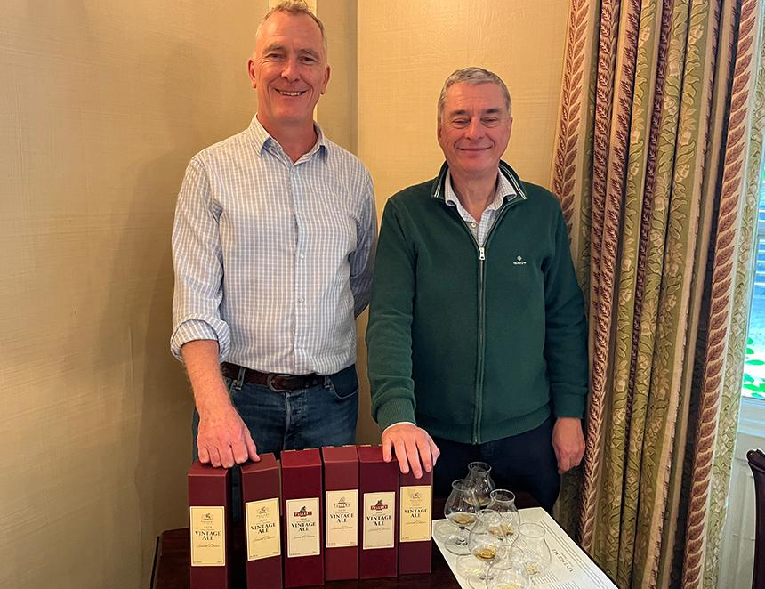

Fuller’s brewery has launched the 2024 edition of its Vintage Ale, marking the 28th year the bottle-conditioned ale has been brewed in Chiswick. Fuller’s head brewer Guy Stewart has added a new twist to this year’s edition, using citrus hops to give the 2024 beer zestier flavour notes than previous versions. The hop varieties used in the 8.4 per cent beer are Emperor, Pilot and an experimental variety, known as CF299, which was developed by hop grower Charles Faram in the UK before being cultivated in the USA. Stewart said the hops have delivered an unexpected but welcome peach quality to the beer, while the use of Crystal extra dark malt brings Christmas cake and raisin notes, alongside the fruit cake and marmalade character from the Fuller’s yeast.  He said: “We always vary the recipe, and the different hops were something I wanted to try. I contact Charles Faram every year when we’re planning the Vintage Ale, to ask what they have that’s a little bit different, and I picked three hops this year that I thought would add a lemony citrus note. Actually, though, it’s the peach character that’s really come out from the experimental CF299.” The 2024 Fuller’s Vintage Ale was brewed in February this year and bottled in July. The beer is sold in boxes to prevent light damage, and drinkers are encouraged to try the vintages after months and even years to see how the character changes as the bottle-conditioning process goes to work. At a Griffin brewery tasting to launch this year’s beer, Stewart was joined by predecessor as head brewer, John Keeling. Keeling had in turn picked up the Vintage Ale mantle from his own predecessor, Reg Drury, who oversaw the first two brews of Vintage Ale from its launch in 1997. With guests given the opportunity to try selected previous vintages from 1999 up to 2020 alongside this year’s brew, Keeling said: “The basic recipe has always been the same, based on Fuller’s Golden Pride, but the ingredients vary to give each beer its own individual character, and set it off on its own journey as it ages.” The Vintage Ale tradition has also passed from Fuller’s itself to Asahi, which acquired the brewery and brands in 2019. While the Fuller, Smith and Turner pub group operates as a separate business, its distribution agreement with the brewery means Vintage Ale will be available on cask in selected Fuller’s pubs as a limited edition in late September. Bottles are available from selected retailers and from Fuller’s online shop at www.fullersbrewery.co.uk Keeling made the point that when the first Vintage Ale was brewed, the cask ale category was a much larger and more mainstream part of the beer market, and suggested the industry should lobby the government for more favourable duty rates on cask beer.  He said: “Government intervention in the beer market usually has unintended consequences, such as with the 1989 Beer Orders, but the fact is they’ve always interfered with brewing and always will. So, let’s get them to interfere in the way that we would want. I think if they just applied the same preferential duty rate as cider to cask beer, it would add up to five per cent to cask ale sales overnight.”        Stewart said that while Fuller’s core cask ale brands, London Pride and ESB, are selling well, there seems to be less demand for seasonal casks. “I would say, currently, if you go into a pub that has two cask beers on, you’re probably going to get a better pint than a pub that has five on, because of the lower turnover.” Pictured, from left, Guy Stewart and John Keeling