CAMRA calls for business rates and duty on pub pints reform

18/09/2024 by Timothy Hampson

Campaign

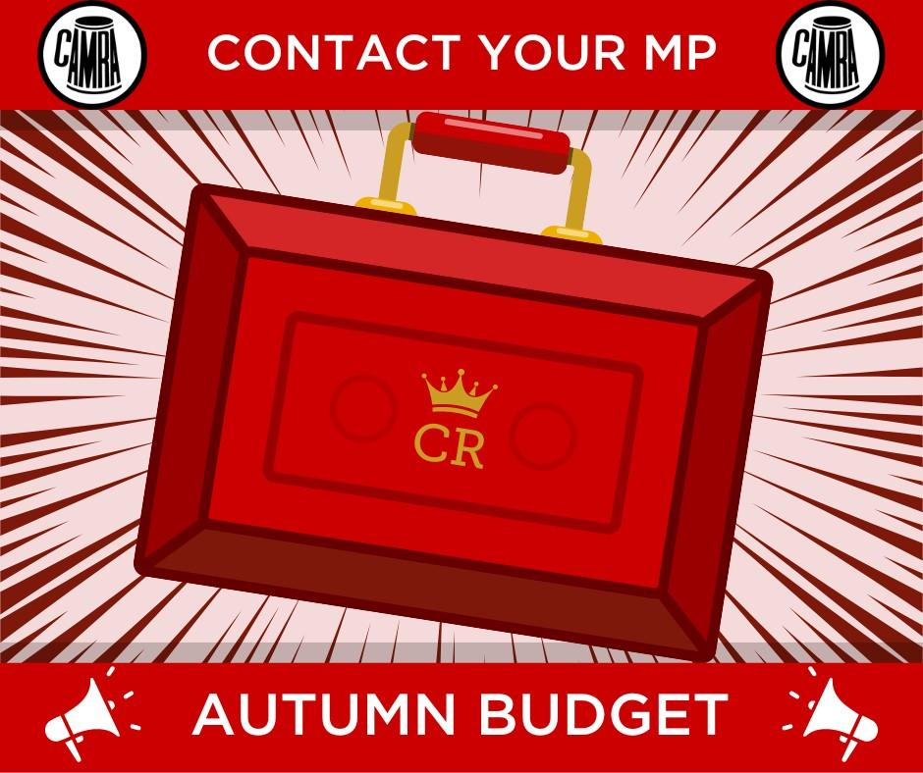

CAMRA is calling on the chancellor to reform unfair business rates and slash tax on pints in the upcoming Budget. Ahead of the Budget next month, around 145,000 CAMRA members are being mobilised to call on the new government to take action to support pubs, social clubs, brewers, cider makers, and to stand up for consumers rights. Joining forces with industry leaders, the Society of Independent Brewers, the Campaign has sent groundbreaking new economic modelling directly to the Treasury showing the transformation a UK-wide cut in duty charged on beer and cider served in pubs could bring. Their proposed 20 per cent discount for tax on pints in pubs would create thousands of new jobs and put millions back into the economy, as consumers are encouraged to move from supermarket alcohol back to being able to support their local pubs and social clubs. The chancellor has also been urged to stick by the Labour manifesto promise on reforming business rates in England. The current system unfairly penalises pubs and makes it harder for all bricks-and-mortar businesses to compete with online shopping. CAMRA’s own figures show the shocking extent of churn in the pub trade, with more than 1,000 businesses closing their doors so far this year. Now the Campaign is calling on all beer lovers and pub-goers to get involved and use its simple online tool to contact their MPs ahead of the Budget. The quick and easy to use e-lobby tool can be found on CAMRA’s website and here: https://action.camra.org.uk/page/156994/action/1 CAMRA vice chair Ash Corbett-Collins said: “Pubs are the beating heart of communities, but they’re being crushed by an unfair system that favours online giants and multinational brewing conglomerates. We want the chancellor to understand that the range of measures we’re calling for aren’t just about supporting the long-term future of the industry – this is also about local jobs, encouraging investment, and ensuring that communities have a space to come together. “Cutting the rate of tax on pints across the UK, and meaningful reform of the business-rates system in England will make all the difference to both consumers and the trade. “I’d urge anyone who values their pubs and independent breweries and cider producers to get involved and let the new government know just how much we need support in the Budget. Our online e-lobby tool only takes two minutes, you don’t have to be a CAMRA member to use it, and every email makes a difference.”