Committed to building a truly inclusive cider world

17/09/2024 by Matthew Rogers

Industry

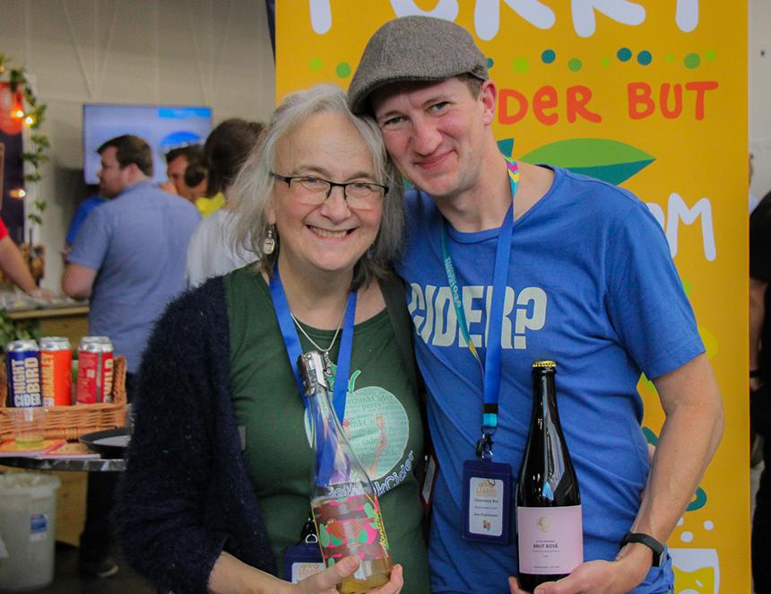

It is with great sadness CAMRA has learned of the passing of Susanna Forbes.  Susanna was much loved across the UK cider and perry scene and her drive for greater education about the drinks will be greatly missed.  Susanna and husband James established Little Pomona in 2015, making a variety of cider and perries from their orchard near Bromyard and partner growers around the region. They moved to their current site in 2019 and opened a tasting room and cider garden in 2020.  In 2018, Susanna published Cider Insider plus she has also served as beer and drinks editor of Imbibe magazine and as a director of the British Guild of Beer Writers.  A staunch supporter of Ciderlands, the international cider tourism and culture network founded by the Basque Country, Susanna worked with Gabe Cook to host its first meeting in Hereford and the Three Counties in 2019.  She also co-led the formation of the group Cider Women in 2019, helping promote the profile and involvement of women within the cider industry and hospitality.  Susanna won CAMRA’s Pomona Award in 2021 for her long commitment to the industry, especially during the coronavirus pandemic, and was a regular contributor to BEER.  CAMRA Learning & Discovery manager Alex Metcalfe said: “Susanna was a beacon of positivity within the cider world, always seeking to support others work via collaborations, tastings, writing and advocacy. A stalwart and staunch ally for those seeking to further the awareness and enjoyment of cider and perry, Susanna was always the first to champion the success of others across the wider drinks industry.   “I was proud to serve as an International Cider Challenge (ICC) judge with Susanna as my captain, and I witnessed first-hand her advocacy in action as she sought to open fellow judges’ eyes to the joys of what cider and perry can be, not what we with our individual palettes and bias, think they ought to be.   “The cider and perry calendar won’t be the same without Susanna’s company, expertise and sense of mischief to look forward to.”  Dick Withecombe and Cath Potter of Central Manchester CAMRA said: “Susanna was a very dear friend and inspiration. We first met at Ross Cider Club in 2018 where Little Pomona and Ross Cider created a spirit of cooperation that soon spread in the renaissance of aspirational cider.  “In early 2019 Susanna and Jane Peyton initiated the #RethinkCider movement which inspired the launch of Manchester Cider Club. There are now cider clubs across the country from Leeds to Bristol, from London to Nottingham, Chester and Birmingham.  "Susanna was one of the founders of Cider Women and its guiding light. She was committed to encouraging and building a truly inclusive cider world raising profiles and building confidence of all women within it."  CAMRA real ale, cider & perry campaigns director Gillian Hough, said: “Susanna was a real visionary who, with her husband James, helped elevate the importance of real cider and perry at their business Little Pomona.   “Susanna took cider and perry very seriously. For example, in September last year, Susanna and James put on one of the most significant cider and perry events I've ever attended – the Artisan Cheese & Cider Summit hosted at Little Pomona. “Susanna will be forever toasted with top-quality cider and perry. I will miss her positive influence and genuine delight in introducing people to real cider and perry.”  Pictured: Susanna with Sam Nightingale of Nightingale Cider at the Discovery Bar during the Great British Beer Festival 2023 (photo: Helen Anne Smith)