CAMRA calls for government help as high street pubs close

16/09/2024 by Timothy Hampson

Campaign

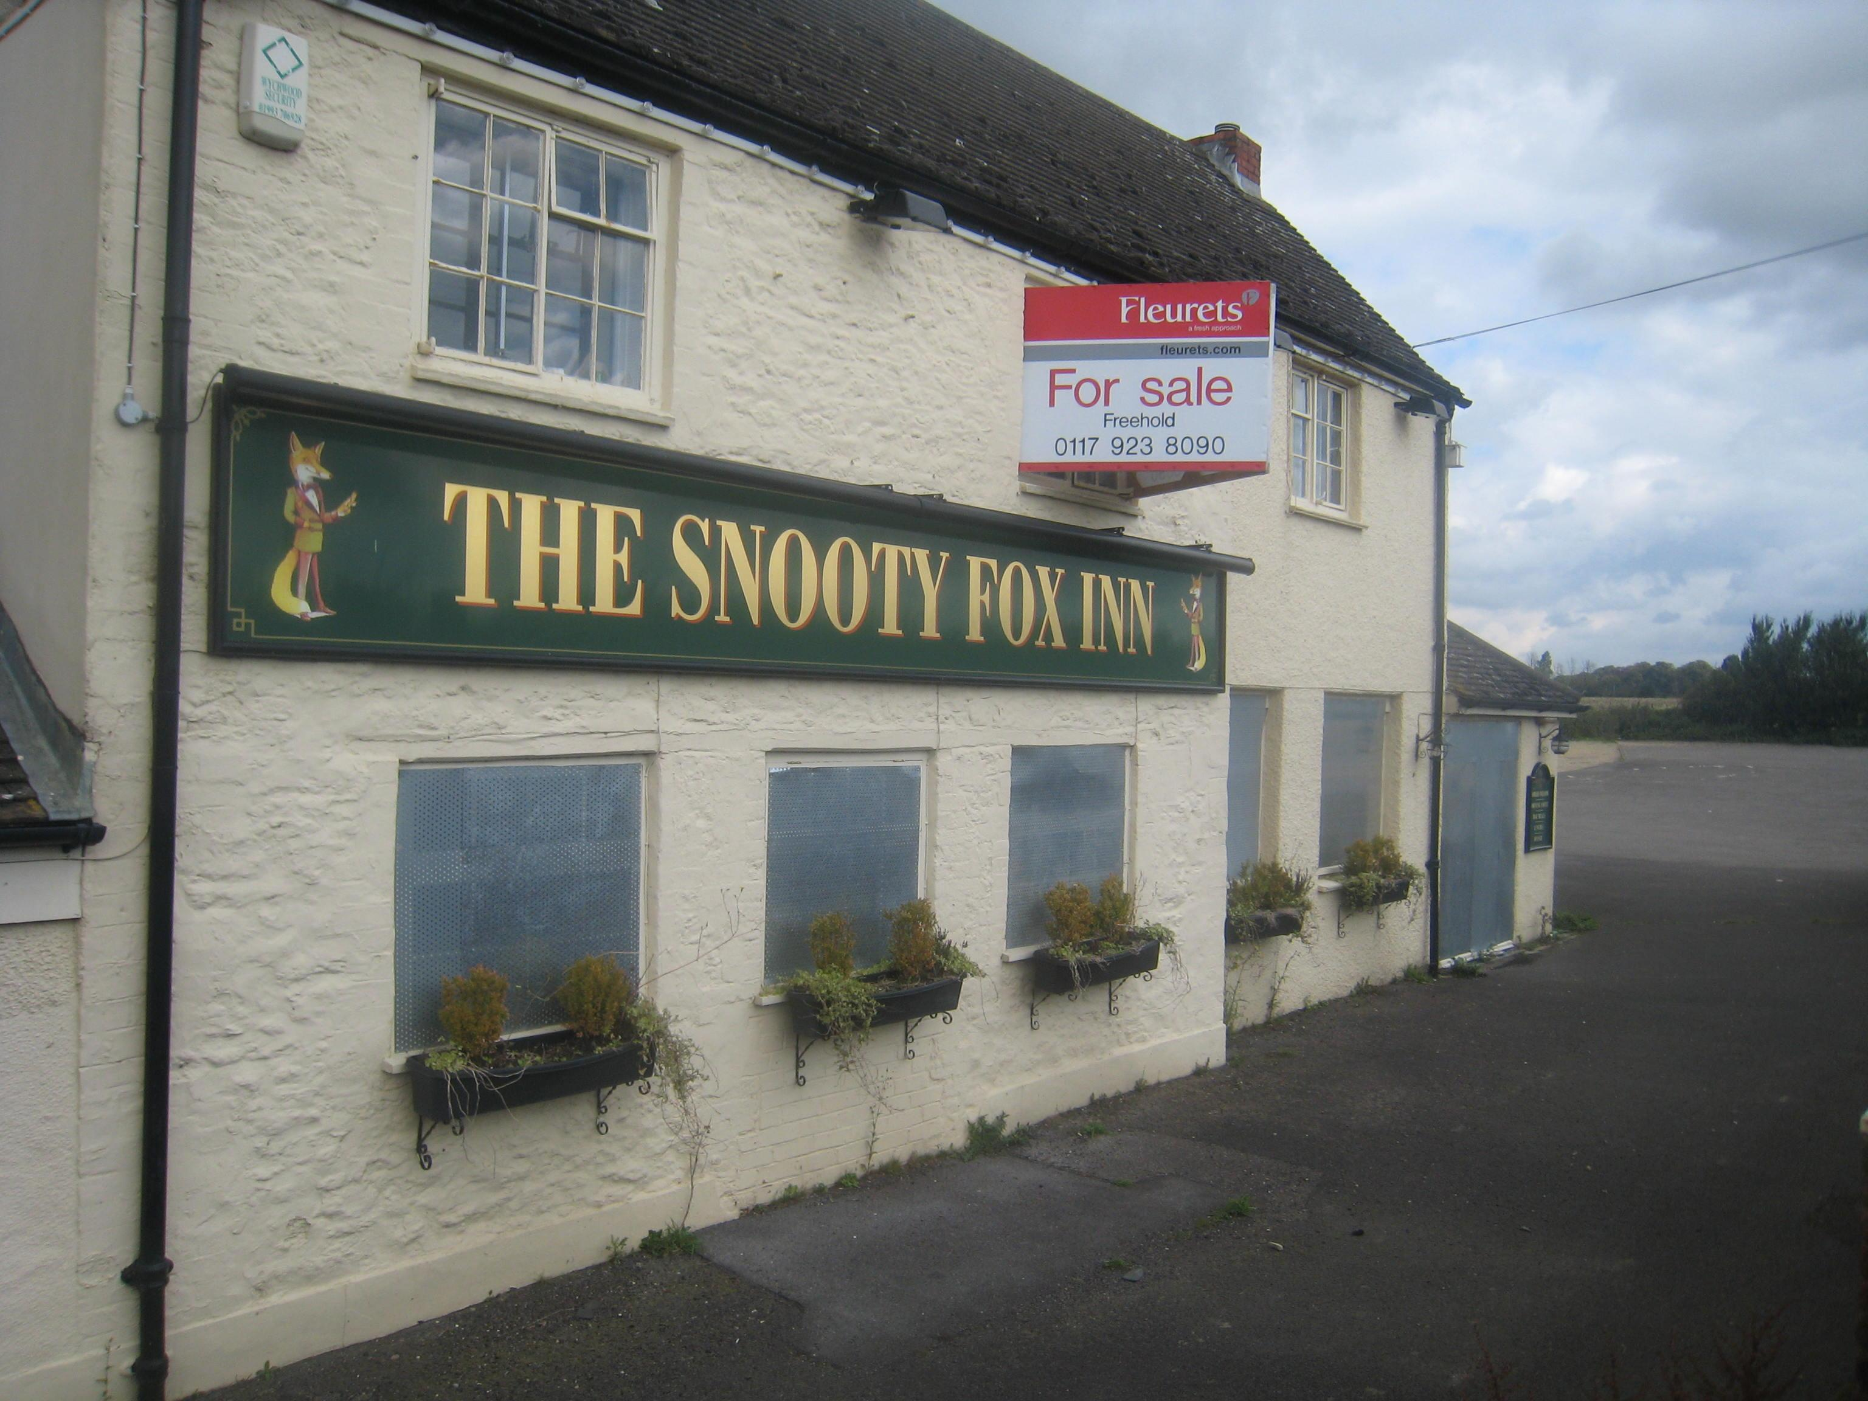

Pubs, pharmacies and banks made up half of the closures on Britain’s high streets in the first six months of this year, according to new data. A total of 6,945 high street stores have closed so far in 2024, the equivalent of 38 per day. On average, 16 pubs, 18 pharmacies and nine banks shut every week between January and June, according to research from accountancy firm PwC. The decline in pubs come as no surprise to CAMRA as it calls for the government to support pubs in the upcoming Budget. CAMRA pub and club campaigns director Gary Timmins said: “Sadly, these figures come as no surprise. CAMRA’s own data shows that while the number of pubs lost to redevelopment has slowed slightly in recent years, pub businesses are cycling through owners at a higher rate than ever before. “More and more communities are facing shuttered pubs as licensees struggle to stay profitable. “The upcoming Budget gives the chancellor the opportunity to make a real difference to UK high streets. Sticking to the Labour manifesto promise to reform business rates in England and cutting the draught duty rate on pints in pubs would give these businesses a much-needed boost, giving communities confidence in the long-term future of their local.”