The Devil’s in the Draught Lines – review

15/09/2024 by Roger Protz

Opinion

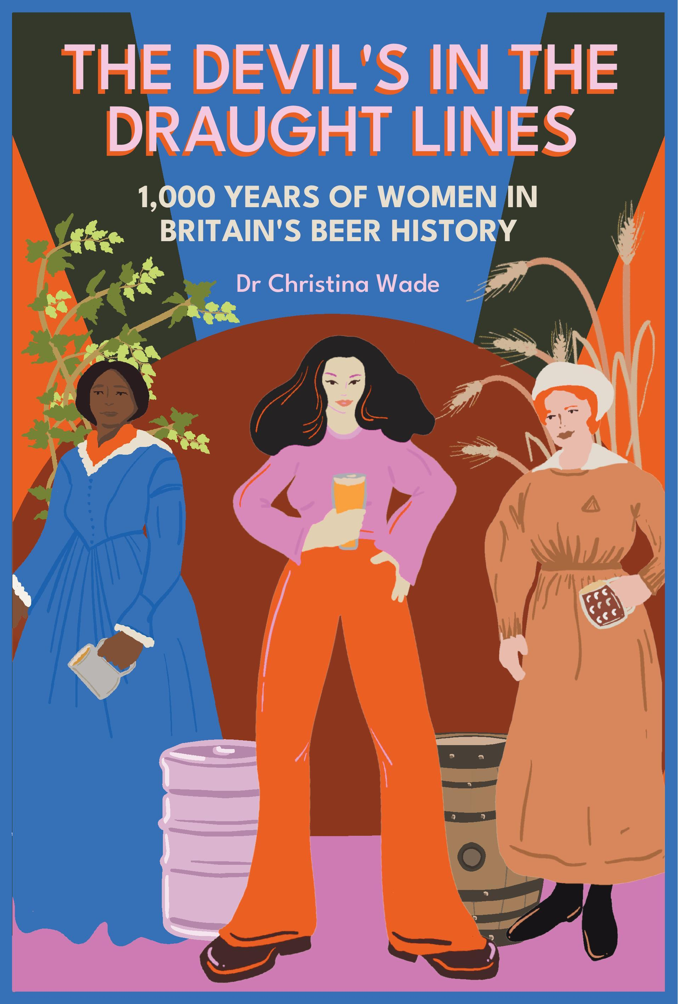

We are still living in the shadow of the Covid pandemic and the lockdowns that followed. The sickness that gripped the country had a profound impact on brewing and pub retailing, and we are still affected by it, with both pubs and breweries closing. As Dr Christina Wade makes clear in this remarkable book, it’s a rewrite of history. In 1348 the Black Death killed between 30 and 60 per cent of the English population, and as a result it changed fundamentally the role of women in brewing. Before the plague, brewing had been a largely domestic affair. It was conducted by women who made ale alongside baking bread. Those who made especially good ale sold it commercially and were known as ale wives or brewsters. When the British Isles emerged from the ravages of the plague, there was a far smaller population to cater for. Freed from the shackles of their homes, where people had taken shelter from the terrible sickness, they hurried to ale houses and other public places to drink and socialise. The seeds of the public house were being sown. Better quality ale was demanded, and many men realised here was the potentiality of a profitable business. They shouldered women aside as they started to lay the grounds for a commercial brewing industry. In a patriarchal society, working men had the power to demand better wages while those higher up the social ladder could raise the capital to invest in bigger and better breweries. Misogyny also played a cruel role in driving down the influence of women. Brewers’ guilds were exclusively male affairs while Wade records the many cases of ale wives being prosecuted for selling bad ale and, even worse, being compared to witches and demons out to poison unsuspecting drinkers.  By the 18th and 19th centuries, with the rise of porter and then pale ale, the industry was firmly in male hands. If you think of the major breweries of those times – Bass, Barclays, Allsopp, Truman, Whitbread, Worthington, Marston’s, Ind Coope and Guinness – you are thinking of men. It took until the late 20th century and, in particular, the rise of small breweries early this century, for women to return to leading roles in beer making. Wade has cast her net wide and has interviewed a large number of women now running breweries or playing leading roles in them. They include Nidhi Sharma, brewer at Meantime in Greenwich (now senior brewer at Diageo), London, Lucy and Lizzie Stevens, owners of Closet brewery in Edinburgh, Joelle Drummond and Sarah McNena of Drop Bear Beer Company in Swansea, Sarah Sinclair at Moonwake in Edinburgh and Doreen Joy Barber at Five Points Brewing Company in East London. The increasing number of women involved in brewing and retailing has been aided in no small measure by the large number writing, broadcasting, podcasting and organising talks and tastings on the subject. Wade has spoken to many of the leading protagonists including Annabel Smith, Melissa Cole, Emma Inch, Jane Peyton, Ash Eliot, Laura Hadland and Natalya Watson. They all agree there’s still a lot to be done to counter sexism in both in the brewing industry and wider society. They have to counter the attitude that it’s fine for women to pull pints in pubs but not to get involved in making the stuff. But this is a positive book, meticulously researched and written engagingly and wittily. There are many fascinating insights into the role of women, including their leading role in hop picking in the 18th and 19th century until mechanisation took over. Women today are brewing far beyond the borders of Britain – in Africa and the Far East, as well as North America. And spare a thought for Nadim Khoury, mashing and boiling at the Taybeh brewery in the West Bank of Palestine. Not an easy gig at the moment. The Devil’s in the Draught Lines by Dr Christina Wade can be purchased here: https://shop1.camra.org.uk/product/the-devils-in-the-draught-lines-1000-years-of-women-in-britains-beer-history/