Keep cask cool

14/09/2024 by Matthew Curtis

Opinion

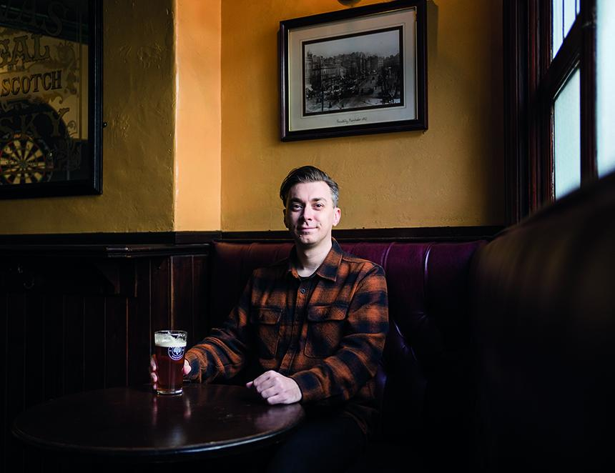

Why does cask beer have a reputation for being warm and flat? I’m not talking about the feelings that exist among people like you and I, those in the know. We also know that cask beer is easy to understand. But it does require a little effort on the drinker’s part to gain that understanding, and appreciate why, when done properly, it’s the best way to present and serve beer hands down. And yet in 2024 I still find myself having conversations with people who believe it should be served at room temperature and is intentionally designed to lack even a modicum of condition. These are with American tourists, usually, but not exclusively. In fact, I find that the majority of people who don’t drink cask beer – which, let's be honest with ourselves here, is the majority – believe this to be true. Sure if you land at Heathrow and take the express train to the first tourist trap pub in London’s West End you will likely be served a beer that is substandard, in the same way that you won’t get a Hawksmoor-quality rib eye if you call into an Angus Steak House. But often for people travelling internationally that is their first experience of cask beer. I tend to find that foreign visitors who appreciate their beer genuinely revere the cultural significance of cask dispense. But they also find only disappointment when, after months of anticipation, they arrive at last only to be served a tired pint of London Pride that is, well, warm and flat. We’re responsible for that reputation because in so many places where cask beer is served it’s not treated with the care it deserves. I don’t believe in the notion that cask should be some sort of protected appellation though. For me, the problem exists because advocates too often tend to raise cask beer on a pedestal, when really it should be treated like the most normal thing in the world. Yes, it’s a wonderful way to drink beer, but it’s not that special, really, it’s just beer, after all. Care and reverence are not the same thing. I know from experience that most drinkers are only one great pint away from understanding how cask beer can be brilliant. In fact, I’ve seen this happen in real time, when someone takes a sip of a perfectly presented pint of amber bitter, and tastes delicate, sweet malt balanced perfectly with the snap and sizzle of English Fuggle and Goldings hops. When you finally get it, it’s magic. The trick is getting people to that point, which is why it’s so important that organisations like CAMRA continue to advocate for beer and pubs, so that more moments like this can be created. I am thankful I still get to experience moments like this all of the time, which helps to preserve my own intentions as an advocate for cask beer. The most recent of these happened at a pub called the Robin, near Finsbury Park in North London. I have frequented this particular pub many times over the past couple of decades, having previously lived just half an hour's walk away. When I first visited it was called the Noble and was perhaps best known for serving an eye-wateringly expensive yet painfully average Sunday lunch. I watched as it changed hands multiple times over the years, with no-one quite being able to make the pub work as it should. At some point it was renamed the Brave Sir Robin, in reference to a character from Monty Python and the Holy Grail. Recently however, it was taken on by a chap called Nick Bailey, who for several years previously had run the wildly wonderful Southampton Arms in nearby Gospel Oak. That was not his pub though, and I knew he was seeking one of his own he could put a stamp upon. Nick took on the vacant Robin in 2023, and in a short space of time has transformed it into a vibrant community hub, as popular with long-time pub goers as it is with a younger crowd looking for a good time. At the centre of its offering are six handpulls. Nick is serious about his cask ale. So serious, in fact, before I visited recently, he texted me in advance to tell me he’d installed a new chiller in his cellar, and he wanted to check I was happy with the temperature of my beer. If he’d been worried, he needn’t have been. My pint of 90 Shilling, a collaboration between Derbyshire’s Thornbridge and Odell Brewing of Colorado, was perfect. Nut brown, rippling with condition and snap and sweetness and citrus, I belted it down and then paid it the ultimate respect by immediately ordering another pint. I live a couple of hours by train away from this pub now, but to visit and see it in such good hands and ensuring that cask beer is front and centre of what it is and does, makes me feel very special. I feel safe and assured that in this pub, countless moments will occur where people start to fall in love with cask for the first time, and they’ll forever banish the idea that it should be served warm and flat.