Walk the talk in Little Chicago

13/09/2024 by Dave Pickersgill

Campaign

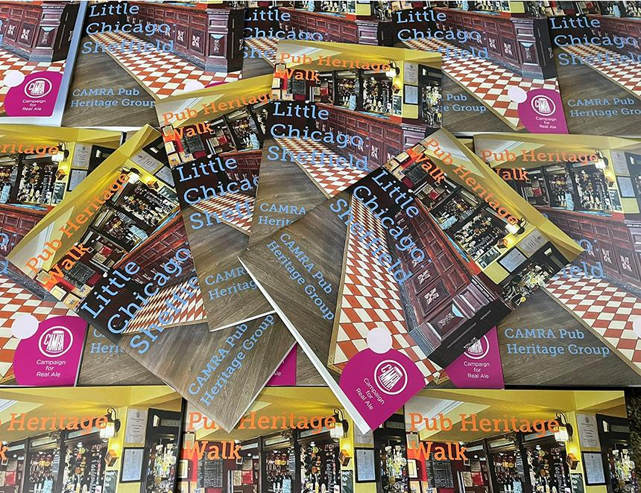

Following the success of the 2023 pub heritage guided walk booklet, Sheffield and District CAMRA has produced a second, focussed on Little Chicago, which will be launched alongside the Sheffield Steel City Beer Festival at Kelham Island Museum (16-19 October). This new booklet (A5, 32 pages, full colour, £2.99) takes you up the hill from West Bar to Scotland Street before heading towards Kelham Island. In addition to information about the three top pubs en route, (Crow, Kelham Island Tavern and Shakespeares), historical detail is also provided, including references to George Orwell, the temperance movement, and the Sheffield gang wars. Festival events linked to the booklet include a guided walk and an illustrated talk. The short walk will explore both the pub heritage aspects of the area plus the streets which feature in the book, Sheffield 1925: Gang Wars and Wembley Glory, with a narrative explaining how the city briefly became the most turbulent place in Britain because of escalating violence involving the Gas Tank Gang, Mooney Gang, Park Brigade and many others. The walk will also explore the beer, social and Industrial heritage of the area, examining the myths and reality of a tumultuous period in Sheffield history. The talk will concentrate on the area covered in the booklet, taking you from the 19th century up to current day. Along the way, mention will be made of the 1884 Sheffield Drinks Map, the establishment of a coaching inn and the city pub with the most local CAMRA awards. A similar talk will take place at the Crow on 10 October at 8pm. The talks and walks will be led by Sheffield’s Real Heritage Pubs editor Dave Pickersgill and local historian and writer John Stocks. The next in the series will focus on Neepsend in 2025 with the following year looking at Kelham Island. Booking details available here: https://sheffield.camra.org.uk/festival/#ib-toc-anchor-22 Sponsored by Abbeydale brewery and the Crow, the booklet is available from a growing number of outlets, including: the Crow, Draughtsman (Doncaster), Famous Sheffield Shop, Kelham Island Books and Records, Kelham Island Tavern, Millennium Galleries and Saint Mars of the Desert tap room. For retail enquiries and postal copies contact: pubheritage@sheffield.camra.org.uk Image: Dave Pickersgill