Who will be our next champ?

12/09/2024 by WB Reporter

Campaign

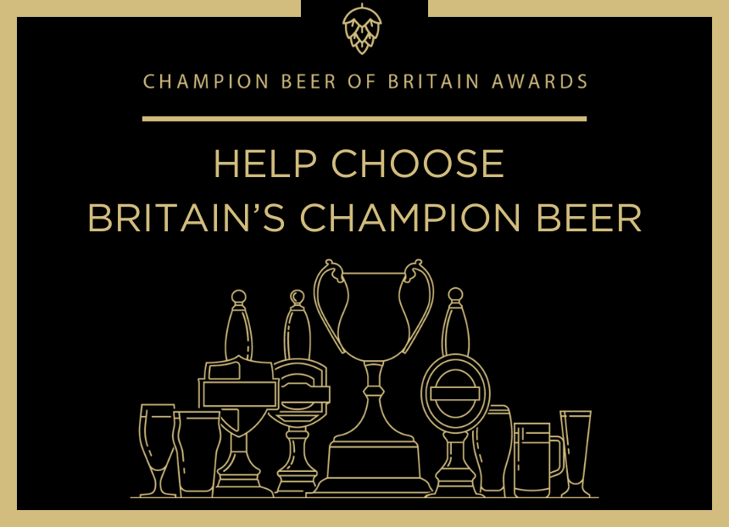

CAMRA has begun its search for the next winner of its Champion Beer of Britain award by opening nominations to members. The Champion Beer of Britain (CBoB) title is one of the most sought-after cask beer accolades in the world. Winning the title is the ultimate honour for UK breweries and has helped many brewers gain both national and international acclaim. The competition starts with nominations from CAMRA members and tasting panels followed by area competitions. All the judging is done by blind tasting. CAMRA members are now able to vote for their champion beers, with a focus on those tried over the past 12 months, until the next stage of the process begins on 4 November. This round of voting will help decide the winner of the 2026 CBoB award as the process takes two years. This year’s champion will be unveiled at Kelham Hall Beer and Cider Festival, Nottinghamshire on 23 October. The competition spans several categories of beer, from milds and IPAs, to stouts, porters and speciality brews. Members can choose up to five beers across each of the categories. There is also a competition for the Champion Bottled Beer of Britain with two categories above and below 4.3 per cent ABV and voting for these is also open now. At the Great British Beer Festival in August 2023, Elland brewery’s 1872 Porter (pictured) was crowned Champion Beer of Britain.  Competition coordinator Kevin Travers said: “The Champion Beer of Britain award is one of the most coveted accolades in the trade, because it is chosen by ordinary people who drink beer day in, day out and we’re very excited to be beginning the process again. “CAMRA members will be able to vote using our special voting portal, and in a range of categories, and we’d love to urge more members to take part in the process. If you’re not a member, it’s simple to join up and have your say in being crowned the next Champion Beer of Britain. “Members can also become part of CAMRA’s tasting panels, which can also provide nominations. Plus, CAMRA members are also invited to train as beer judges to take part in regional heats and national finals, so they have the unique opportunity to taste beers from up and down the country and have their say in who they deem to be the champion.” Voting is now open and available to CAMRA members here: https://cbob.camra.org.uk/ Find out more about becoming a taste panellist at: https://camra.org.uk/what-we-do/champion-beer-of-britain/ Training to be a beer judge details can be found here: https://camra.org.uk/volunteers-area/training-for-volunteers/taste-training-and-beer-judging/ CAMRA members have until 4 November to nominate their champion beers. CBoB categories: Milds: up to and including 4 per cent ABV Session bitters: up to and including 4.3 per cent ABV Premium bitters: 4.4 per cent-6.4 per cent ABV Session pale, blond and golden ales: up to and including 4.3 per cent ABV Premium pale, blond and golden ales: 4.4 per cent-6.4 per cent ABV British & New World IPAs: 5.5 per cent and above Brown and red ales, old ales and strong milds: up to 6.4 per cent Session stouts and porters: up to and including 4.9 per cent ABV Strong stouts and porters including imperial stouts and Baltic porters: 5.0 per cent ABV and above  Barley wines and strong ales: 6.5 per cent and above Speciality beers: differently produced Speciality beers: flavoured