Watch out for Greene King’s new cask and bonkers brews

10/09/2024 by Timothy Hampson

Industry

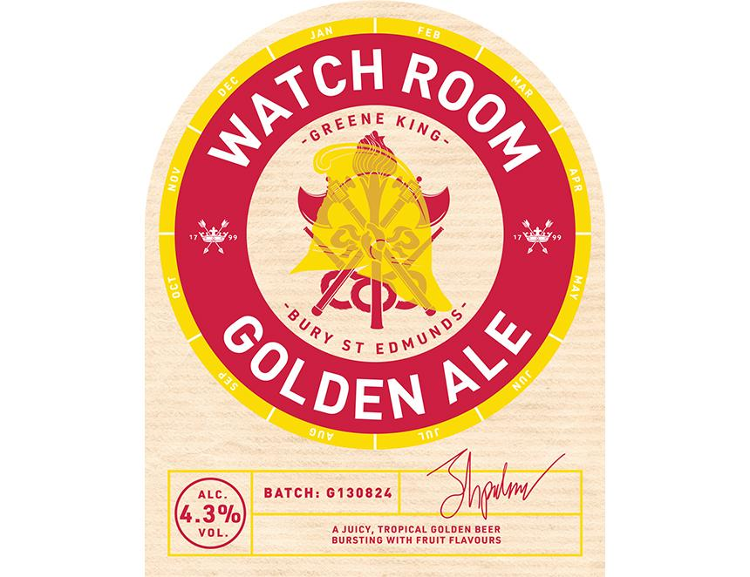

Greene King brewery (GK) is set to launch two seasonal brews for September as the industry gets set to celebrate Cask Ale Week later in the month. GK is launching a brand-new seasonal beer, Watch Room, which has been inspired by a part of the brewery’s heritage. The 4.3 per cent golden ale is a juicy and tropical brew, with fruit flavours of pear, watermelon, mango and pineapple. The name is a nod to Greene King’s own fire brigade that was formed in 1888 and disbanded in 1997. The Westgate Brewery Fire Brigade played an important role during the war years to fight fires during the raids on the town and in more recent times was there to protect the brewery and its local public houses. As part of the creation of Watch Room, Greene King enlisted the help of the previous fire chief for the Westgate brigade, the late Brian Crack, to design a beer that commemorated his service and also included his favourite flavours. Following a discussion with Brian, the brewing team crafted a golden ale to match his preference of a lighter beer, with low bitterness and a hint of sweetness. Watch Room was the end product with a vibrant tropical fruit profile using three hops – El Dorado, Kohatu and Azacca. Returning as a favourite brew, Bonkers Conkers will be available for customers to order throughout September. The autumn ale was originally launched in 2008; however, it had an exciting new look as it joined the seasonal calendar last year. The 4.1 per cent ale is brewed with more than five hop varieties and is said to perfectly pair with a hearty soup, pumpkin pie or warm autumnal dishes. GK head brewer Jack Palmer said: “Watch Room is a brilliant example of storytelling through our beers and paying tribute to our history and our brilliant people that make us proud to have. It was a pleasure to create something for Brian as a thank you for his time spent volunteering in our fire brigade service. “Watch Room is a delicious fruity beer and a great addition to the bar as guests try to capture those last moments of summer and so it’s great to have a limited-time beer available as pubs start to look at changing their range for a new season. “Bonkers Conkers has been a much-loved beer for many years, and it had great success in the calendar last year, so we felt it right to bring it back for such a key month for cask. We are excited to celebrate Cask Ale Week this year and we have many activations taking place in our pubs, brewery and also with our customers, so we encourage pubs to get behind it too and inspire people to enjoy a pint, or sample, of cask ale.” Watch Room and Bonkers Conkers both form part of the wider Fresh Cask Releases calendar, a portfolio of 13 limited-edition cask beers available at specific times throughout the year.