Can you help community pubs project?

09/09/2024 by Camilla Weddell

Campaign

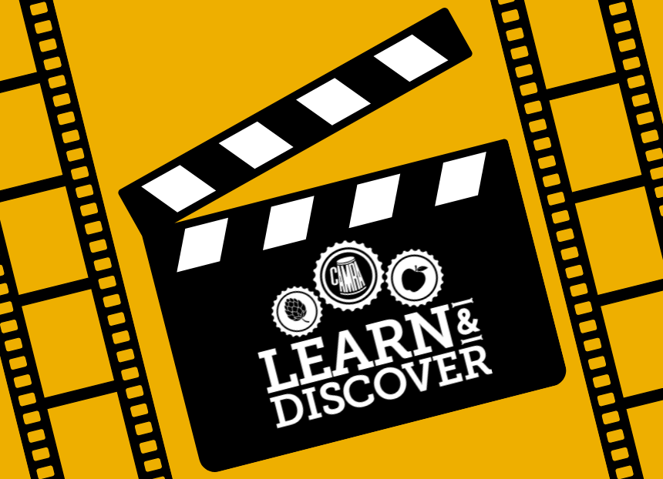

CAMRA’s Learn & Discover platform is seeking a film maker/videographer for an exciting new project documenting communities as they take over their local pub. The content will chronicle the journey of community groups as they work towards owning and running their local. CAMRA wants to use this to raise awareness of the community ownership process, the depth of feeling involved and benefits.  A list of venues and community group contacts will be made available plus a detailed content brief.   CAMRA commissions via a press kit model requesting core products, stills and social media assets in one package. The project itself would be released as a short series of films.  You can find Learn & Discover’s full content guidelines here.  Some knowledge of community owned or run pubs would be preferable but not essential. If you can create video content that is friendly, approachable, full of warmth and engaging then get in touch.    If you haven’t done a project like this but are passionate about community pubs then get in touch for a chat. To discuss this project, send examples of your work and details of your fees to discover@camra.org.uk.   Learn & Discover is an online learning platform, supporting education in beer, cider, perry, pubs and social clubs through articles, video and audio content, created by trusted industry voices and our volunteer community.