Restoring Burton’s pride

08/09/2024 by Roger Protz

Industry

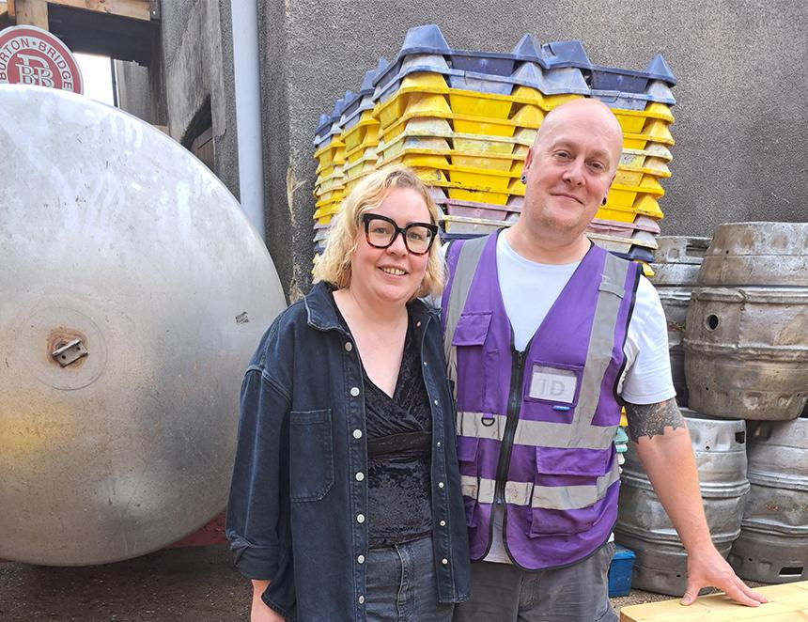

Expansion is underway at Burton Bridge brewery. New brewing kit is waiting to be assembled to replace vessels that are leaking and no longer fit for purpose. Brewery manager Emma Cole and head brewer Al Wall (pictured) need council agreement to expand the site by knocking down some derelict buildings to install the new kit. There are also plans to open up the brewery yard for outside events and weekend street food. But nothing will take the shine off the memory of Geoff Mumford, co-founder of Burton Bridge, who died in late July. His range of beers continues to be made and Emma plans to bring back Draught Burton Ale (4.8 per cent ABV) and the bottle-conditioned Empire Pale Ale (7.5 per cent). “We need to get the recipe right for DBA,” she said. “Some people said the version Geoff made was the wrong colour and we are trying to sort out the original recipe.” She says the second-hand brewing kit Geoff and his business partner Bruce Wilkinson installed, is now more than 100 years old and is close to collapse. They were keen to retire but wouldn’t do so until the right partner came along. It came in the shape of Heritage brewery, owned by Planning Solutions, which bought Burton Bridge just a month before Geoff died. The new equipment will produce not only Burton Bridge beers but also those made at the Heritage brewery that had to move when Molson Coors closed the National Brewery Centre (NBC). Planning Solutions is a company that specialises in leisure parks and visitor centres. When it took over NBC as tenants of Molson Coors it inherited the small brewery founded by Steve Wellington and first called the William Worthington brewery. Steve, now retired, spent most of his career in various parts of the Bass empire and he specialised in recreating its old beers at Heritage. They include Charrington’s IPA and Massey’s from Burnley with a cask version of Worthington E. Molson Coors refused to sell him the rights to the bottle-conditioned Worthington White Shield, even though it has no interest in the historic beer and has now stopped producing it. Steve responded with Masterpiece (5.6 per cent) that’s White Shield in draught form. Al Wall will use the Heritage yeast culture to keep them separate from Geoff’s and Bruce’s beers and maintain their correct flavours and character. Al and Emma are keen to build on the Heritage range and are frustrated by their inability to find the recipe for Offiler’s Bitter that was brewed nearby in Derby. Offiler’s was bought by Charrington in 1965, and brewing ceased when the London brewer became part of Bass. Emma and Al are convinced Offiler’s Bitter would be a hugely popular beer to bring back for pubs in the area. They have worked together for 10 years. Al is Burton-born and started out as a home brewer before moving to Cloudwater in Manchester. Emma has worked in management and ran pubs before joining Planning Solutions. She also did a stint with BrewDog and lived to tell the tale. Emma and Al will build on Geoff Mumford’s legacy with an oak-aged version of the strong, 8 per cent Tickle Brain and will also restore Staffordshire Knot Brown Ale (4.8 per cent). There will be special versions of the popular Stairway to Heaven golden bitter (5 per cent) using different hop varieties. They will include Stairway to Simcoe and Stairway to Brewers Gold. On the Heritage front, they plan to brew Bass P2 Stout for Christmas. The 8 per cent imperial stout was first brewed in the 19th century for export to Russia and was recreated by Steve Wellington at the NBC. The brewery is fronted by the Burton Bridge Inn, a small, two-roomed, oak-panelled pub with comfortable settles. There’s a skittle alley in an upstairs room. Pub manager Chris Sherratt says Bridge Bitter (4.2 per cent) and Stairway to Heaven are the most popular beers and he complements them with a good range of Belgian brews and Ayinger lager from Germany. The brewery supplies around 100 pubs a week. There are a handful of outlets in London and Manchester, but the main distribution area is the East Midlands. When the new brewing kit is up and running, Burton Bridge will be able to brew three times a day and will produce 100 barrels a week, with room for further expansion. Emma says she is keen to add bottled beers and may make some craft keg, but she feels cans are not right for the brewery’s image. She also has plans to add a shop on site that will sell home-brewing kit and beers for take-home. “We could soon be the oldest brewery in Burton,” Emma said. She adds everyone in the town expects Carlsberg to close Marston’s. It’s not just because the Danish lager company has little interest in ale but, she says, the brewery’s site is worth a fortune. Burton is expanding fast as a town and there’s a new housing estate going up at the back of Burton Bridge to stress the point. “It would break my heart if Marston’s goes,” Emma said. She is determined, come what may, to maintain the traditions and heritage of brewing in the town. To that end – and this is top secret and can’t be revealed yet – she and Al are planning to install an additional piece of equipment that will stamp “Burton made” indelibly on the brewery. In the meantime, if anyone has a recipe for Offiler’s Bitter, please get in touch with Emma and make her a very happy Burtonian.