Scottish licensees call for VAT change to save pubs

06/09/2024 by Timothy Hampson

Pub

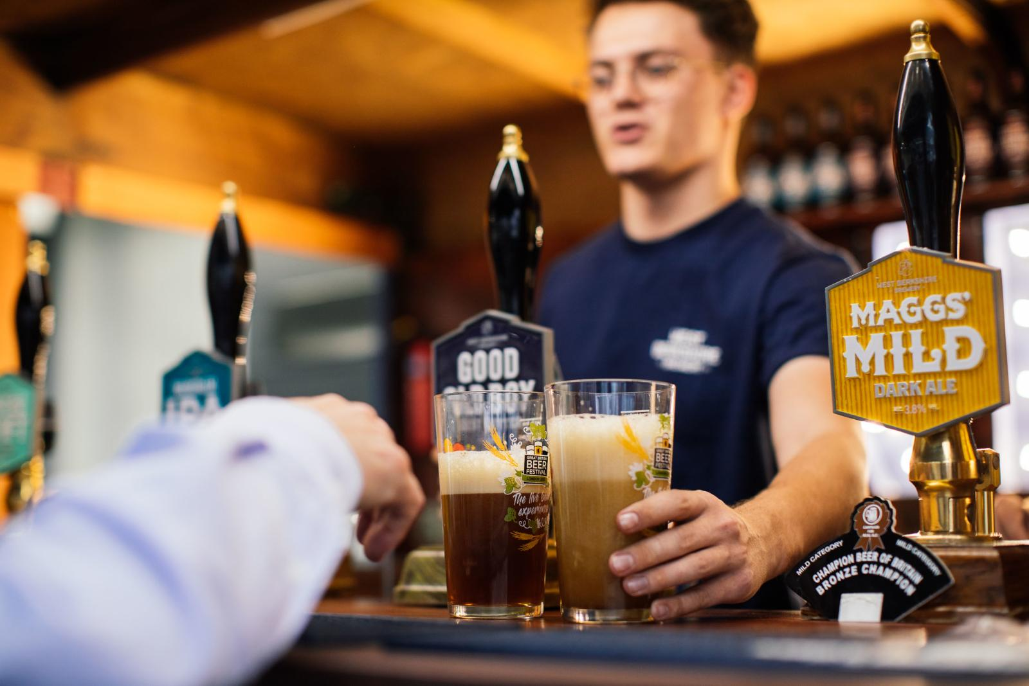

The Scottish Licensed Trade Association (SLTA) has released its latest survey, offering a stark snapshot of the challenges facing Scotland’s pubs and bars. As the sector grapples with rising costs and a reduction in customer visits, an overwhelming 78 per cent of outlets are urging the UK government to reduce VAT as a vital measure to support the industry. SLTA MD Colin Wilkinson said: “Our sector is at a critical juncture. Despite the brief uplift from Euro 2024, 62 per cent of outlets have seen lower trade than last year. “Customers are becoming more selective about when they visit, with 19 per cent leaving venues earlier and 16 per cent attending only for specific events. The report also highlights that 64 per cent of respondents have noticed customers spending less, visiting less frequently, and spending less time in the venue.” The survey highlights the dual pressures of rising operational costs and reduced consumer spending power. A worrying 77 per cent of venues reported a 10 per cent or more increase in their costs - a sharp rise compared to just 30 per cent in January. Additionally, 42 per cent of outlets have seen their rates increase by 10 per cent or more, adding further financial strain. In light of these findings, the SLTA is calling for immediate government intervention. The most urgent request from the sector is for a reduction in VAT, which 78 per cent of respondents identified as the most effective way for the UK government to support hospitality businesses. Wilkinson said: “We need both the UK and Scottish governments to recognise the value of our industry and act swiftly. A reduction in VAT for licensed venues would provide much-needed relief, while a review of the commercial rating system could alleviate some of the ongoing financial pressures.” In the January 2024 survey, the SLTA found that 96 per cent of respondents felt the Scottish government was out of touch with the needs of the business community - a sentiment echoed in the current findings. The SLTA now urges both the Scottish and UK governments to work together to support one of Scotland’s key industries.