Fans flock to pub’s Oasis tribute

05/09/2024 by Timothy Hampson

Pub

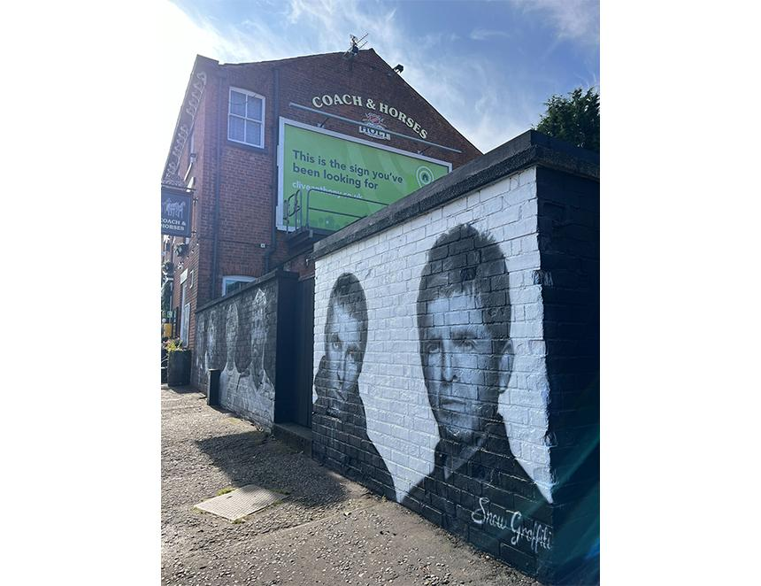

When Liam and Noel Gallagher return to Manchester to play a series of homecoming Oasis gigs in July, there’s no doubt that enjoying some of the local beer could well be on the cards for the brothers. But nowhere will they get a warmer welcome than the Coach and Horses in Whitefield, a short walk from Heaton Park where Oasis will be staging five concerts as part of their sensational comeback tour. The pub has become a magnet for fans of the supergroup after the landlady of the Joseph Holt pub Sue Hawley commissioned a monochrome mural of the siblings on the front of the building (above). Hawley has issued an open invitation to the Gallaghers and their bandmates to come and enjoy Joseph Holt beer on the house when they come to town for the concerts. “The brewery which owns the Coach and Horses has been making beer from its Manchester premises for 175 years and runs 127 pubs across the North-West. As such, it is as inextricably linked with the city as Oasis themselves.” The artwork was produced by Scott Wilcock on the day Oasis made their bombshell reunion announcement. Wilcock who runs Snow Graffiti, originally painted a mural featuring famous Manchester footballers at the Coach and Horses. When he came to give the artwork a bit of a touch up, Oasis had just announced their tour dates for the park just down the road. Hawley said: “I immediately said to my husband, Lee, we must do something to mark this. So, I asked Scott to paint the Gallagher brothers. “After nine hours he had produced this incredible mural. We have since had people from around the world visiting it and posing in front of it with floppy hats and green coats – which we know Liam loves to wear.”