Rotherham first for winter celebration

03/09/2024 by Timothy Hampson

Campaign

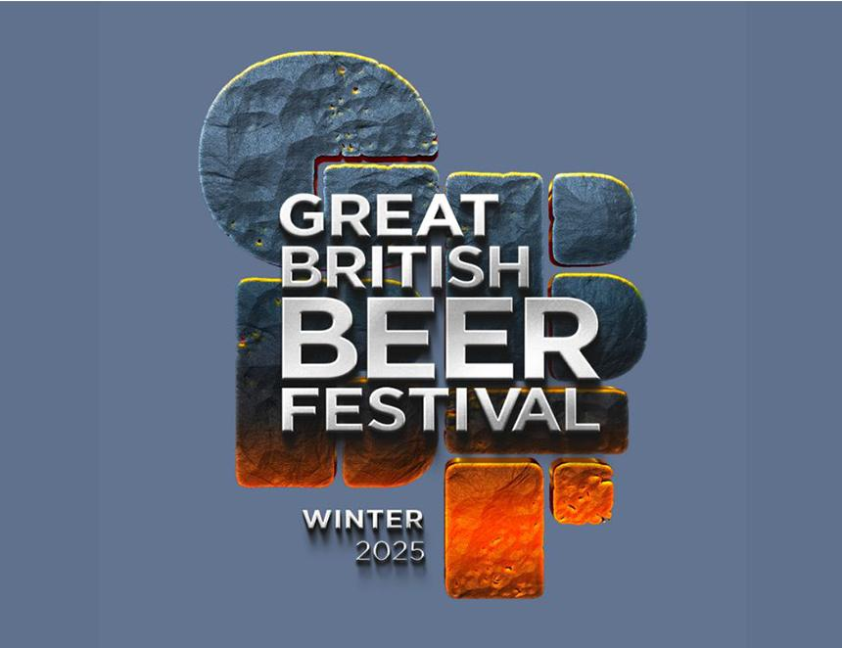

CAMRA’s Great British Beer Festival Winter will take place for the first time in Rotherham on 12-15 February and tickets are now on sale.

The festival will feature beers, ciders, perries and gin at the Magna Science Adventure Centre where visitors can also enjoy a range of entertainment and food throughout the week. After a fallow year for CAMRA’s flagship summer event, the Great British Beer Festival Winter will boast a large selection of dark ales and winter brews, alongside a range of light and hoppy beers. GBBF Winter organiser Andrew Taylor said: “The Magna Science Adventure Centre offers us an impressive space to ensure a fantastic festival for visitors from across the country. Whether you enjoy a stout or a session ale, there’ll be something for everyone to try.” CAMRA vice chairman Ash Corbett-Collins said: “We are absolutely delighted to bring the Great British Beer Festival Winter to Rotherham. We can’t wait to welcome a host of breweries to a large venue fit for a national festival, and we’re very much looking forward to seeing everyone there.” Tickets for the event are now available at https://winter.gbbf.org.uk/