Brew like a pro with CAMRA Book’s latest release

29/08/2024 by Timothy Hampson

Campaign

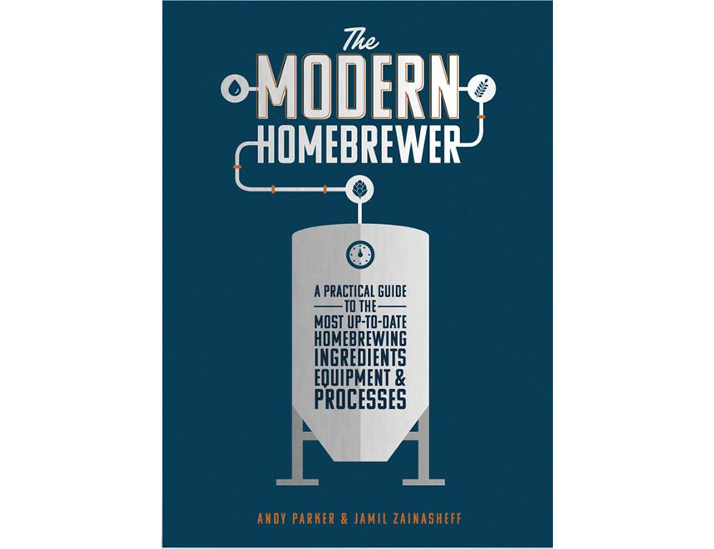

The Campaign’s latest title, The Modern Homebrewer by Andy Parker and Jamil Zainasheff, debuts on 5 September. CAMRA is supporting the next generation of brewers with the publication, which is a hands-on, practical guide to the most up-to-date techniques, ingredients, equipment and processes for producing professional-quality beer at home. Ideal for both curious beginners and the most seasoned home brewers wanting to experience a new challenge, this ultimate guide features many world-class recipes from around the globe. Each chapter features a QR code link to videos, calculators, and other links to valuable brewing resources. Many of today’s most popular independent brewers first started their career as homebrewing hobbyists, and it is hoped CAMRA’s new guide will inspire the next generation of beer-producing talent. The two authors are prime examples of award-winning homebrewers who turned their passion into a profession. Andy Parker is the owner and head brewer of Berkshire-based Elusive Brewing and champions the vibrant British homebrewing scene from where his love of beer and brewing developed. Elusive Brewing’s flagship beer Oregon Trail West Coast IPA was awarded UK’s Best IPA at the 2021 World Beer Awards, and Andy was named the British Guild of Beer Writers Brewer of the Year in 2022. Jamil Zainasheff is a homebrewer, author, beer judge, and host of The Jamil Show and Brew Strong shows on The Brewing Network. Jamil and his wife Liz, were, until recently, founders and owners of Heretic Brewing Company, a 30-barrel brewery in California’s San Francisco Bay area. The release coincides with the start of judging for CAMRA’s Homebrewer of the Year competition. Homebrewers can enter their beers into one of 11 categories to be judged at the Nailmaker Brewing Co. From there, the best of the best will then be judged at the Bohemia, home of the London Brewing Company, on Wednesday 2 October, with the winners announced on the day. Entries are open until 6 September at: https://gbbfhomebrew.brewingcompetitions.com/ More information about the competition can be found here: https://camra.org.uk/what-we-do/homebrew-competition/ Meet the authors  Andy and Jamil will be at the Love & Beer Festival at the Hackney brewery, Unit 10, Lockwood Way, London E17 on 14 September where you can get yourself a signed copy. Tickets can be purchased here: https://www.themaltmiller.co.uk/product/love-beer-festival-september-14th-2024-tickets/ The Modern Homebrewer – order your copy here: https://shop1.camra.org.uk/product/the-modern-homebrewer/