Hogs Back to the future harvest celebration

25/08/2024 by Timothy Hampson

Industry

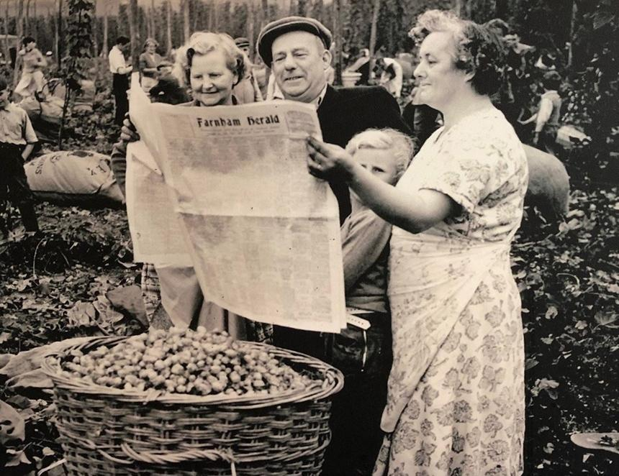

As Surrey-based Hogs Back brewery approaches its 10th harvest, it has recreated historic hop farming photographs lining the walls of its tap room, with local residents helping to update the images during an open evening. Two original images were recreated, one showing a group of hop pickers reading the local newspaper, while in the other, Matthew King, Hogs Back's estate manager, is shown with brewery owner Rupert Thompson inspecting the ripening hop plants, replacing Mr Tice, a member of a local hop growing family, in the original photograph. The Hop Garden Open Evening drew 120 guests, who enjoyed a tour of the crop next to the brewery, followed by a pint or two in the Brewery Tap. Guests made a £5 donation to British Heart Foundation, Hogs Back’s chosen charity this year. Thompson said: “We’re immensely proud to mark 10 years of hop growing. We planted our first hop garden, across the road from the brewery, to help us become more sustainable, to bring hop farming back to the Farnham region, and to build ties with the local community. “A decade on, we have relocated to a larger hop garden even closer to the brewery, meaning the hops travel ‘from field to firkin in a furlong' as we say. We capture them at optimum freshness and create a carbon footprint that’s close to zero!  We are producing around 60 per cent of our hop requirement and growing three varieties: Fuggles, English Cascade and Farnham White Bine.” He added: “Hop growing is not the faint hearted!  Hops are a delicate, high-maintenance crop, much impacted by climate; this year’s heavy rain has delayed growth and therefore our harvest. “However, it has been enormously rewarding, not least because of the support from the local community, in particular our loyal band of volunteers. Not only do they help us tend our hops during the growing season and bring in the harvest in September, but some of them are now immortalised in our recreations of classic hop farming photographs.” This year's hop harvest will culminate in the traditional celebrations, held from 13-15 September. This year, Hogs Back is expecting more than 3,500 people to join the festivities, which include:   – Roots Festival, 13 Sept from 6pm featuring original music, headlined by Newton Faulkner – Hop Harvest Festival, 14 Sept 2-11pm: beer, street food and music, this year including indie folk to electropop and headlined by Britpop tribute band Blurasis – TEA Party, 15 Sep midday-5pm: family-friendly day with children’s entertainment including dray rides around the hop garden, face painting, magic show, and music including a Taylor Swift tribute act.  For details see: https://hogsback.co.uk/pages/festival-beer-and-music-party Pictured: hop pickers in Farnham in 1958 – a recreation of this photo is on display in the Hogs Back tap room