Star pub set to shine again

23/08/2024 by Timothy Hampson

Pub

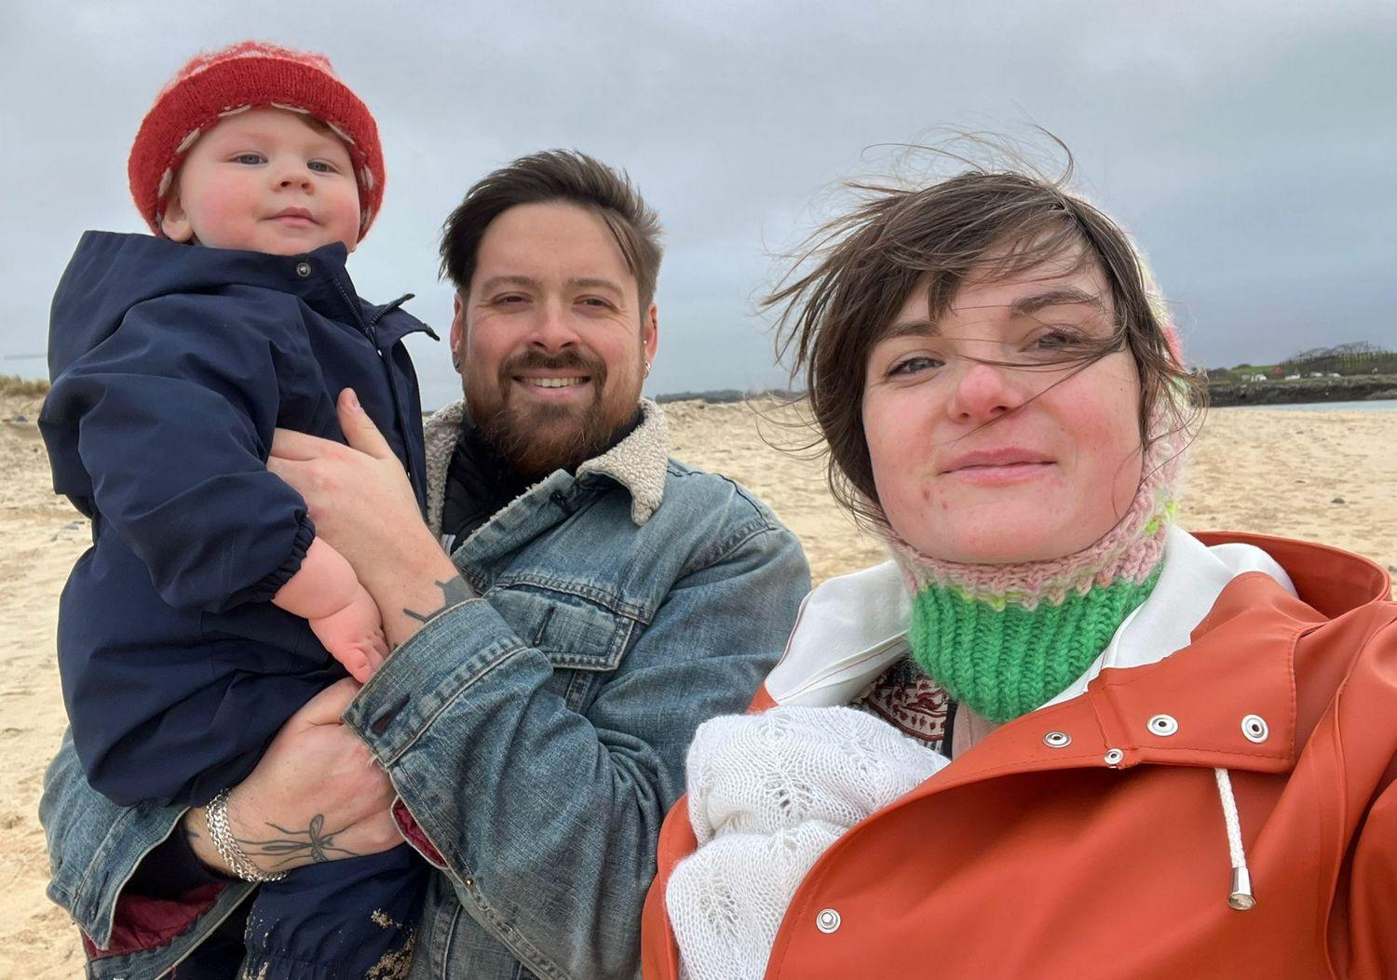

The new owners of an award-winning Cornish brewpub are crowdfunding ahead of a planned reopening this autumn. Husband and wife team Trystan-Ross and Daisy Pooley-Tolkien-Williams (pictured) are returning to their Cornish roots and aiming to make the Star Inn, Crowlas, the heart of the community once more. They’re also taking on the popular Penzance Brewing Co, which shares the same premises. The pub was run for 25 years by Peter Elvin and his partner Tracey, with the brewery being added in 2008. Pete passed away at the end of 2023 after a battle against cancer, and the family decided to put the pub on the market. For Trystan and Daisy, their purchase is all about continuing Pete and Tracey’s work, while adding their own influences, gained from years of experience in hospitality. Trystan has spent 17 years working in the industry with a decade spent in Michelin-starred kitchens under the likes of Angela Hartnett, Nieves Barragán Mohacho, Gary Foulkes, and Sat Bains. Daisy spent the best part of a decade living in Falmouth, studying both her undergraduate and postgraduate degrees at the art school. During her time there she was a core team member of Hand Bar, one of Cornwall’s original speciality beer outlets, and remains closely connected to the county’s hospitality scene. Together they run family lifestyle brand Raising an Ally, where community and kindness are the founding and driving ethos. Something to be carried through into the Star. The beer will remain the star, of course, but the kitchen will be fired up for fish Fridays and Sunday roasts, as well as other special events. “Fish Fridays will be built around what is available direct from local day boats, while our Sunday roast will boast higher welfare meats,” said Trystan and Daisy. “Both with drinks pairings found in the Penzance Brewing Co stock and some of our other favourites from further afield.” The crowdfunder is now active at bit.ly/starcrowlas and there’s a range of rewards from vouchers and beer and food matching events to meals and brew day experiences.