CAMRA reveals UK’s top pubs

21/08/2024 by Timothy Hampson

Campaign

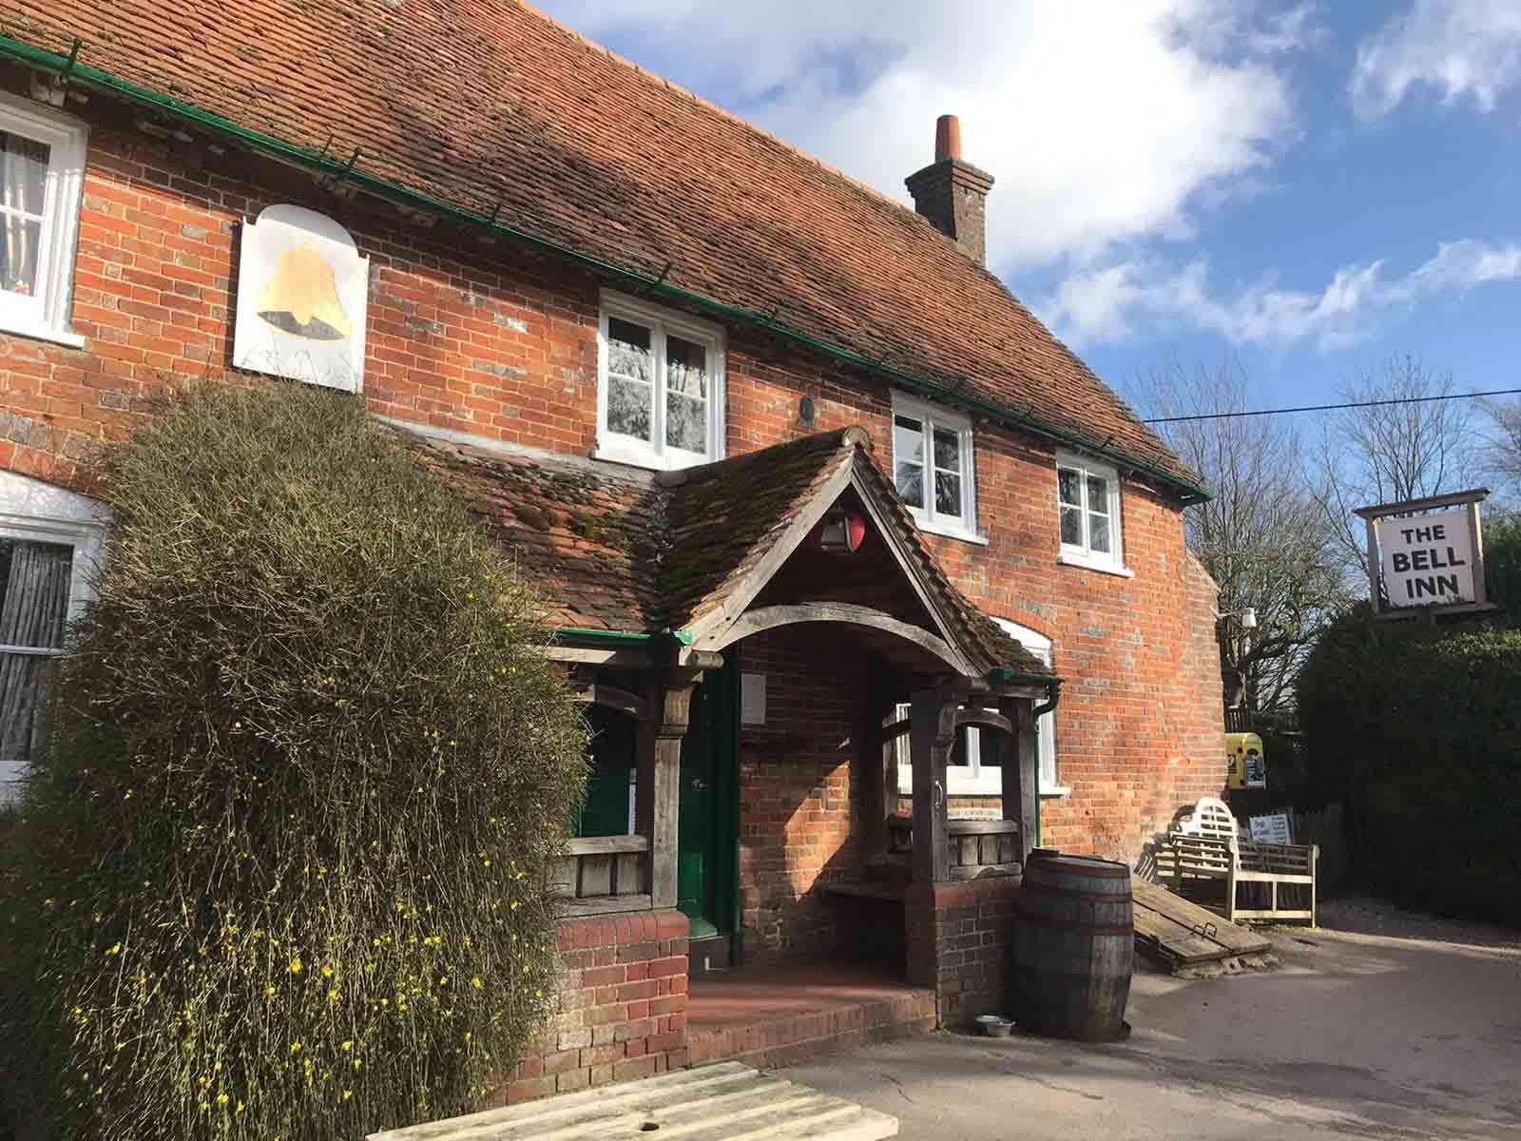

CAMRA’s 2024 Pub of the Year competition is hotting up ahead of the Bank Holiday weekend, with the announcement of this year’s finalists from the UK’s nations and regions.  A total of 17 pubs have battled it out with thousands of rivals across the UK to be crowned the winner in their area. For the first time a Northern Ireland winner has been crowned this year, having previously been part of a joint Scotland and Northern Ireland competition. Pubs in the competition are scored on their atmosphere, decor, welcome, service, inclusivity, overall impression, but most importantly – the quality of live beer, real cider and perry. The regional and national finalists will now compete for the National Pub of the Year award, with judges whittling the 17 down to just four in late September. The overall winner will be announced in January 2025. Last year’s winner was the Tamworth Tap in Staffordshire, which also took the crown the year before.   The recognition of pubs and their place in our communities has never been more important, as the announcement of the top 17 pubs comes hot on the heels of the one-year anniversary of the demolition of the Crooked House in Himley, Staffordshire. The destruction sent shockwaves across the nation, putting a spotlight on unlawful demolitions and conversions of pubs.  National coordinator for the Pub of the Year competition Andrea Briers said: “These amazing pubs really are the crème de la crème and I would encourage the public to seek out the 17 winners – they are top-tier pubs serving excellent beer, cider and perry, run by welcoming, hardworking staff.  “It’s also important to support your local all year round. With constant pressure from stubbornly high energy prices, fluctuating running costs and grossly unfair business rates threatening to drown pubs across the UK, it’s vital to get out and support the licensed trade.”   The top 17 are: Central Southern Bell Inn, Aldworth (pictured) This wonderful village pub is described as a perennial gem, having previously won the National Pub of the Year title in 1990 and 2019. Remaining in the hands of the same family since the 18th century, the pub’s interior is of outstanding national historic importance. The pub is adorned with attractive historical furnishings such as a Victorian rear screen dating back to the 1880s, and one of the last surviving 1930s glazed-in serveries with sliding windows in the country. The large open garden and range of six beers, five changing regularly, attracts walkers and drinkers from far and wide. Along with excellent beer, The Bell is renowned for its home-made soups, filled rolls, ploughman's platters and hot puddings. East Anglia Blackfriars Tavern, Great Yarmouth This Victorian corner pub resides in the shadow of the medieval Great Yarmouth town walls. Showcasing East Anglian produced cask beer and ciders, the Blackfriars Tavern has made its mark as a must-visit beer destination, serving a varied range of styles, alongside a wide choice of bottled and draught Belgian beers. In addition to a fantastic set of beers, a selection of artisan loose-leaf teas are available as well as food. Visitors describe the Blackfriars Tavern as a real gem of a pub and is well worth seeking out. East Midlands Horse and Jockey, Stapleford The Horse and Jockey was a finalist for the National Pub of the Year title in 2013 and 2022. Known locally as the Jockey, this welcoming free house boasts 13 cask beers, five of which are from local brewers and includes at least one dark brew, plus five ciders. The split-level pub is decorated with photographs of local landmarks and Stapleford from previous eras, along with whisky water jugs hanging from the ceiling. Renowned for being dog-friendly, with water bowls and treats provided, the pub has become a popular destination for walkers and cyclists, as it is close to the eastern side of the Erewash Valley trail. The Horse and Jockey hosts monthly tap takeovers, highlighting local and regional brewers, and stages occasional beer festivals too. Greater Manchester Northumberland Arms, Marple Bridge Saved from closure in 2017, following a successful campaign by the locals to bring the Northumberland Arms into community ownership, the pub has continued to flourish. Now run by a group of enthusiastic local people who have worked hard to restore this cosy, welcoming pub to its former glory, a varied range of well-kept beers is always available. Becoming the beating heart of its community, the pub, locally referred to as the Thumb, is a hub for events and activities, including running, cycling and walking clubs – affectionally known as Thumb Runs, Thumb Wheels and Thumb Legs. The pub organises an annual event to raise money for MIND. Kent Nelson Arms, Tonbridge This beautifully refurbished side-street local, just a few minutes’ walk from Tonbridge station and the high street, was a finalist in last year’s national Pub of the Year competition. Serving six to eight beers across a range of styles from national and local breweries, supplemented by 10 keg taps and up to 15 real ciders, it is easy to see why. The pub's spacious and comfortable interior displays a nautical theme, with decorations including a ship’s wheel, barometer, naval brasses, and a painting of Lord Nelson, along with attractive breweriana. Greater London Little Green Dragon, Winchmore Hill A former shop unit, Enfield’s first micropub opened in 2017, with the aim of providing the community a place to socialise with a drink, free from TV screens and slot machines. The pub is named after the long-gone Green Dragon pub further along the road and became a regional award winner just one year after opening. Focussing on the quality and diversity of real ale, the Little Green Dragon has an everchanging selection of four cask beers sourced from local microbreweries and other independent brewers from further afield, plus real cider, perry and four keg beers. Traditional pub games such as table skittles and shove ha’penny are available for pub-goers. The Little Green Dragon’s interior features an eclectic range of seating, from wall-mounted benches to low sofas, and even repurposed bus seats. Merseyside and Cheshire Turks Head, St Helens An attractive Tudor-style pub dating back to the 1870s near the town centre, the Turks Head has previously won the Merseyside and Cheshire Regional CAMRA Pub of the Year in 2023. The friendly and welcoming pub offers an enormous range of 14 cask beers and 15 ciders, plus an impressive whisky and gin selection. An extensive variety of craft and continental beers can also be found in the upstairs Tower Lounge room, which hosts live music and events for local community groups. The pub has an expansive beer garden with an outside bar and wood-fired pizza oven. North East Grey Horse, Consett The oldest pub in Consett, and one of the oldest public houses in the region, the Grey Horse dates back to 1848 and took the North East England Regional Pub of the Year crown in both 2019 and 2023. The attractive interior of this traditional pub comprises of a lounge and L-shaped bar, with a classic wood-beamed ceiling. The Consett Ale Works brewery is located at the rear of the pub and is a regular sight among the six changing cask beers on offer. With quality beer being brewed on the premises and two roaring fires, the pub promises a great atmosphere and a traditional experience. The Grey Horse hosts beer festivals twice a year, raising money for local charities. The pub is a popular stop for cyclists, with the coast-to-coast route nearby. Northern Ireland Dog and Duck, Lisbellaw A family run, dog-friendly country pub, the Dog and Duck Inn is in the rural village of Lisbellaw, about five miles from Enniskillen. Noted for its welcoming and cosy atmosphere, it specialises in independent beers, ciders and spirits. No less than 14 taps including four traditional cask handpumps, usually serving one real ale and three ciders, can be found at the bar. The pub is also home to the Glenwinny micro distillery, which produces small batch rum, brandy and whiskey using locally sourced ingredients. Pub-goers can sample the range of spirits and even book a personalised tour and tasting experience. Scotland Hillend Tavern, Dalgety Bay This community-focused village pub near Dalgety Bay, Fife previously won the Regional Scotland & Northern Ireland Pub of the Year award in 2023. Locally known as the Tav, the pub has a friendly and welcoming atmosphere with cosy coal fires. The traditional bar serves four changing cask beers, and a spacious area at the rear is used to host village events. The Hillend Tavern proudly supports and sponsors local sports teams, including cricket, football and squash. South West Crossways Inn, West Huntspill The Crossways Inn has fast gained a reputation for good food and outstanding choice of beer, becoming a must-visit for those wanting a huge selection of well-maintained drinks. Located on the idyllic Somerset Levels, the 17th-century inn has several bar areas, boasting of nine handpumps and an ever-changing range of up to 25 guest cask beers per week, plus a selection of real ciders and craft beers.  Surrey and Sussex Brickmakers Alehouse, Bexhill on Sea Converted from a former shop and showroom of a local brick manufacturer, the Brickmakers Alehouse opened as Bexhill’s first micropub in 2019. Conveniently close to the town centre and seafront, the pub is a welcoming space for the community, where everyone can discover and enjoy a varied range of regularly changing beer and cider. Owned and run by two cask ale and cider enthusiasts, drinkers can expect at least six cask beers, including those from local producers, and four real ciders. Wales Cresselly Arms, Cresswell Quay Situated on the Cresswell River, stepping into this Grade II-listed hostelry is like stepping back in time. Dating back to the 1880s, the Victorian public bar has changed little over the centuries. The homely farm kitchen interior is of national historic interest, with a red and black quarry-tiled floor, roaring open cast-iron fireplace, Victorian-era counter and bar-back shelves held up by slender columns. Accessible by boat from the Milford Haven estuary at high tide and a short drive from Tenby, the pub also lies on a series of interesting walking routes, making it a popular destination for hikers. The Cresselly Arms is a haven for locals and tourists alike, staging community events and collaborating with local food outlets, while serving four cask beers. Wessex Woodman Inn, Bridport A fiercely independent, traditional pub at the heart of its community, with a focus on quality beers and ciders. The Woodman Inn offers a range of five constantly changing beers, rarely serving the same drink twice, with one handpump dedicated to dark beer. Exhibiting a vast array of ciders, the pub also won the Regional Cider Pub of the Year award in 2023. The Woodman Inn has a cosy one-bar interior with a stone floor and log burner, a pleasant garden to the rear and a skittle alley. West Midlands Bailey Head, Oswestry Nestled near the Welsh borders in the charming market town of Oswestry, the Bailey Head is a must-visit for beer lovers. The pub has one of the largest beer ranges of any in Shropshire, claiming to have sold more than 3,400 draught beers since opening in March 2016. Six constantly changing cask beers, always including one dark brew, are supplemented by 11 other draught beers, plus four ciders and a perry. The pub also has a substantial range of canned and bottled beers from across the UK and overseas. The Society of Independent Brewers (SIBA) named the pub the UK’s Best Rural Independent Craft Beer Pub or Bar in 2020 and has been a finalist many times since. Regular tap takeovers and meet the brewer events, among other activities are organised for the local community. The Bailey Head is dog friendly, being voted Most Dog Friendly Pub in the West Midlands in 2017 by DogBuddy. West Pennines Black Horse, Preston A visually stunning Victorian Grade II-listed pub opposite the historic Preston open market. Having an interior of national historic importance, the Black Horse is a fantastic example of Victorian architecture, retaining original fittings from the era. Most noteworthy is the beautiful semi-circular ceramic bar, tiled walls and meticulous mosaic flooring throughout the pub. A seating area has been dubbed the ‘Hall of Mirrors’ due to the impressive use of original stained glass. The Black Horse serves through 10 handpumps including four changing guest beers from far and wide, plus a range of ciders. Yorkshire Three B’s, Bridlington Run by a husband-and-wife team who are passionate about beer and cider, the popular micropub is described as Bridlington’s Real Ale Destination, showcasing four cask beers usually from Yorkshire microbreweries. The pub aims to never sell the same beer twice, making for an exciting range at the bar, becoming the Society of Independent Brewers’ (SIBA) UK’s Best City Independent Craft Beer Pub or Bar finalist in 2021. Also, as a National Cider Pub of the Year finalist in 2023, at least 10 of varying styles and strengths are served from local suppliers.