Robin Hood moves on to hallowed ground

20/08/2024 by WB Reporter

Campaign

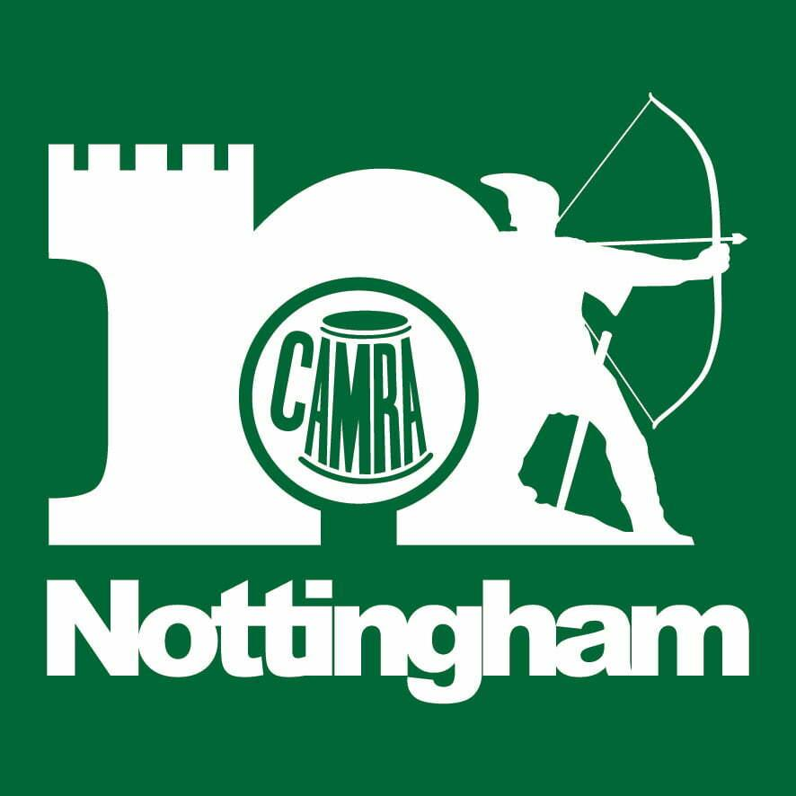

This year’s Robin Hood Beer and Cider Festival will move on to the hallowed Trent Bridge turf for the first time this year with a new bar on the venue’s outfield in front of the pavilion. The festival is set to return to the home of Nottinghamshire County Cricket Club from 9-12 October, with in excess of 600 draught beers and 140 ciders and perries available. Patrons will be able to enjoy the festival experience from the new marquee or take in the scene from the stands, while the ground’s concourse and courtyard will continue to feature bars, food stalls, retail outlets and live music. “We’ve been delighted with the way the character of Trent Bridge has seamlessly blended in with that of our beer festival – but actually moving onto the turf has always been something of a holy grail for us. The field has seen so many historic sporting moments over the years, so we’re sure cricket lovers and beer lovers alike will relish the chance to take in the event from ground level for themselves. “The extra space also allows us to welcome brews from further afield, including some from the USA, however we are featuring all East Midlands breweries and our famous Nano Bar in this new area,” said Nottingham branch chairman Steve Westby. More than 15,000 attendees have visited the festival during each of its previous three events at Trent Bridge. This year has seen the introduction of a season pass, allowing access to all four days, along with a Saturday night Party Night ticket for the festival’s finale, which will feature music on two stages and live DJs. “We’re always seeking ways to make our staging of the beer festival bigger and better – and hosting a bar on the outfield was the obvious next step,” said Notts CCC’s commercial director Michael Temple. “This opportunity to extend the event onto the field will bring something new to the experience for seasoned festivalgoers and regular visitors to Trent Bridge alike. “It’s really special to see our venue come to life during what were once seen as our quieter months as a cricket venue, so I can’t wait to see the festival take shape again this October.” Tickets, priced from £16, are available now from trentbridge.co.uk/camra Opening hours: Wednesday 9 October, 4pm-11pm Thursday 10 October, 11am-11pm Friday 11 October, 11am-11pm Saturday 12 October, 11am-11pm Saturday Party Night ticket after 7pm.