Chequers seeks top player

18/08/2024 by Timothy Hampson

Pub

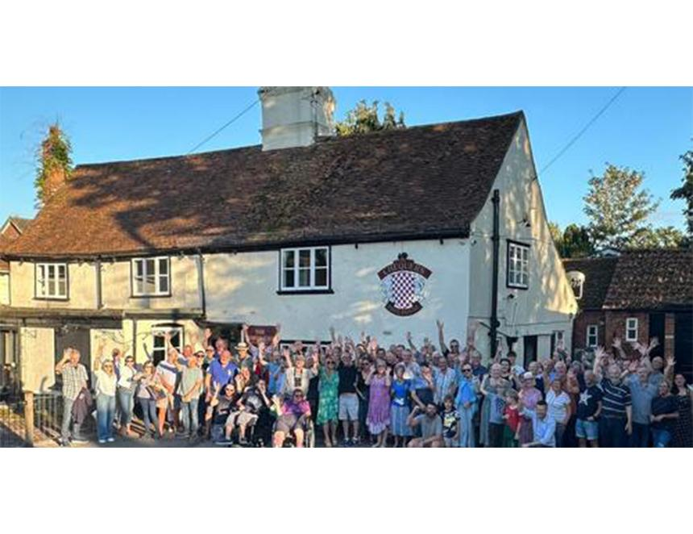

The Chequers Inn of Roxwell, Essex is looking for a tenant after a successful campaign to buy and restore it by enthusiastic supporters. The Grade II-listed building stands as a testament to traditional country pubs, nestled in a beautiful setting by the village church. Following the retirement of the pub’s long-serving landlord and its sale to a third party, the pub was closed for the last three years. The Roxwell Chequers Community Benefit Society (RCCBS) was formed by residents determined to keep it alive. Through a show of community spirit, the RCCBS initiated a community buy-out of the pub, with the support of the government’s Community Ownership Fund and the Plunkett Foundation.  Following the successful purchase in the spring of this year, the RCCBS embarked on an extensive refurbishment programme. The aim was not only to preserve the pub's historic charm but also to ensure it is equipped to serve the community in a modern and inclusive way. The renovation has included the installation of a commercial kitchen, new heating and electrics, and the addition of full disabled access and toilet facilities. Inside, the Chequers boasts two main bar areas, each with its own fireplace, along with a range of other characterful spaces and snugs that can accommodate approximately 50 seated covers. The pub also offers a beer garden to the rear and a courtyard at the front, perfect for alfresco dining and socialising. With the refurbishment nearing completion, RCCBS is now seeking a tenant to lead the Chequers into its next chapter. The society is keen to find an operator with strong business acumen, a passion for traditional country pub services, and the ability to engage effectively with the community. This is an opportunity for an experienced publican to take on the Chequers and build on the community support that has already been demonstrated. RCCBS is looking for a tenant who can deliver high-quality, affordable traditional pub food, offer a selection of real ales, and create a welcoming atmosphere that draws in locals and visitors alike. RCCBS received strong backing from local and national organisations, including CAMRA, Plunkett Foundation, and local political leaders. The community's dedication to preserving the Chequers Inn is by the success of the share offer, which raised substantial funds from those eager to see the pub thrive once again. RCCBS chair Sam Metson said: “We are incredibly excited to move into the next phase of this community-driven project and are now actively seeking the right tenant to take the Chequers Inn forward. Our successful purchase and the extensive refurbishment of the pub demonstrate the community’s strong commitment to this venture. "With our modernised facilities and enhanced accessibility features, we are confident that the Chequers is once again poised to become a thriving hub for Roxwell and beyond. We encourage passionate and experienced operators to come forward and join us in continuing the pub’s legacy. This is a unique opportunity to be part of a project that not only revitalises a cherished local landmark but also strengthens community bonds.” For more details on the tenancy contact RCCBS at roxwellchequerscbs@gmail.com