Women in Beer unveils its biggest festival

15/08/2024 by WB Reporter

Industry

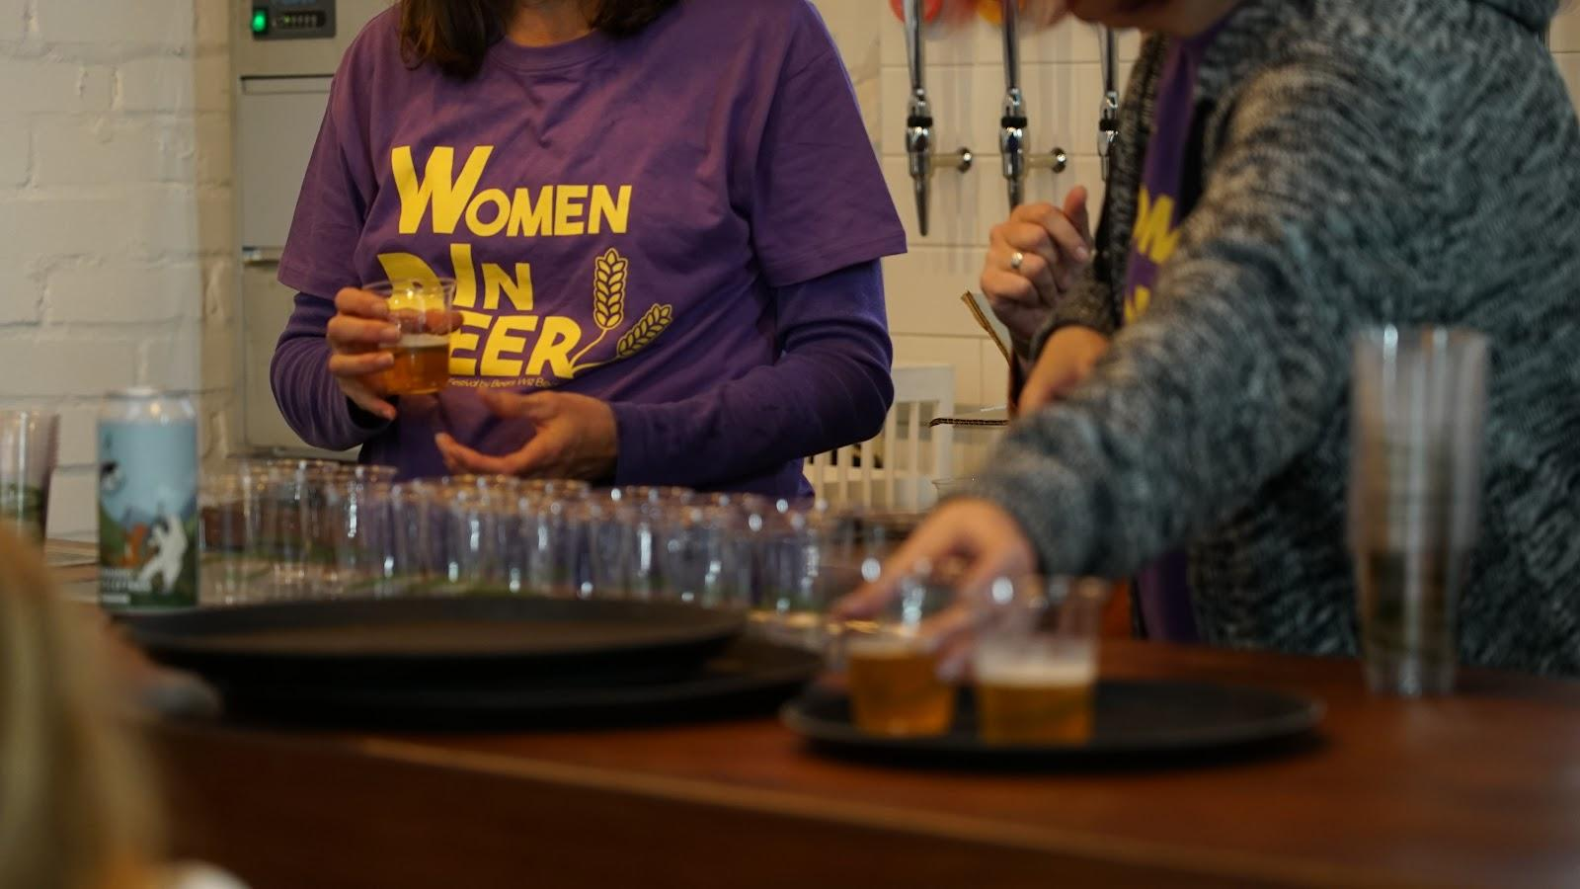

Women in Beer, the Scottish women-who-beer community, has launched its largest festival yet, with five days of events in Edinburgh running from 23-27 October.  Launched in 2019, the festival has learning opportunities, networking and community sessions plus tap takeovers showcasing the women who work in the beer industry.  The festival will launch on the Wednesday with a welcome party at Cold Town House in Edinburgh, before two days of training and conference events at the Port of Leith Distillery in Edinburgh’s historic whisky district. Events will include sensory training led by Lallemand Brewing and a half-day seminar with panel discussions. The festival will also host a Wine & Spirit Education Trust qualification for those on the Women in Beer mentorship programme.   Founder Amélie Tassin said: “We’re excited to announce the third edition of the Women in Beer Festival. I started Women in Beer as a way of celebrating women who enjoy good beer and good company, and to support women working in the brewing industry with a community and training opportunities. “An industry survey in 2023 found that only 30 per cent of the brewing industry identified as women. Women in Beer exists to challenge that statistic, providing support and opportunities for women to meet and discuss the industry and enjoy good beer together.” People will be able to participate in the festival across Edinburgh, as Women in Beer partners with pubs and bars in the city to showcase a selection of the best beers owned or brewed by women with a series of tap takeovers. The popular Women in Beer Big Meetup will return to the Stockbridge Tap on 26 October to launch the festival’s collaboration beers, brewed by Cold Town (Edinburgh); Holy Goat Brewing (Dundee); Jump Ship Brewing (Midlothian); and Round Corner Brewing (Melton Mowbray). Tassin added: “It’s important for us to make sure we can raise awareness with as many people as possible and not only the ones who would buy a beer festival ticket. Teaming up with pubs and bars around Edinburgh allows us to reach people who might have not known that women can also be behind their favourite drinks. Brewing collaboration beers is also a way for us to show we exist and for our members to experience a real brew day.” Tickets for industry events will be on sale from 18 September on the Women in Beer website: www.womeninbeer.co.uk.