Freedom of the borough for CAMRA champs

14/08/2024 by Timothy Hampson

Pub

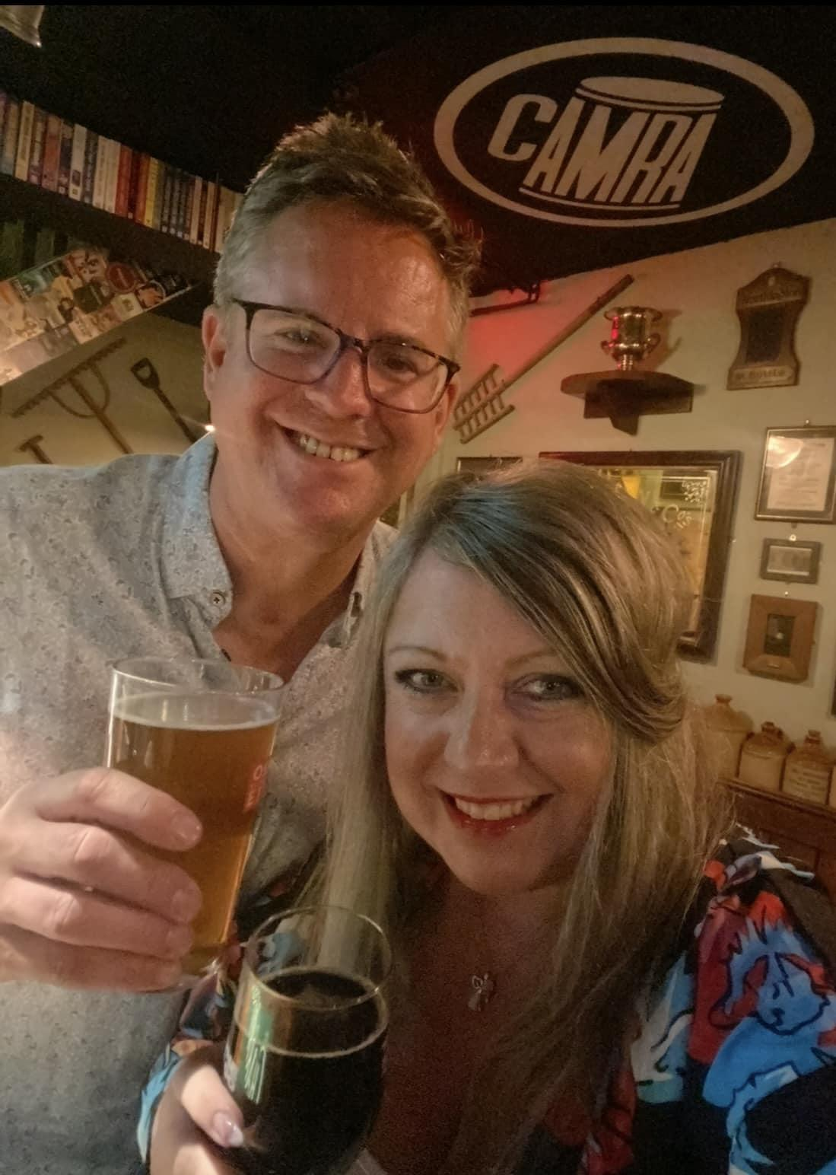

Honorary freedom of the borough has been awarded to George and Louise Greenaway (pictured) in recognition of their entrepreneurship, innovation, and promotion of Tamworth. George and Louise have run the Tamworth Tap Brewing Company for several years during which they have twice won CAMRA’s National Pub of the Year crown and other accolades which has put the town on the national map. Visitors from all over the UK visit the tap to enjoy a host of real ales, live entertainment and other activities. George and Louise have turned a heritage building back to its former glory and character. The couple will receive the prestigious accolade at a presentation at the Town Hall with Tamworth mayor Gareth Coates. Freedom of the borough is awarded to an individual who has given Tamworth exceptional service over a significant period of time in a voluntary, professional or philanthropic capacity. Councillor Nova Arkney said: “Tamworth Tap has taken its success and given back to the people of Tamworth, bringing an old building back to life and attracting locals and visitors to our town. “We’re delighted to bestow the honour of the title freedom of the borough to George and Louise.”