This round’s on us, first minister

13/08/2024 by Timothy Hampson

Campaign

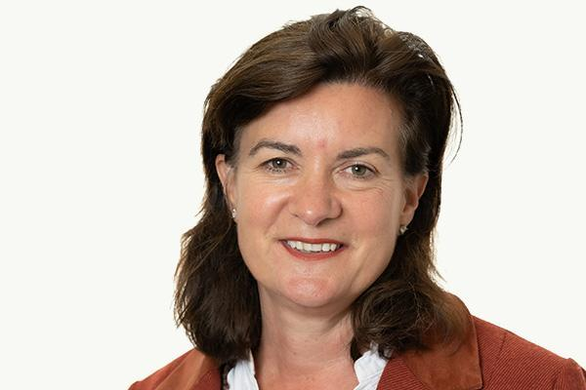

CAMRA has invited the new first minister of Wales for a drink to discuss the future of the nation’s pubs. The newly appointed Eluned Morgan (pictured) has been invited to a pub of her choice to discuss the issues impacting the Welsh pub and beer industry, particularly the losses of many pubs due to rising costs or conversion into shops, takeaways and housing. In 2023, CAMRA data showed as many as 73 pub businesses were forced to shut their doors with a further 10 lost to redevelopment. With a reduction in help for business rates for Welsh hospitality businesses and the weakest planning safeguards for pubs in Britain, CAMRA hopes to see an introduction of new powers to allow communities to save their local from being converted or demolished. CAMRA national chairman Nik Antona said: “I congratulate Eluned Morgan on her appointment as first minister. We know she will be busy with the many issues in her in tray, however, pub-goers across Wales are concerned about the many locals being closed or demolished and will want this issue, as well as the promotion of community pubs and Welsh beer, to be prioritised. “Inviting her to the pub, with a drink on us, gives us the opportunity to discuss these issues with an emphasis on the future of Welsh pubs, clubs, breweries and cider makers, which continues to be uncertain. CAMRA members want the Welsh government to implement stronger protection for community-loved pubs to lower the number being closed, converted or demolished.” CAMRA’s Wales director Chris Charters added: “Business rates, rising prices and costs and consumers lowering their spending budgets due to the cost-of-living crisis are all seriously impacting many community pubs’ ability to remain open. Because of this, CAMRA continues to call, alongside licensees and local breweries, for the reintroduction of the 75 per cent discount on business rates bills. “The first minister should look at improving planning laws to increase the number of community run pubs in Wales – communities should, in the first instance, be able to take ownership of their local should it be faced with closure or conversion.”