Fuller’s acquires Lovely Pubs

12/08/2024 by Timothy Hampson

Industry

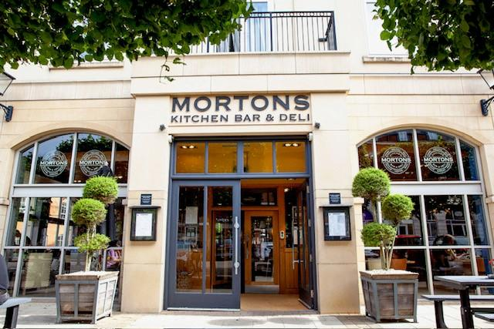

Pubco Fuller, Smith & Turner has added to its estate with the purchase of seven Lovely Pubs in Warwickshire for £22.5m. Fuller’s chief executive Simon Emeny said: “I am absolutely delighted to be announcing this news. “We are very careful when it comes to finding great sites to add to our iconic pub estate and the Lovely Pubs business is a perfect match and a fantastic acquisition. “It was established 30 years ago and is an excellent business with outstanding, well-invested sites offering delicious, fresh, locally sourced food, a great drinks range and a wonderful welcome. “It adds scale to our presence within our geography and is a great next chapter in the Fuller’s story. “We can’t wait to welcome the Lovely Pubs team to the Fuller’s family. We will continue to run the sites with their existing offer and it’s exciting to be working with the Lovely Pubs founders. “We have spent the last few years getting the Fuller’s business in the best possible shape – and this is a perfect opportunity to grow our managed pubs and hotels estate.” Lovely Pubs founder Paul Salisbury added: “We have spent the last 30 years building up a wonderful business and we are delighted to be partnering with Fuller’s for the next stage in the Lovely Pubs journey. “Our ethos, values and vision are very similar, and Fuller’s has the credentials and expertise to deliver further success for these seven fantastic pubs. “We are looking forward to working with the Fuller’s team, and we know we have a lot to offer with our expertise in the local area. The similarities are obvious, and the opportunity is incredibly exciting.” Six of the pubs are freehold and in affluent commuter locations. The sites are the Orange Tree in Chadwick End, Boot Inn at Lapworth, Farm in Monkspath, Morton’s Kitchen in Dickens Heath (pictured), Baraset Barn in Alveston – which comes with 16 bedrooms, Moat House Inn at Kings Coughton, and Queen’s Head in Stoke Pound.