Finger lickin’ chicken

11/08/2024 by Timothy Hampson

Uncategorised

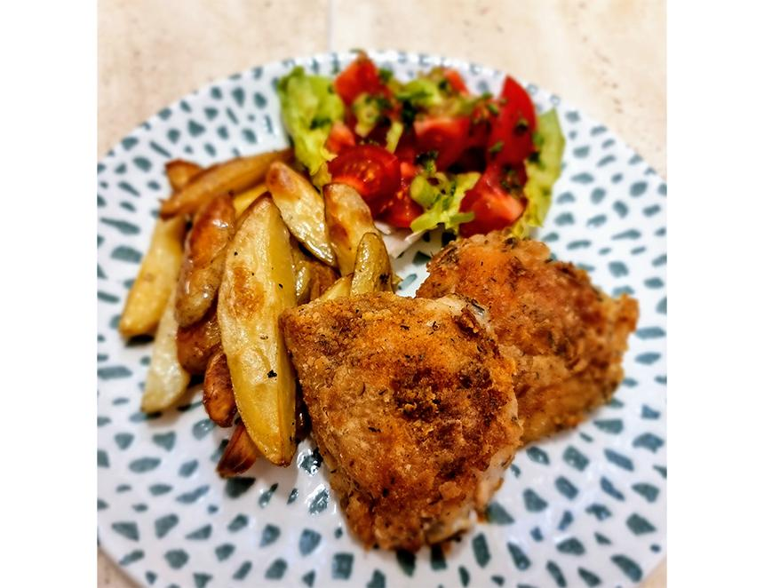

Did you know that somewhere in a bank vault in Jersey is a copy of the original Colonel Harland David Sanders recipe for the secret blend of herbs and spices in KFC (Kentucky Fried Chicken)? The original UK franchise partner retired to Jersey, and he was one of the few people entrusted with the secret formula. However, the secret to commercial fried chicken is not, as some assume, in the ingredients of the coating, but large pressure fryers that lock in the moisture and almost steam the chicken during cooking. Today’s recipe has all the taste of deep frying, but without the need for a large commercial piece of kitchen equipment. Crispy coated oven-baked chicken pieces with herbs and spices, made with my secret to tender, juicy chicken - a beer-flavoured brine. A brine is a salt solution that professional chefs use to infuse flavour into meat and poultry and tenderise the meat. It has the added benefit of helping keep the meat extra juicy when cooked. A brine at its simplest is a solution of salt and water. You can add sugar, herbs and spices, apple juice, wine and, in my recipe, beer. Chiron is a multiple award-winning American-style pale ale, from Thornbridge brewery in Bakewell. It is full of citrus and stone fruit flavours with a distinct hoppy finish. These notes add a lovely base flavour to the chicken, complementing the more earthy thyme, garlic and sweet paprika in the seasoned coating. Beer-brined chicken 1.5kg chicken thighs and drumsticks Brine 330ml Thornbridge Chiron Juice of a lemon 25g light brown sugar 10g sea salt 1 bay leaf A few black peppercorns, crushed Coating 150g plain flour 1tsp garlic salt 1tsp celery salt 1tsp smoked paprika ½tsp ground black pepper ½tsp dried thyme ½tsp dried oregano ½tsp dried mustard powder Vegetable oil for shallow frying Place the chicken pieces into a large plastic tub. Add the brine ingredients and sufficient water to cover the chicken. Put on a tight-fitting lid and place in the fridge for at least four hours. The maximum time in the brine should be no more than eight hours. Thoroughly mix the coating ingredients. Remove the chicken from the brine and shake dry. Place in the seasoned flour and ensure they are properly coated. Preheat your oven to 350F/180C/Gas Mark 4. Heat half a centimetre of oil in a large, heavy, bottomed frying pan and add around a third of the coated chicken, fry on both sides for five minutes then transfer to a baking tray. Fry the next two batches of chicken then place on the tray, then put the chicken in your oven. Cook for 35 minutes carefully turning the chicken over halfway through. Remove from the oven and move the chicken onto kitchen paper before serving with spicy potato wedges, a simple salad or apple slaw from my pulled pork recipe.