Burton MP fights for town’s brewing future

10/08/2024 by Roger Protz

Industry

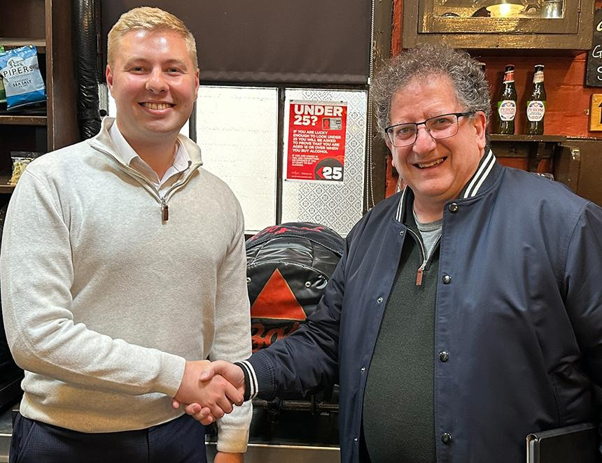

Jacob Collier has been an MP for such a short time that he doesn’t yet have an office in parliament, but as the member for Burton and Uttoxeter he has been busy on the beer front. He is Burton born and bred and within days of being elected a Labour MP, he wrote to Carlsberg to request a meeting to discuss the Danish giant’s commitment to brewing in the town. This came as a result of Marston’s selling its brewing division to Carlsberg in July and the closure of Marston’s Union Room fermenters earlier in the year.  Jacob wrote to the Carlsberg chief executive Jacob Aarup-Anderson, saying Burton had a proud brewing heritage that had to be maintained. “The brewing industry is a major employer in the town,” he added, “and brewers must continue to brew heritage ales that are loved by local people and around the world.” The meeting took place without delay and Jacob says that, while Carlsberg gave no firm commitments, it wants to engage with him and continue a dialogue. “They stressed the importance of Burton and brewing, and they also understood the role of cask beer in the town,” he said. “They said cask was an important part of their brands. They were pleased they had been able to pass on two sets of union fermenters to other brewers so the system could be continued.” Jacob is now heavily involved in the future of the brewery museum and archives in Burton that had to be moved when Molson Coors, the Canadian/American group best known for Carling lager, closed the site in 2022. At present the archives that trace brewing in Burton for several centuries, are stored in a disused Rymans stationery store on the High Street. He said plans by East Staffordshire Borough Council will turn two buildings, Bass House and Town House, into a new museum. “It needs funding,” he said. “The council has applied to the National Lottery and the Levelling Up Fund.” He added that Nottingham University’s School of Brewing is interested in creating a business enterprise centre at the new museum. He grinned and said: “As an alumnus of Nottingham uni, I would want it to be involved.” The Bass House, he says, is very attractive inside and much bigger than it appears from the street. It has a spacious hall, five large parlours, bed chambers on the ground and first floors and an attic storey. It’s a listed building and was where William Bass established his first brewery in 1777. Jacob says under the council’s plans, a block of flats near Bass House will be demolished and a popular local feature, the Water Tower will be renovated. "He hopes that if the additional space is created it will be possible to house such large artefacts as steam engines and old brewery vehicles from the former centre. On his to-do list is a meeting with Molson Coors. When I mentioned the company had stopped producing the famous Victorian IPA, Worthington’s White Shield, he said he would take this up with it and see if it was prepared to sell the brand to another brewer. “When I was younger, I often worked behind the bar at Burton Albion football club,” he said. “A lot of White Shield was drunk there, and I could see how popular it was.” Lower down the pecking order, he has visited the Uttoxeter Brewing Company, set up in 2016. “I discussed with them measures needed to allow small brewers easier entry into pubs,” he said. “People want variety.” He will campaign in parliament for further cuts in excise duty on beer. He laughed and added: “Burton MPs always want lower rates of excise duty!” He says Rachel Reeves in opposition had called for lower business rates and he hopes this will be addressed in her Autumn Statement. “The new [publicly owned] Great British Energy Company should be able to help the brewing industry with lower prices for electricity and gas,” he said. He agrees that the anomaly whereby supermarkets can claim back VAT on alcohol sales needs to be tackled. To add to voices supporting brewing, he has joined the All Parliamentary Beer Group and, following a meeting with CAMRA national chairman Nik Antona in the Coopers Tavern in Burton, he’s now a member of the Campaign. Jacob is primed for action. All he needs now is an office and a desk. Pictured: Jacob Collier (left) with Nik Antona