Beer sommelier programme returns

09/08/2024 by Timothy Hampson

Industry

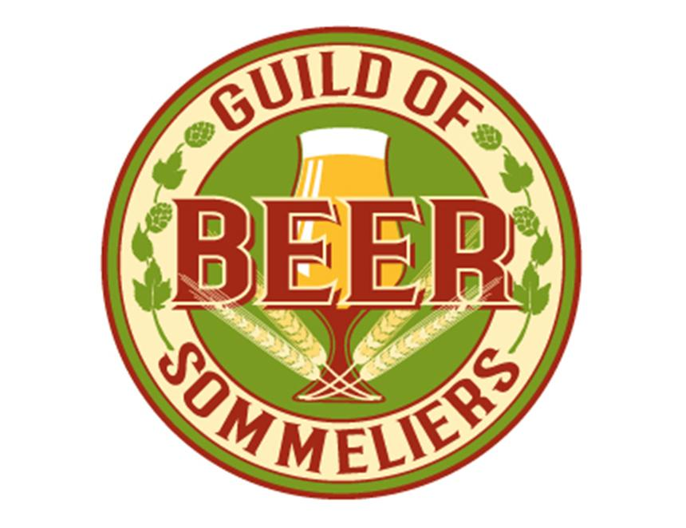

Cask Marque, with the support of Wine and Spirit Education Trust and Institute of Brewers and Distillers (IBD) is relaunching the beer sommelier programme. Previously it was run by IBD and prior to that, the Beer Academy. The accreditation lapsed in 2019 and now currently there are more than 200 accredited beers sommeliers. Cask Marque has now established an advisory board to create the Guild of Beer Sommeliers. Cask Marque chair Paul Nunny said: “The purpose of the guild is to promote and support members as the best beer educators in their field. We will encourage new individuals to expand their knowledge and communicate about beer. “The guild will be communicating with existing beer sommeliers to gain their input into the future plans.” British Beer and Pub Association chief executive Emma McClarkin said: “We are delighted to see that Cask Marque has relaunched the beer sommelier programme as an important tool to educate and support individuals, including those working in brewing and pub businesses, to become beer educators and to promote the diversity, quality and heritage of the great British pint. “This year, the 200th anniversary of the British pint, provides the perfect backdrop for the relaunch of this amazing course and I look forward to seeing Cask Marque deliver the next generation of beer ambassadors.” Find more information here.