Crooked House scandal – One Year On

05/08/2024 by Madeleine Hardman

Campaign

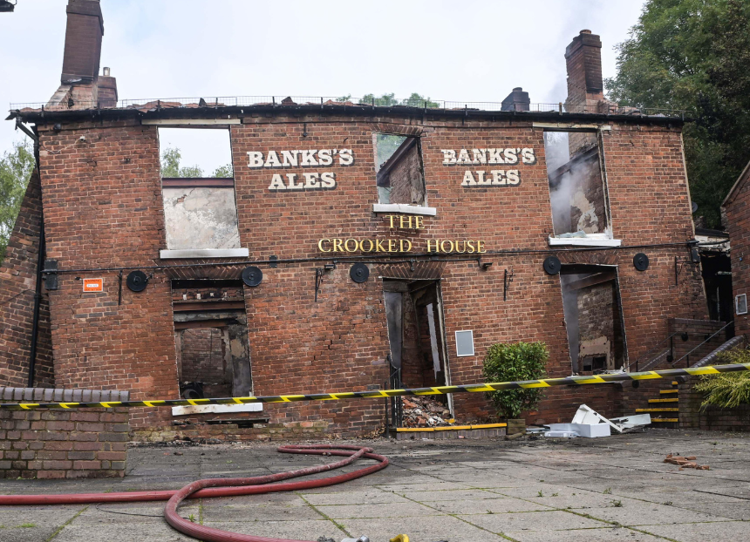

In this special Public Affairs Round Up, the CAMRA Campaigns and Communications Team looks back at the 12 months of campaigning following the tragic fire and unlawful demolition of the pub, which caused an outpouring of anger from pub lovers across the UK.  A year ago, the Campaign mourned the loss and destruction of the Crooked House, a historic “wonky” pub in Himley, that caught fire shortly after it was sold by Marston’s PLC, destroying much of the interior building.   But the fire wasn’t the full cause of this pub-ending tragedy; less than 48 hours later, the remaining facade of the building was demolished, and after a public statement from South Staffordshire Council was released, it came to light that the fire’s safety inspection did not deem the building necessary for demolition.  The tragedy caused public uproar and received mass media coverage, which continued after CAMRA released shocking data, collected from reports from Campaign volunteers across the country, that revealed the number of pub conversions and demolitions in England without planning permission, and declared the cause a “nationwide scandal”.  Despite the change in planning law back in 2017 which stipulated pubs in England could not be converted or demolished without planning permission, CAMRA’s closure data showed an appalling 155 English pubs that had been converted or demolished in the time between January to June 2023.  An additional 10 pubs faced the same devastating fate where planning applications were unable to be found, prompting speculation that laws could have been broken.  With the Crooked House scandal and the revelation of many other pubs facing similar unfair – and unlawful – endings, CAMRA called for government to take action to make sure that planning legislation ensures pubs demolished or converted in an unlawful manner must rebuilt brick-by-brick.  At the same time that the data was published, CAMRA’s director of pub and club campaigns Gary Timmins raised the matter with the then government’s planning and housing ministers.  On behalf of the Campaign, Gary emphasised the horrific outcome of the Crooked House tragedy and highlighted that pubs in England face a similar fate far too often – demanding more effective planning enforcement options for local councils; making the demolition of a pub without permission a specific offence; and to make those found to have converted or demolished pubs against planning rules be required to restore the original building brick-by-brick.  Gary, along with CAMRA colleagues Paul Ainsworth (national planning policy adviser) and Ellie Hudspith (senior campaigns and communications manager) met with the then planning minister Lee Rowley to discuss next steps.   While members of CAMRA’s Planning Advisory Group and the Campaigns & Communications Team continue to have regular dialogue with planning officials in the recently renamed Ministry of Housing, Communities & Local Government, the General Election took place before more work could be completed with Rowley.  In the fire's immediate aftermath, CAMRA campaigners in Dudley and South Staffordshire met with former MP for Dudley North, Marco Longhi, to discuss the Crooked House and what else could be done to protect heritage pubs in the West Midlands. When the Dudley Winter Ales Fayre took place later in the year, the Crooked House was the central campaigning theme of the festival, and was commemorated on the official glasses.   Marco Longhi introduced a Private Members’ Bill in parliament to strengthen protections in law for heritage pubs. Although that proposed legislation fell when the General Election was called, CAMRA is continuing to call for the new government to introduce similar improvements to pub protection laws.  While CAMRA’s calls for the UK government to strengthen planning enforcement legislation continued, staff and volunteers were delighted to work with former West Midlands mayor, Andy Street, who strongly advocated for the case of the Crooked House after an enforcement notice was issued to the owners to rebuild the pub back in February.   West Midlands Combined Authority teamed up with CAMRA by introducing the List Your Local Campaign, giving people the opportunity to nominate pubs with heritage value for statutory listing – securing more protection against illegal demolition or conversion.  Out of the 80 pubs nominated by the public, CAMRA identified and submitted 16 that were likely to meet the Historic England criteria, which were then submitted as listing applications to Heritage England for consideration. The Campaign continues to wait for Heritage England’s decision on these pubs.  In England the listings are made by the secretary of state for culture, media and sport Lisa Nandy, with the advice of English Heritage, and in Wales, listings are made by Cadw on behalf of the Welsh Assembly.  These listed buildings will fall under one of the three graded options:  Grade I: this highest of gradings covers just 2.5 per cent of all listed buildings: these are those that have “exceptional”, even international interest.

Grade II\*: (known as two star) covers a further 5.5 per cent of listed buildings. They have “outstanding” interest.

Grade II: 92 per cent of all English and Welsh listed buildings are at this grade. They have what is described as “special” architectural or historic interest.  Any heritage pub successful in becoming a listed building will benefit from greater protection measures than those which are not, and should any alterations made to the building that could change their historic character this can only be done with a “listed building consent” from the planning authority.  Anybody can apply for a building to be listed. For more information on how to list a building in England, Scotland, Northern Ireland and Wales, you can find it here.  Discussions continued in the aftermath of the Crooked House scandal with parliamentarians and government ministers in Scotland and Wales about improving pub protection laws and closing planning loopholes in both of those nations. Members in Scotland and in Wales will soon be asked to take part in an e-lobby of MSPs and MSs to help put pressure on government ministers there to better protect pubs from conversion or demolition.  Following the UK General Election on 4 July, the team got straight to work writing to new secretary of state for housing, communities & local government – and deputy prime minister – Angela Rayner, urging her to commit to strengthening planning laws to protect England’s pubs, and to give communities more of a say over saving their local if it is under threat.  The King’s Speech, setting out the new government’s legislative priorities, acknowledged the problems caused by the loss of community businesses, including pubs, and announced its plan to introduce of a community “right to buy” to give it first refusal over saving a local to keep it as a pub if it is under threat of demolition or conversion.  Hopefully the Team will be pushing at an open door with the deputy prime minister and the new government more widely when it comes to protecting and promoting pubs.  But the Campaign is certainly not complacent. CAMRA will be reiterating the importance of improving planning protection and enforcement for viable and valued pubs and social clubs so we can prevent pubs from facing unfair or unwanted demolition or conversion. Crucially, we must have protections in place that result in a consequence if demolition or conversion does happen without planning permission including the power to order pubs to be rebuilt if necessary.  Members of the National Executive, CAMRA’s campaigning committees, the Planning Advisory Group, regional directors, branches and the staff in Campaigns and Communications Team will continue to work with parliamentarians, government ministers, civil servants, metro mayors and councils across all parts of the UK to make the case for effective pub protection laws and for the powers and resources for local authorities to enforce them.  It is vital that no pub ever has to face the same scandal as the Crooked House. If they do, they must be rebuilt so that justice is served for the communities that the pub serves.  Finally, if you are a CAMRA volunteer or campaigner whose pub is under threat, join us by exploring CAMRA’s Save Your Local Pub Toolkit where you can access campaigning resources that could prevent another community from losing a pub at the beating heart of community life.  Cheers! The CAMRA Campaigns and Communications Team Photo from Alamy