Town museum included in brewery expansion

04/08/2024 by Timothy Hampson

Industry

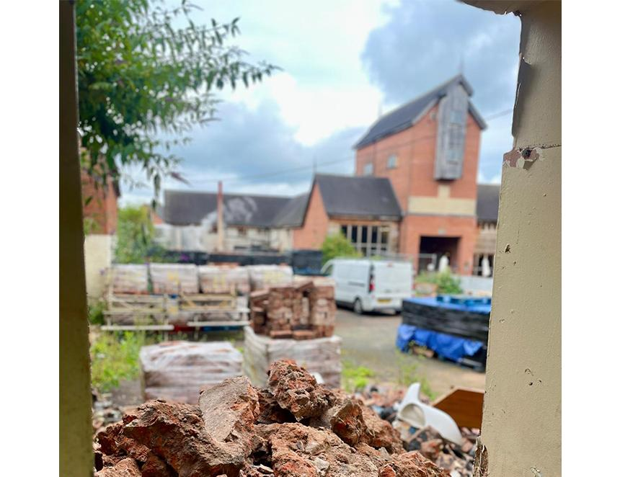

Joule’s brewery has broken ground on its much-needed brewery expansion. It marks the beginning of a new chapter for the brewery and the Market Drayton, Shropshire community as it includes an exhibition space. The expansion, part of an ambitious £1m development, aims to enhance its brewing operations, increase capacity, and integrate new community spaces. “Our investment will see the addition of more maturation vessels and essential infrastructure, ensuring we can continue to meet the growing demand for our beloved craft lager, Green Monkey,” said the Joule’s. “With the addition of new maturation vessels, we will be able to produce more of our signature Green Monkey lager. We are thrilled to partner with the Drayton Civic Society to create a new, purpose-built space behind the Stag for the town’s museum. This 200m² exhibition area will provide an accessible venue for showcasing Market Drayton’s rich heritage. “The new building will feature reclaimed 19th-century red clay bricks and clay roof tiles, seamlessly blending with the surrounding historical architecture while incorporating modern design elements.” Construction is expected to continue through to early 2025, with the aim of having all developments completed by summer 2025. “We are committed to keeping the community informed throughout this process and look forward to celebrating the completion of this project with you all,” said the company.