Pioneer scoops sustainability prize

02/08/2024 by Timothy Hampson

Industry

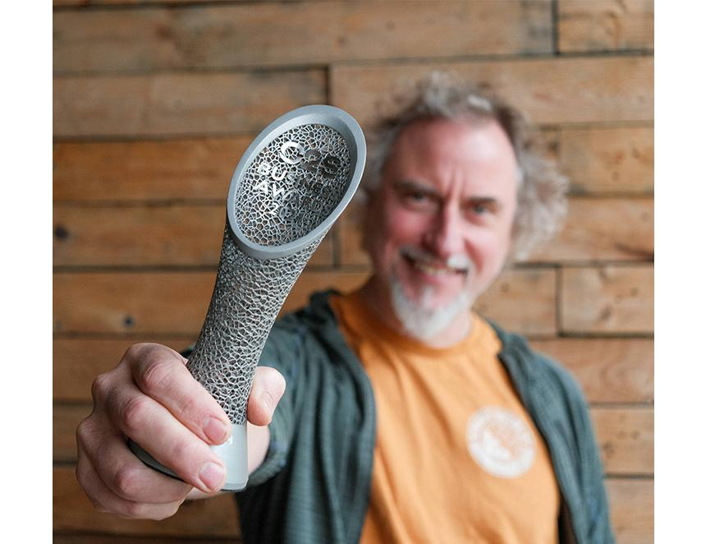

Environmental pioneer Stroud brewery is raising a glass after winning the Sustainability Award 2024 in the Circle2Success SW Business Awards. A leader since the 2000s in the task of marrying environmental responsibility with making beer, it was the first brewery in the UK to be certified as both organic and a B Corporation. The Circle2Success Awards showcase the best of business innovation, dedication and excellence across the SW of England from Cornwall to the Midlands. Stroud  beat stiff competition including last year’s winner. Founder Greg Pilley (pictured) said: “It was tough competition so we’re thrilled to be chosen. “It’s so exciting to see how many other companies – both within brewing and in general – are now eagerly embracing sustainability as they understand how it’s a win-win all round. Not only do the environment and communities benefit, but businesses do, too.”