Whitbread under fire for mass pub closures

01/08/2024 by Timothy Hampson

Campaign

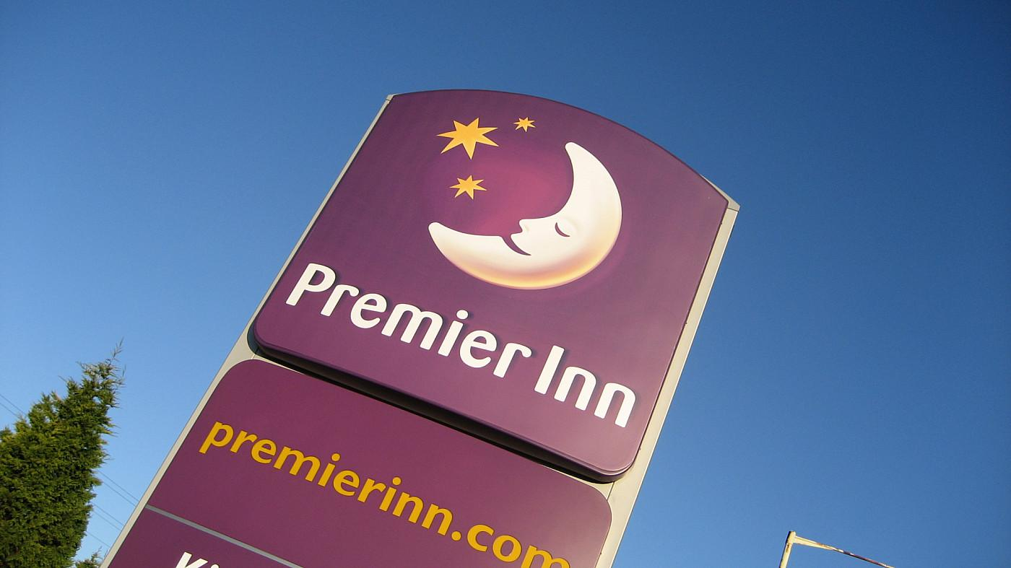

One of the draws of staying in a Premier Inn is popping in to the pub next door for a pint of cask ale, but that is coming to an end as owner Whitbread plans to turn them into restaurants and hotel bedrooms. CAMRA has expressed “utter dismay” at the decision and chief executive Tom Stainer has written to Whitbread challenging it to reconsider. In the letter, Tom said: “Closing a pub – which is a community amenity facility and gathering space – to the local community that it serves is not only contrary to the aims of your Environmental, Social and Governance strategy, it will also impact upon your ability to maintain that you are a ‘trusted brand’.” CAMRA’s pub-saving campaigners are also concerned about how the conversions have taken place. Whitbread has been able to use a grey area in the current English planning system that makes it easier to claim pubs are restaurants, which makes change of use more likely to be granted. CAMRA’s national planning policy adviser Paul Ainsworth said: “Concerningly, it appears that most of these pubs have been closed to the public, under the argument that they are restaurants, and worryingly most local authorities have accepted that. “We are now campaigning for a legal definition of a pub for planning purposes so that if you can buy a drink at the bar without purchasing a meal, the venue would be considered a pub. “In the wake of scandals such as the Crooked House demolition, unacceptably high levels of unlawful conversions and demolitions, and now this, we need the new government to act now to strengthen planning protections and enforcement options for local councils.”