Campaign for Ivy grows

31/07/2024 by Timothy Hampson

Pub

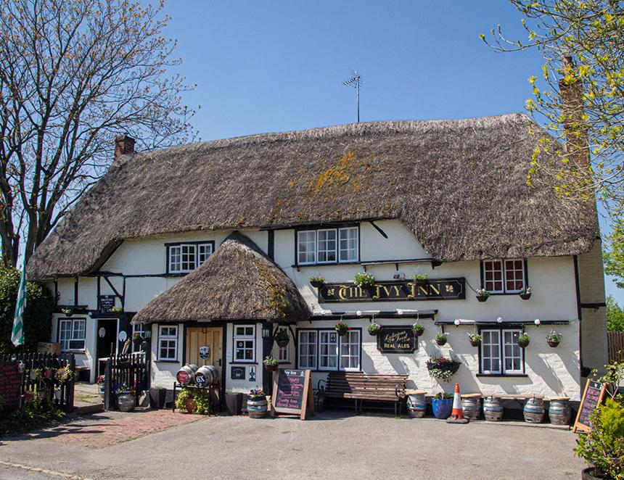

Wiltshire villagers are coming together to buy their local after owner Wadworth brewery put the Ivy Inn in Heddington up for sale. The Ivy is has Asset of Community Value status which prevents Wadworth from agreeing a sale for six months, allowing time for campaigners to explore buying and running it as a community-owned pub. A well-attended public meeting was followed by a survey of the village which demonstrated overwhelming support for the proposal which, in addition to keeping the pub open, will also develop other community benefits such as a café and meeting space. An application has been made to the Financial Conduct Authority to establish Friends of the Ivy as a community benefit society that will drive the initial campaign and, if successful in buying the pub, to oversee its future. With support from Plunkett UK and the advice from other community-run pubs in the South-West, Friends of the Ivy are progressing with a detailed business plan, raising awareness and fundraising. A community shares scheme will be announced at friendsoftheivy.org.uk. Campaigner Paul Moyle-Harris said: “The Ivy Inn dates back to at least 1886 and, along with the village of Heddington, has significant historical interest. “We are actively researching the fascinating story of this unique public house, which we hope will continue to be enjoyed by generations to come.”