Geoff Mumford – Burton brewing pioneer

30/07/2024 by Roger Protz

Uncategorised

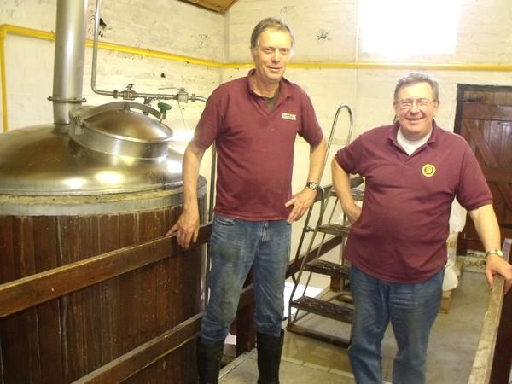

Geoff Mumford, (above right) a pioneer of the small brewery movement, has died aged 82 just weeks after securing the future of his Burton Bridge brewery. With his business partner Bruce Wilkinson (above left), he launched Burton Bridge in 1982 under the noses of such giant Burton brewers as Bass, Allied and Marston’s. They prospered, winning prizes for their ales and, to Geoff’s delight, the Best Pub Renovation award from CAMRA for their upgrading of the Burton Bridge brewery tap. Exhausted by the hard slog of running pubs and brewery, Geoff and Bruce had wanted to retire for some time but were determined to sell only to people who shared their vision of good beer. It finally came in the shape of the Heritage brewery that had been forced to leave its site when Molson Coors closed the National Brewery Centre. Heritage says it will honour Geoff’s memory by continuing to brew his range of beers. Geoff was the chief engineer at Ind Coope’s brewery in Romford, Essex. He met and became close friends with another engineer, Bruce Wilkinson, and the two played rugby together. Ind Coope, with Ansells, Allsopps and Tetley, was part of the national Allied Breweries group. “Bruce and I were heads of our departments at Romford and we could see the writing on the wall,” Geoff recalled. “Allied had closed Ansells in Birmingham and Romford was treated as the Siberia of brewing, so we decided to jump ship.” They went on a small business course in London and planned their own brewery. Geoff was visiting the Ind Coope plant in Burton one day, drove over the historic Burton Bridge across the Trent and saw a For Sale sign on the Fox & Goose pub. “It had plenty of room at the back for a brewery,” Geoff said. They bought the pub, renamed it the Bridge Inn and installed brewing kit where they produced their first beer, Bridge Bitter, in 1982. “We’d seen the cheap ingredients used at Romford and we wanted none of that,” Geoff said. They bought Maris Otter malting barley and “the finest hops money could buy”. Using the local water, rich in mineral salts, Bridge Bitter had the famous Burton snatch of sulphur on the aroma. Golden Delicious, brewed as a summer special for Midsummer Inns, caused such interest that it became a permanent member of the range and was one of the first golden ales. The beer portfolio grew to include Festival Ale, Top Dog Stout, Porter, Damson and Bramble stouts and Stairway to Heaven. They were delivered to pubs throughout the Midlands and through wholesalers further afield. Geoff and Bruce also bought four more pubs in Burton – the Devonshire Arms, Great Northern, the Plough and the Prince Alfred – though they were sold a few years ago as the duo started to reduce their work load. Geoff was critical of many modern interpretations of India Pale Ale that he said owed too much to over-hopped American versions. In 1996 he and Bruce designed a bottle-conditioned Empire Pale Ale (7.5 per cent) in the true Burton style. It’s brewed with pale malt and brewing sugar, with no darker grains. The hops are English Challenger and Styrian Goldings from Slovenia – the latter is an off-shoot of the English Fuggle variety. The beer is conditioned in the brewery for six months to replicate the length of a journey by sailing ship to India in the 19th century. It’s then bottled with live yeast. It won a gold medal in a bottled beer competition held by the Guardian newspaper in association with CAMRA. Geoff with Bruce restored another Burton tradition when they brewed Draught Burton Ale in 2015. A beer of that name was first brewed in the late 1970s by Allied using the Ind Coope name. It met with such demand from consumers that it helped boost the real ale revival started by CAMRA in 1971. The 4.8 per cent beer is the only one produced by a national brewer to win CAMRA’s Champion Beer of Britain competition. When Allied Breweries was wound up and became Carlsberg Tetley, DBA was moved to Tetley in Leeds but then phased out. Encouraged by local CAMRA branches, Geoff and Bruce brewed their version of the beer for the Burton Beer Festival in 2015. It proved so popular that it became a permanent member of the range. When Geoff was asked if he was worried that Carlsberg might sue Burton Bridge, he chuckled and said: “It’s draught, it’s ale and it’s brewed in Burton – so it’s Draught Burton Ale!” He never heard a peep from Carlsberg. He was delighted when Heritage merged with Burton Bridge but, says Bruce, he was worn down by the years of hard work that often took up seven days a week with early morning starts. He leaves a legacy of fine beers brewed in the Burton tradition and he inspired a legion of other beer lovers to pick up his mantle and start their own small breweries. His contribution to the cause of good beer will not be forgotten.