Council and campaigners save historic London pub

26/07/2024 by Timothy Hampson

Pub

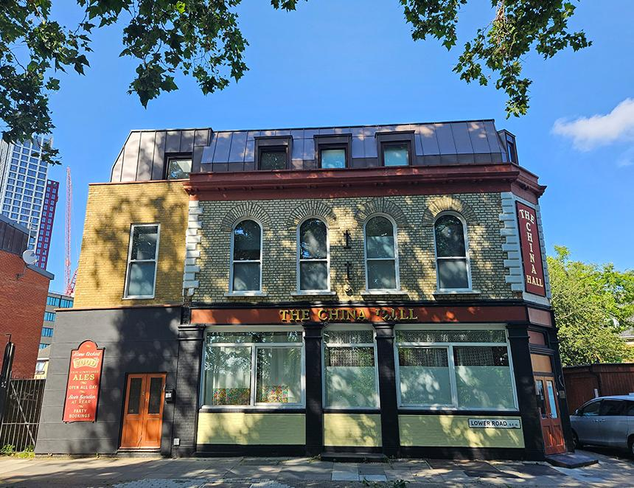

A determined local authority and a concerted campaign by locals has helped save a historic pub in South London. Last year, Southwark Council issued a planning enforcement notice following an unauthorised change of use for the China Hall pub in Rotherhithe which was being turned into two flats. A subsequent public inquiry found in favour of the council forcing the owner to return it to a pub. In January 2022, work had begun to convert the ground-floor into two flats before planning permission was obtained. Council enforcement officers visited the site and discovered the bar had been removed, beer lines cut, fixtures, fittings and carpets stripped out, leaving the ground floor little more than an empty shell. The planning inspector ruled the pub was unlawfully converted and must once again be a public house. South East London CAMRA branch chair Andy Large said: “I am delighted with the result and extremely grateful to the team at Southwark Council for its dedication and diligence in the defence of the China Hall over a prolonged period. “I hope it serves as an inspiration to other local planning authorities to defend against unauthorised development that results in the loss of valued community facilities. Thank you very much.” Cabinet member for New Homes and Sustainable Development Cllr Helen Dennis said: “This is a huge win for our planning enforcement team and local residents who worked together to save the China Hall as a functioning pub. “Pubs are specifically protected by planning policy and for good reason. I’m thrilled that such an important piece of Rotherhithe’s history and community has been protected. It serves as a warning that it is never acceptable for works for go ahead before a planning application has been approved.” Michael Robertson and Steve Cornish of the China Hall Local Community Group said: “We’d like to thank council officers and their legal representatives in their outstanding energies, due diligence, and tenacious amplification of the China Hall’s cultural significance to Rotherhithe and Bermondsey. “A legacy of which can now hopefully be enjoyed as public realm for generations to come via the pubs welcomed return.”